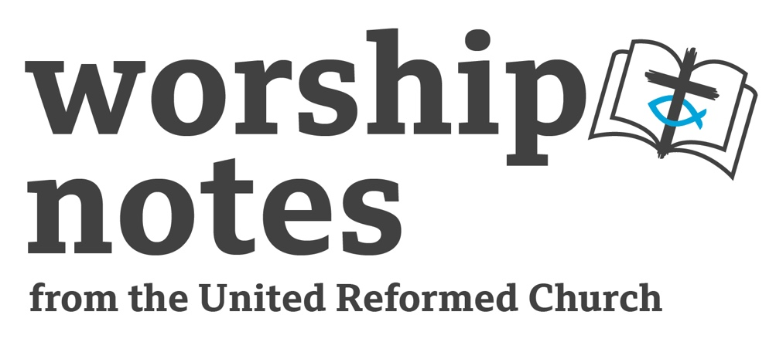

Second After Pentecost

Proper 7 / Ordinary 12

19th June 2022

The Rev’d Andy Braunston

Opening Music

You might like to find a recording of We Have Come This Far by Sweet Honey in the Rock and play.

Call to Worship

Come and worship the God of our salvation who gives water from the rock!
Come and follow Jesus our saviour and friend our manna from heaven.
Come and be filled by the Holy Spirit, who fashions us into living stones.

Prayers of Approach

We come to you, Eternal One, our rock and our salvation, to worship,
to find, in the wilderness of our lives, water from the rock and bread from heaven.

We approach you, O Christ, divinity embodied, coming in awe and wonder,
finding in your Way, love and grace, water from the rock and bread from heaven.

We feel your presence, O Spirit, energy of all creation,
knowing you form us as a mason works stone into things of beauty,
living stones which reflect Your glory,
given water from the rock and bread from heaven.

Confession

As we come to You in worship, Eternal One,
we gaze upon You and become aware of our lack of holiness.
We become conscious of the times when our lives
have reflected malice and guile instead of kindness and grace;
insincerity and envy, instead of honesty and sharing;
slander and quarrelling, instead of love and peace;
we demand milk instead of feasting on the meat of Your Word.
Give us time to change O God,
time to see ourselves as we really are – beautiful yet in need of work;
living stones yet in need of polishing, glorious, yet fallen. Amen.

Affirmation of Forgiveness

As of old when:

the Eternal One forgave the quarrelsome disobedient pilgrim people;

the Lord Jesus forgave those who hardened their hearts;

the Holy Spirit forgave the living stones who didn’t wish to be changed;

so God forgives you, and gives you the grace to change your lives.

Have courage, forgive yourselves and change!

A Prayer of Inspiration

Break open Your Word to us,
O Rock of our salvation,
that as we hear, ponder and understand,
You may shatter our resistance to Your uncontainable word,
that we may follow You wherever You call.
Amen.

Readings

Exodus 17: 1 - 7 | I Peter 2: 1 - 10 |

Sermon Notes

You might want to ask the congregation what they associate with rock. They might think of firmness, security, foundations, firmness or difficulty – after all it’s hard to dig a garden with a lot of rocky soil. We make buildings from rock – stone, cement made from the dust of rocks, and brick. We decorate our buildings with rock – all those kitchens with granite work surfaces, grand cathedrals with marble pillars and floors, even now in modern houses people have polished concrete floors! We want the firmness and stability of rock in our lives.

The People of Israel had little security in their formative years and in their life as a nation as recorded in the Old Testament. As they fled Egypt they lived, not in houses of stone but in tents so they could journey on through a formational journey which, eventually, led them to freedom. Security was found in God – who gave them water from the rock. Even when they settled in the promised land and built their stone houses and the grand Temple they found that the prophets warned them, again and again, to trust in the Lord - their rock and redeemer not in foreign policy. The prophets, of course, were ignored.

The writer of Peter was in an insecure place. The Church was embryonic, had no buildings but met in graveyards of the day – hewn from the rock – or in the houses of rich converts. Instead the strength of the Church was not found in its buildings, wealth or property but in the “living stones” who were the members. Living stones which are knit together, polished to remove rough edges just as stones are tumbled now to smooth and give them a sheen.

How might God be at work in your congregation to make you a Temple of Living Stones? How might God be smoothing off your rough edges? And to what end does God do this? Where does God lead us as living stones? For what purpose is God at work in your church, in your life and in your neighbourhood? Are you willing to be living stones on the move instead of a glorious, but immovable, building?

An Affirmation of Faith (Ruth Whitehead, see notes for Pentecost 2022)

We believe in God, whom Jesus called Father,

who created all things in love.

We believe in the Holy Spirit,

who was with God the Father from the beginning

who co-created the universe, and holds it in being.

We believe in Jesus Christ – one with the Father and the Spirit –

who came to live a human life

and gifted the Spirit as comforter and guide.

We believe in God who is three in one

who was and is and is to come. Amen.

Prayers of Intercession

God of the ages, we praise you for the ways you:
cared for your people of old,
fed and quenched their thirst in hard times,
and enabled our forebears in the faith
to be fashioned into your holy people.
Guide your people now, O God, throughout the world
as we seek to follow you,
obey your commands,
and treasure your creation.

Pause

In your mercy….hear our prayer

Eternal One,
in an age of change, insecurity, terror and fear
we cling to you our rock and our salvation,
bless with your love
those who struggle against oppression in all its forms.
Bring to justice the despots and dictators of our own age,
that the crimes of our world which cry out to heaven
will be met with justice.

Pause

In your mercy….hear our prayer

God as a mother you care for your people,
feeding us with your very self,
and teaching us of your loving kindness
in the hope we will reflect this in our lives.
Help us to love those we find difficult,
to pray for those we don’t vote for,
to wish the best for those who would do us harm.

Pause

In your mercy….hear our prayer

Eternal One,
Sovereign of the ages
we bring to you those who lead in our world,
all those who hold elected or appointed office,
and those whose grasp on power is through war, terror and oppression;
enable all who lead to know your law and justice,
bring to judgement those who use their office for service of self, for greed or for unworthy ambition.

Pause

In your mercy….hear our prayer

God of transformation
as you form us into living stones
we bring before you in a moment’s silence
those whom we love and worry about

Pause

In your mercy….hear our prayer

And so we join all our prayers together as Jesus taught us…. Our Father…

Offertory

In a culture where material goods are valued, and security is measured in how many possessions we have, giving is radical. In an economic system which favours the wealthy giving seems foolish. In a political culture which is obsessed by appearing to cut taxes, giving is a stumbling block to those who see themselves as wise. In an age where power and fuel bills rise way faster than pensions and wages generosity is counter cultural. In worship we challenge the way things are as we long for the age to come which will be radical, foolish to the wise of the world, a stumbling block to the powerful and where our culture is inverted. And so we give. We give to challenge the wisdom of the world. We give to further the work of the Church. We give to show our gratitude to God. Let us pray.

O God you call us to envision a different age,
a different economic model,
a different political structure,
a different way of being wise,
where generosity is life giving.
Bless these gifts and help us to use them wisely
as we proclaim your coming Kingdom. Amen.

Blessing

May the One

who gave the thirsty water from the rock,

who told us to build on firm foundations,

and who formed God’s people into living stones,

quench your thirsts,

enable you to build on the rock of faith,

and trim your rough edges,

that you be transformed from glory into glory,

and may the blessing of Almighty God,

Father, Son and Holy Spirit,

be with you all,

now and always, Amen.

Closing Music

You might like to find and play Maddy Prior’s version of How Firm a Foundation Ye Saints of the Lord

Hymn Suggestions

Hymn | RS | StF | CH4 | MP
Praise to the Lord, the Almighty, the King of Creation | 74 | 88 | 124 | 564
O God of Bethel | 71 | 475 | 268
Earth’s Creator, Everyday God |  | 45
Bring Many Names |  |  | 134
Guide Me O Thou Great Redeemer | 345 | 465 | 167 | 201
Key:
RS = Rejoice and Sing, StF = Singing the Faith, CH4 = Church Hymnary 4, MP = Mission Praise

The Rev’d Andy Braunston is the URC’s Minister for Digital Worship

