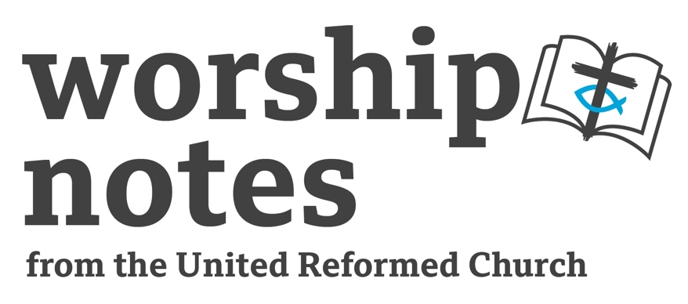
November 6th 2022
Proper 27 | Ordinary 32
The Rev’d Fiona Bennett

Call to Worship

One: God of the past All: Source of all being
One: God of the present All: Saviour beside us
One: God of the future All: Shaper of hope
One: God beyond time All: Holy Three in One, we worship you.

Prayer With Focusing Movement

A movement is offered for the congregation to make while saying the words which open the prayer. It is suggested you invite people to try the movement before formally joining in prayer.

Learning the movement: Invite people to point back over their shoulders with both hands, whilst saying: God of the past who has fathered and mothered us. Then to point forward with both hands, whilst saying: God of the future who is always ahead of us. Then to hold both hands in front of you, palms upward and fingers open, as you say: God of the present, who is here in the midst of us. Please let the congregation know that they are welcome to join in the movement or to remain sitting still, as they feel comfortable. Don’t rush the movements or words. Offer easy pace to think about them as you say and do them.

One: Holy One, we pray…
All: God of the past who has fathered and mothered us (point behind)
All: God of the future who is always ahead of us (point in front)
All: God of the present, who is here in the midst of us (hands open)
All: God of all time, we offer you our worship and praise.

One: We gather in this moment bringing with us:
joy and sadness from our past,
hope and fear for our future,
faith and doubt in the present.
God of all time,
You have seen our love and fear.
You have seen our prejudice and acceptance.
You can see our self-loathing and our kindness.
God of all time and beyond time, help us always to trust in your love.
As we look to the past, grant us wisdom and insight.
As we look to the future, inspire us with vision and hope.
As we live in the present, transform us with your love which knows no limits.
We unite our prayers together in the Lord’s prayer,
using the form of words most worshipful for us…

Readings

Job 19:23-27 | Psalm 145 | 2 Thessalonians 2:1-17 | St Luke 20:27-38

Sermon Notes

Job

I understand Job to have been written as a book of wisdom literature, in which an individual or perhaps a group explore the question as to why God allows humans to suffer. There is no single simple cohesive answer to the question, but in Chapter 19 in the reading we heard, Job is expressing a desire for his story to be written down in indestructible stone, for he believes that one day, probably long after he is dead, he will be vindicated; one day someone will stand up for him (his “go’al” – translated redeemer; this was a member of your extended family who could represent you in public life and who was given the tribal responsibility to deliver you when you could not stand for yourself) in public and it will be seen and known and believed that Job’s suffering did not come about because of anything he did or was. Job believes that eventually there will be justice, eventually the truth will out, despite his experience of loss and suffering. Job’s words remind me of the quote which Martin Luther King Jr made from Theodore Parker: “The moral arc of the universe is long, but it bends towards justice”. This is an expression of faith; trust that the Holy One of Abraham, Moses, Isaiah and Jesus shaped Justice into the DNA of the world. It may not seem to be present in my life time, but eventually it will come if we keep striving for it in the ways of love and grace Jesus showed. As we look back today and reimagine history from the perspective of Black Slaves, we read the cries for justice etched into stones with an iron pen and we too can stand as redeemers for those voices long gone.

The Psalm

Like most of the Psalms, we have little historical context to this Psalm, but an expression of a timeless human experience: the importance of remembering. “One generation shall laud your works to another” – this Psalm is part of that process of lauding. The whole Psalm is an encouragement to remember: to remember what God has done, to remember what God is like and to trust the God who our ancestors remembered and told us about. For in trusting in a God who is gracious and merciful, good to all, effects how we perceive the world today and how we choose to live today and tomorrow.
2 Thessalonians

For some back ground to this reading I would point you toward commentary by Bill Loader who is an Emeritus Professor at Murdoch University. In the midst of anxiety and fear the writer of this letter is encouraging the recipients to remember; to look past the chaos and conspiracy, the fear and apocalyptic scintillation which seems to have caught their world, and to remember Christ’s Gospel, their calling, and to trust in the God who they can see in these. This God’s love and hope is not restricted nor does their goodness ever fail. As the Jesuit Antony de’Mello wrote (Awareness 1990) “You know all the mystics agree on one thing, no matter what their theology or religion they are unanimous on one thing: that all is well, all is well. Though everything is a mess, all is well. Strange paradox to be sure.” Politically and personally people may be experiencing crisis and chaos today. This letter invites us not to be mesmerised by evil but to meditate on goodness, as we remember and focus on Jesus, his message of abundant life for all and our calling to share in his mission.

St Luke

This passage reflects a way of thinking which may be unfamiliar to us. The Sadducees were trying to ridicule the logic of the idea of resurrection. For more background on Levite marriage I would again direct you to Bill Loader’s commentary. The Sadducees are trying to provoke a clever conversation about the technicalities of life beyond death. I think the heart of Jesus response is in v38 “Now he is God not of the dead, but of the living; for to him all of them are alive.” I read this response as a push back to the Sadducees to not use their energy trying to organise a logic for the afterlife, both side of the grave are in God’s hands. What they should concern themselves about, and what we should all be concerned about is how to live; how to live in God’s eternal life now? How to awaken to and live in God’s Realm now and in hope for the future? Is there an invitation in this story not to be distracted by rabbit holes (however theological) but to remember to focus on living as a disciple alive to God, today?

Prayers of the People
by Kate McIlhagga (The Greening Heart of the Snowdrop – WGP)

Wind of God, blowing from the four corners of the earth, breathe on us.
Where our bones are dried up and hope is lost,
breathe hope and sinew into desperate spirits:
in flooded villages, in refugee camps, in hungry homes.
May your arm be under the head of the helpless,
may they rise up from the graveyard of despair
and find new life through the power of love.

Hurricane of God, blowing across the universe,
stir the hearts of the compassionate, overturn the caution of the hesitant,
that the resources of the world may be shared with the hungry,
that tanks may be turned into tractors
and the debts of those ensnared in poverty cancelled.

Breath of God, gently whispering in our ears,
remove the dust of apathy which clouds our vision.
Energise us that we may be a source of comfort for the sick,
a solace for the bereaved.
Holy Spirit of comfort and change, send us out in confidence and joy
to keep the faith and share it.

Holy Communion
by Ruth Maxey
The Invitation

The first time this story was told they gathered around a table, a ragged collection of people – sinners, betrayers, the power-hungry, fragile, lonely, lost.

The first time this story was told, Jesus promised that is was for all time, that whenever the bread was broken and the wine was poured, wherever the story was told around the table he would be there.

Today we tell the story as it has been told a thousand times over; we break the bread, and we pour the wine; sure, as we do, that we belong at this table and that Jesus is here with us

So, let us hear the story of how this meal, this sacrament, began: On the night that Jesus was betrayed, took bread gave thanks, broke it and said: ‘this is my body, broken for you’.

Then he took the cup saying: ‘this is my life of the new covenant, poured out for you, do this whenever you drink it, to remember me’.

So now following Jesus’ example and command, we take this bread and this wine, the ordinary things of the world which Christ will make special.

Prayer of Blessing

Send down your Holy Spirit on us, and on these gifts of bread and wine. That they may become for us your body, healing forgiving and making us whole; and that we may become again your body, loving and caring in the world until your Kingdom come. Amen
If we come to this table angry, let this bread and wine be our peace.
If we come to the table as sinners, let this bread and wine be our grace.
If we come to this table betrayed, let this bread and wine be our wholeness.
If we come to this table broken, let this bread and wine be our hope.
If we come to this table empty, let this bread and wine be our life.

For this is a holy table, with food to fill a hungry world and wine to quench thirsty hearts. It is God’s in the making, and ours for the taking.

Let’s take the bread together…..the bread of heaven in Christ Jesus (Eat bread)

Now we share the wine…. the wine of the Kingdom (drink wine)

Prayer after Communion

God our salvation, we thank you for our communion with the Risen Christ and with all those who love him in earth and heaven. We pray that, strengthened by his grace, we may serve you faithfully all our days; through Jesus Christ our Lord. Amen

Peace

Presider: Let us sign the Peace to each other…

Blessing

May the blessing of God,
the source of all life,
the source of all living,
the source of all abundance,
be with us today and always, Amen.

Hymn Suggestions
 | RS | CH4 | StF | MP
Sing for God's glory |  | 172 | 116
Let us talents | 453 | 673
Lord of Life |  | 781 | 651
O Lord Thou Art My God and King | 732 | 100

RS – Rejoice and Sing, CH4 – Church Hymnary 4, StF – Singing the Faith, MP – Mission Praise

