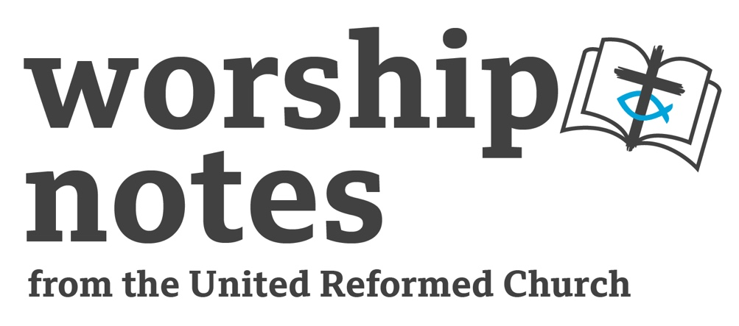

Sunday 23rd October 2022

The Twentieth Sunday

after Pentecost

Proper 25 | Ordinary 30

The Rev’d Jenny Mills

Call to Worship

Praise is due to you, O God, in Zion;
O God of our salvation;
you are the hope of all the ends of the earth and of the farthest seas.
You visit the earth and water it, you greatly enrich it;
The pastures of the wilderness overflow,
the hills gird themselves with joy,
the meadows clothe themselves with flocks,
the valleys deck themselves with grain,
they shout and sing together for joy.

We delight in you, your world and all of creation as we come together for worship.
May we find joy, hope, peace and love in our time with you and with each other.
Whoever we are, however we feel, whatever is happening in our lives:
come, let us worship the Lord our God in word and music and silence.

(from Psalm 65)
Prayers of Approach, Confession and Forgiveness

Loving God, You have created all that is.
You love all that you have created.
You look and see that it is good.
We are a small part of your creation.
You love all of us. Even when we do not live as you desire.
You are almighty, Lord. You are wonderful.
You are beyond our understanding and our true comprehension.
Bigger than we can imagine and yet more caring than we deserve.
You know us all, as we are, and still, even when we struggle to love ourselves,
you let us know we are precious to you.
You chose your people to grow-
leading them through journeying and exile and betrayal and redemption.
And when they still failed to live as you had taught them through the prophets,
you gave your Son to show the way to real life.
And when he had to die to show the world the breadth and depth of your love,
still you gave your people more through your Holy Spirit:
guide and strength and sustainer.

Today you keep calling your people to live as you desire.
To seek righteousness and justice,
to live lives caring for each other and sharing all we have.

Yet still today we fail, as so many have before, and you do not turn away -
you are always allowing us the chance to repent and be forgiven.

We know we have not lived as you want us to –
we have failed in thoughts, words and deeds,
through what we have done and what we have left undone.

We have told others how to behave when scarcely thinking about our own behaviour.
We have considered ourselves the permanent top priority
and hardly given a thought for those who should be there.
We have judged ourselves in need help
when we have failed to look and see that others may need help, too.
For all the times we have chosen the path that has separated us from you,
we ask for forgiveness and the chance to start again.

silence

Let us be open to the prompting of your Holy Spirit
and to open our hearts to change, to reconsider, to listen more closely
and live more faithfully.

Jesus said: ‘come to me all you who are heavy laden, and I will give you rest.’
We come. Help us to let go of the burden of self-righteousness and to let you in
and allow you to speak to our souls and know ourselves forgiven, loved and free.
Amen.

An all-age activity

Rate my role.
(Give everyone a piece of paper and pencil- ideally with list of roles printed on).

Name a series of roles or jobs and get people to score them honestly 1-10 in terms of whether they think they are good jobs or not eg:

Doctor | Refuse Collector | Coffee Barrista | Lawyer | School Teacher
Road Sweeper | Data Analyst | Checkout Assistant | Member of Parliament
Warehouse Worker | Delivery Driver | Heart Surgeon | Nursery School Teacher
Garden Centre worker | Car Mechanic | Plumber | Research Scientist
Get people to look at their numbers, which ones have they rated more highly? Why do they think this? See if people are willing to explain why they have chosen some roles over others. Is it about qualifications? Social perceptions? Skills? Would be interesting to comment on challenging our own prejudices about other people…. What is it we value about people??

A Prayer for Illumination

Loving God, as we encounter your word in Scripture may we find challenge and comfort. Through the texts and through our musings and reflections, may we come closer to you and learn more about your love in the world. Open our eyes and hearts to your presence. AMEN.

Readings

Joel 2:23-32 | St Luke 18:9-14

Sermon Notes

Our first reading from the book of Joel is one that contains a section we are all familiar with. The prophet Joel looks forward and envisages a time when the present hardships will be reversed. He writes in response to a dreadful plague of locusts that had blighted the land. And yet he writes that God, who honours the Covenant promise, will ultimately save the people. God will shower the people with blessings, and they can look forward to a time of abundance. In this reading you can hear the hope and the possibility of better times. The people will know this change of fortune comes from God and will celebrate and give thanks for God’s faithfulness. Out of this time of blessing will come opportunity and new thinking. There will be signs of this new beginning for all to see. But there is a price- the better times will only come if humankind (the people of Judah in this reading) live in harmony with the whole of creation and honour their part of the Covenant, respecting God’s will and way.

The parable only occurs in the Gospel according to Luke. It is a scene set in the temple. It is a story that seems so simple on the surface. The Pharisee would have been considered respectable, righteous, pious and honourable and the tax-collector a sinner as he would have worked for the Roman authorities. The Pharisee was satisfied that he was doing everything God wanted of him, following all the laws and living well. The tax collector was aware of his own failings and confessed them before God. This reading makes us very uncomfortable. We need to be careful not to exclaim- thank goodness I am not like the Pharisee!

How to live in times of trial. The people of Judah had struggled and yet Joel was reminding them that it wouldn’t always be like this. What happens when the unexpected happens? Where can we find strength and hope?

Where do we see God at work? Are we aware of signs in the world around us and in our lives? Or do we find it easier to see and know God when we look backwards? How can we cultivate a way of being aware and alert for God in our everyday lives? How do we share these glimpses and signs? And how do they help us as we seek to be followers of Jesus?

What attributes do we think that a Christian ought to have? The Pharisee had all the trimmings and yet he lost the balance between believing and behaving. What things says Christian and what doesn’t? Inclusivity? Acceptance of difference? Being faithful to the words contained in the Bible? Making judgements on others in the name of God? Honesty and integrity? Knowing we could be wrong?

Prayers of Intercessions

You may wish to sing R&S 401 interspersed with the prayers ‘Through our lives and by our prayers, Your kingdom come.’

In a time of thanks for the blessings we have and the possibilities before us, we come before God. As we celebrate the Jubilee of the URC and we come to recall the events of the Reformation, as we recall celebrations, joys and happiness in our lives and the lives of those we love, we give thanks and we pray.

So we sing….

For all those who lead us:
those who make plans that shape our lives and our communities.
all who lead governments and countries: that they lead with integrity and wisdom.
For all who support us: those who are there when we need them, give them all courage and hope.

So we sing…

For all who are in need:
the sick especially those with terminal illnesses who have lost the will to keep going, the suffering,
the poor and the hungry so afflicted by starvation and need that they feel they cannot carry on,
the lost, the lonely and those in despair, those struggling with mental ill health
and hurt and those who feel that their lives are not as good as those around them
We pray. Give them all courage and hope.

So we sing…

For all the areas in our world where there is fighting and bloodshed, conflict and war.
For the innocent people caught up in these conflicts who have been injured or lost family and friends. Lord there is so much despair in our world, and for many there seems little reason to hope. May your light shine and your presence be found.

So we sing…

As now in a time of silence we bring our own concerns and prayers to God. (pause)

Reach out we pray to all whose belief in the future has been destroyed, and grant new dreams where the old ones have died, rekindle purpose where confidence has been undermined, support when there seems to be nothing else left to hold onto, and hope that one day your kingdom will come and your will be done and life will get better.

And so we sing….

Help us to step up and step out and seek to be the ones whose attitude is that of compassion and care and may we go through the week filling the buckets of others and seeking to ensure our buckets are never empty- by loving ourselves as well as our neighbour. Amen.

Blessing

Go out into the world to love.
God out into the world knowing God goes with you.
Go out into the world seeking to be the person God wants you to be.
Go out into the world seeking to bring justice, peace and hope.
Go out into the world and live the abundant life God wills for all.
Go out into the world to sow seeds of love.
And the blessing of God Almighty,
Creator, Son and Sustainer,
be with you and those you love,
now and always. AMEN.

Hymn Suggestions
 | RS | CH4 | StF | MP
A Touching Place |  | 724
We cannot own the sunlit sky by Ruth Duck.
Words: https://tinyurl.com/mr24r78b Listen: https://tinyurl.com/ywexsm2m
The day of the Lord shall come | 637
Jesus calls us o’er the tumult | 355 | 509 | 250 | 359

