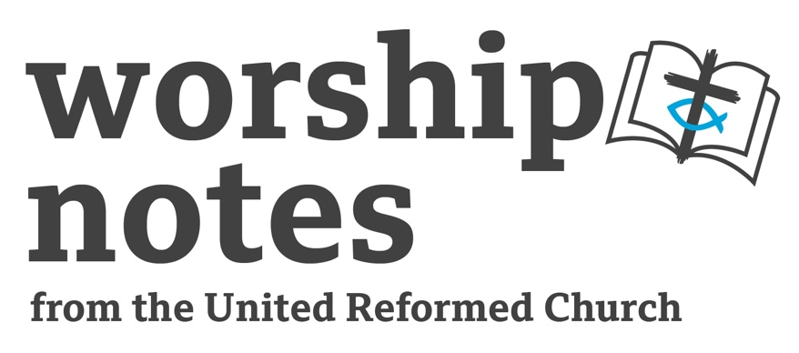

Sunday 16th October 2022

The Nineteenth Sunday after Pentecost

Proper 24 | Ordinary 29

The Rev’d Jonnie Hill

Call to Worship

God, like Jacob, we wrestle.
Like Jacob, we confess who we are.
Like Jacob, we do not let you go.
Like Jacob, we seek your blessing.
Hear and answer us, O Lord, we pray. Amen.

Attributed to Revd Dr Barb Hedges-Goettl

Prayers of Approach, Confession and of Forgiveness

God of many names,
those revealed in scripture – Mother, Father, Christ, Spirit -
and those known personally to us.

God, we proclaim your holy names,
longing to know you more fully,
yet aware that any name we invoke
can never capture your true likeness.

Holy Mystery, loving Saviour, creative Source,
in you we discover our own true name – beloved child,
one in whom you are well pleased.

Open our hearts, that as we come to meet you in worship.
we might be reminded of your words of grace
– those pronounced over us at baptism.

As we encounter your divine presence now,
may our souls be saturated in your love,
may we be strengthened in faith
and empowered for loving service.

We pray, in all your holy names – one God in perfect unity,
Amen.
God of grace and mercy,
very often, confession does not come easily.
We would rather not admit our mistakes,
prefer not to air our dirty laundry,
whether in private or in public.

But somehow, deep down, we recognise,
confession as that necessary first step,
an admission of how things truly are,
which offers freedom and the possibility of all we might become.

Help us now, in a moment of silence,
to be honest about ourselves,
to admit how things truly are,
we come seeking healing and wholeness.

silence

God, forgive us, we pray, and help us to forgive ourselves.

silence

God of grace and new mercies, remind us once again,
that in Christ, we are forgiven.
We are freed from all that is passed,
and offered the fullness of new life.
Thanks be to God, Amen.

A Prayer for Illumination

Spirit of life, bearer of truth,
dwell now in our hearts and open our minds,
that as we hear scripture read, and the word preached,
Sophia, divine wisdom personified might be heard and received. Amen.

Readings

Genesis 32:22-31 | St Luke 18:1-8

Sermon Notes

Genesis 32: 22 – 31

In this story, Jacob reached as crisis point when his past has finally catches up with him. He is going to meet with his brother Esau whom he humiliated by tricking him out of his birth right and their father’s blessing. Jacob is someone who knows how to live by his wits, as evidenced by the deceptions earlier in his story. But Esau, the physically stronger of the two, knows how to fight and Jacob predicts that Esau will enact his revenge when they meet.

It is on the banks of the Jabbok which Jacob later calls Peniel (meaning ‘face of God’), that Jacob goes through a spiritual transformation and has his name changed to Israel, ‘the one who struggles with God and man’.

- You could explore the idea of spiritual transformation, and the idea that we can be transformed by coming face-to-face with our past. Jacob’s story tells us that we can encounter God in the midst of the painful struggles and experience God’s blessing.
- There is some discussion on who ‘the man’ in verse 28 is, some commentators suggest it is an actual person, an angel, a desert demon, or even God. When the Bible is not wholly clear on something we are invited to step into the story for ourselves. You could preach about how transformation can come from wrestling with different issues, from the mundane or the spiritual, and how often God turns up in the most unexpected places. The identity of the ‘man’ or the situations we face may not matter so much, what does matter is God is present to each of us inviting us to new life.
- Using an image of Sir Jacob Epstein’s statue ‘Jacob and the Angel’ could provide an opportunity to invite the congregation to reflect on the story in a visual way https://thenewartgallerywalsall.org.uk/wp-content/uploads/2019/05/IMG_8577-488x732.jpg.
- You could use a Lectio Divina approach to encourage people to enter the passage for themselves. For further information on this approach see - www.biblesociety.org.uk/explore-the-bible/lectio-divina/

St Luke 18: 1 – 8

This intriguing parable is part of a pair that Luke records. On first reading it seems to suggest a simple message of ‘keep praying and don’t give up’. However, as with all of Jesus’ parables, the meaning may not be so straightforward. For example, Jesus seems to be comparing the woman to his followers, and the unjust judge to God. The latter comparison would seem problematic because God is not an unjust judge. So, does the parable suggest that even an unjust judge will answer a widow’s pleas, and how much therefore will God the just judge do for us?

We should remember that ‘the widow’ is someone vulnerable in society, so she may represent more broadly those who are oppressed. This might mean the parable is about the call for Jesus’ followers to seek justice, and persistent prayer equating to a striving always against injustice and standing for the good of the vulnerable.

I suggest consulting a good commentary before preaching on this passage.
- The sermon could explore the riddle-like nature of parables, and the danger of the preacher deciding on the meaning rather than inviting the congregation to explore the meaning for themselves. To do this, you could preach a sermon that asks lots of questions and offer potential ways of answering these questions rather than offering actual answers.
- When we consider suffering in the world, God can appear to be ‘an unjust judge’. This idea could be deepened and explored more fully. For example, you could ask why God does not seem to act in a hurting world? It could be good to reflect on our responsibility, as Jesus’ followers, to stand always against injustice.
- A creative way of exploring this passage could be asking the congregation to act out the story and then reflect on it as a community. This could take many directions, so be open to going where the Spirit leads.

Affirmation of Faith

We believe in God the creator,
who is always creative
and invites us to affirm and explore who we are,
with all our differences;
and who is the source of our faith.
We believe in God the Saviour revealed in the world as Jesus the Christ
who died and is risen, the one Lord of the church.
We believe in God the Reconciler, the Holy Spirit,
who is always with us bearing witness with our spirits
that we are the children of God.
We believe that our smallness can never diminish God’s vastness;
that our frailties can never overcome God’s will for wholeness;
that our sin can never crush God’s power for new life even in the face of death.
We believe, and in this belief, we need one another,
as a choir needs every voice and every part
for the harmony to be complete.
We believe - that in the Holy Spirit,
in Jesus Christ and in the love of God - we are one!
We believe - and may our lives reflect our belief.

Ian Tozer (1997 Uniting Church in Australia)
Prayers of Intercessions

Eternal God,
whose love is made known in the richness of relationship
we bring to you our prayers of concern
for our world, for ourselves and for one another.

Short silence

We bring to you those fearing the onset of winter,
we cry out – no one should have to choose between heat and food.

Short silence

We pray for an economy that is fairer to all
one which leaves no one behind.

Short silence

We remember our earth, so damaged by human action
praying that we might wake up to our short-sightedness.

Short silence

We pray for bodies, minds and spirits that are ill,
for peace, hope and healing – and where needed acceptance.

Short silence

We pray for the Church, human, frail and imperfect, yet so full of promise and potential,
may we never forget our calling.

Short silence

We offer our prayers in the name of Jesus, who taught his disciples to pray

Our Father who art in heaven…

An Offertory Introduction and Prayer

We are but custodians of this earth and all its resources. God grants enough for all people, and yet fears of scarcity and greed mean few have much and many have little. Let us be like God in our generosity, let us not give from fear of lack, but from the truth of God’s abundance.

God of all people, you give us what we need
use the gifts we offer, of money and of our lives
to bring the good news of your abundance
that your kingdom might come on earth as in heaven. Amen.
Blessing

May the blessing of God Creator, Christ, and Spirit
– the one who knows you by name be with you, and strengthen you today
and all the days of your life. Amen.

Hymn Suggestions
 | RS | CH4 | StF | MP
Praise the name of Jesus |  |  |  | 556
Come, O thou traveller unknown |  |  | 461
O Lord hear my prayer | 398
There’s a spirit in the air | 329 | 616 | 398
I the Lord of sea and sky |  | 251 | 663
Breathe on me breath of God | 295 | 596 | 370 | 67
I am a new creation |  |  | 553 | 254

RS – Rejoice & Sing, CH4 – Church Hymnary 4, StF – Singing the Faith, MP – Mission Praise

Other Online Suggestions for Songs

Your grace is enough (Great is your faithfulness O God of Jacob) https://www.youtube.com/watch?v=LISbMRp0Y64

Forgive us now https://soundcloud.com/bucpost/forgive-us-now?in=bucpost/sets/tune-in

You are called to tell the story https://www.youtube.com/watch?v=S0FOiS9efTM

