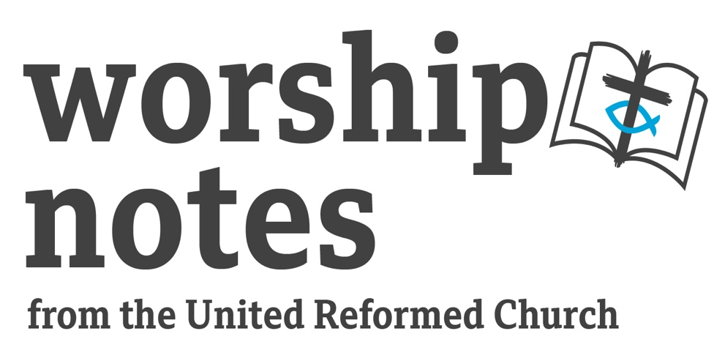

Sunday 9th October 2022
Proper 23 | Ordinary 28
The Rev’d Dr
Elizabeth Welch

Theme – Hope, healing & Thanksgiving

Call To Worship

Let us worship God, the Creator of all things,
who calls us into God’s loving presence
Let us worship Jesus, the life-giver and healer,
who offers us the gift of life and healing
Let us worship the Holy Spirit, source of power and peace,
who offers us strength and encouragement to live in God’s way.

Prayer of Adoration

Loving and gracious God,
you are the source of all goodness,
on earth and in heaven.
We praise you for your love for each one of us,
love seen in the offering of yourself in your Son Jesus Christ,
love that surrounds and uplifts us in our struggles and suffering.
We praise you that you touch our lives with your Holy Spirit,
bringing us healing from the things that wound us
and giving us the courage to try new ways of living.
Living God, one in three and three in one,
we praise you that you invite us to share in the relationship of love of the Holy Trinity, reaching out in love to those we meet day by day.
But as we come before you, we are also aware of our own shortcomings.
We turn to our prayer of confession.

Prayer of Confession

Gracious God,
Forgive us when we forget your life-giving presence,
and live in ways that are not full of life.
Forgive us when, in the midst of all that we have to be thankful for,
even in the midst of the most difficult times,
we forget to offer you our thanks and praise.
Forgive us when we get caught up in arguments with one another,
instead of listening to you and to each other.

A moment of silence for reflection on what we regret in our own lives.

Words of Forgiveness

God knows your voice;
God hears your cry for mercy;
God turns his ear toward you.
God is gracious and righteous,
God is full of compassion;
in your need God has saved you.
Be at peace God forgives you, through Jesus Christ. Amen

Introduction to the theme, with children present

Ask the children 2 questions, giving them time and space to respond to each one:
firstly ‘what gives you joy?’ and secondly
‘how often do you give thanks?’

Talk about how it’s not always easy to give thanks – and how we see this even in the Bible. Today’s Gospel reading will be about 10 people who were healed, and only one who gave thanks!

Readings

2 Kings 5.1-3, 7-15c | St Luke 17.11-19

Prayer for Illumination

May the words of my mouth
and the meditations of all our hearts,
be acceptable in your sight,
O God our Rock and our Redeemer. Amen

Notes for a Sermon

Hope, healing and giving thanks – these three themes are raised up by today’s passages from a variety of different perspectives. Between them, these passages take us to both the simplicity and the complexity of Scriptural texts, and the need to take time to dig in and reflect on what the Scriptures, written so long ago, are still saying to us today.

Firstly, there’s Naaman. Naaman is referred to positively by Jesus at the start of his ministry in what turns out to be an interesting incident of threatening behaviour by the crowd. The passage from Kings takes us back in some detail to the story of Naaman and his illness, pointing to the young Israelite woman, in service to Naaman’s wife, who directs him to as the place of healing. The verses from Kings give the details of the ups and downs of what actually happened, and the arguments along the way before Naaman is healed by Elisha. This story points to the significance of the God of Israel’s action embracing people who are outside Israel. It also points to some of the issues with regard to healing and personal pride, as to whether Naaman is prepared to listen to what Elisha asks of him. This text invites us to be open to hearing God’s voice through the words of unexpected people. It also asks us not just to put our own presuppositions on what we’re looking for in terms of healing, but to be open to the different ways in which healing might come to us.

The themes of hope, healing and giving thanks are taken further in today’s Gospel. Here we have 10 lepers who are healed. All of them are healed, but only one of them comes back, praises God and gives thanks to Jesus. And this one was a Samaritan. The story is both about Jesus’ capacity to heal, and about the responses that people make to being healed. Only one person, and this one, a stranger, an alien, a foreigner, returns to give thanks. Perhaps the others wanted to hurry off to get to the priest? Or they were just delighted that they were healed and wanted to get on with their lives? The story comes as a reminder that God’s healing is open to all people. When we testify to healing today, we don’t just do so for those already in the life of the church. God’s healing is open to all who are suffering. The role of the church is to seek out the suffering and bring good news to each one, regardless of nationality or ethnicity. It also comes as a reminder about being attentive to giving thanks to God for what God makes possible.

Prayer of Thanksgiving

Loving God, we give you thanks for the blessings in our lives,

- for the smile of friend and stranger
- for the days when we have enough to eat and drink
- for a roof over our heads
- for your healing touch
- for companions in the faith with whom we can share our lives
- for your promise of hope in even the most difficult times

We take a moment of silence to reflect on God’s blessings this day.

Silence

Loving God, open our hearts and lives to be attentive to you
and to welcome all that you give us.
Prayers of Intercession

Response after each period of silence: Lord in your mercy, Hear our prayer

Gracious God,
when we feel troubled and overwhelmed by the difficulties in front of us,
come to us and help us and heal us.
In the silence we name before you all that oppresses us today.

Healing God,
we bring before you our hurts,
and the illnesses and struggles of those around us.
We pray that you will touch each one’s life with your love,
and bring comfort and healing.
In the silence we place into your hands the people for whom
we are particularly concerned this morning.

Peace-making God, we bring before you our troubled world,
where too often there is conflict rather than reconciliation,
war rather than peace,
oppression rather than justice.
We pray for countries and governments across the world
in need of new beginnings and new ways forward.
In the silence we remember those countries and peoples
particularly on our hearts and minds today.

God of justice, we bring before you the people who suffer from injustice,
through abuse, racism, homelessness and hunger.
We pray for better ways to be inclusive and caring,
and to learn from the examples of those who suffer.
In the silence we commend into your hands
those places and situations we are aware of today.

Creator God, as we give thanks for your bountiful gifts of creation,
we pray for the way in which your created world has been misused.
Help us to be more attentive to cherishing the gifts of this earth
and to working for climate justice across all your created earth.
In the silence we call to mind places of your created world that give us life,
and all who are working for a better and fairer approach to your creation.

God of new life, we bring before you those who are dying and those who have died; those who are struggling with the thought of death,
either for themselves or amongst their families and friends;
those who have passed on and those who are mourning their loss.
In the silence we remember those we know.

Loving and merciful God,
we give you thanks that you hear our prayers, both spoken and unspoken.
Receive now all that we have offered in words and silence,
that it may be your will that is done, and your kingdom that comes.

In Jesus name we pray. Amen

Offertory Prayer

Gracious God, we give you thanks for your outpouring of love in our lives.
As we have freely received, so may we freely give.
Help us to use your gifts for the upbuilding of your church and the care of your people.
Receive now what we offer from our own lives and all that we have.
Bless us and our gifts as we dedicate these to you service this day.
In Jesus’ name we pray. Amen.

Holy Communion

Invitation

After walking with the disciples on the Emmaus Road, Jesus went into the house with them, took bread, blessed and broke it, and gave it to them. Then their eyes were opened and they recognised him.
St Luke 24.30,31

Open our eyes O God, that we may see Jesus as we break bread,
wherever we are today.

Prayer of Thanksgiving

L: Lift up your hearts
All: We lift them to the Lord.

L: Let us give thanks to the Lord our God.
All: It is right to give him thanks and praise.

L: We thank you, loving God.
You are present with us, joining us together as your people,
wherever we might be.
In your grace, in the risen power of Jesus,
you open the fullness of life to each one of us.
We gladly thank you
with everyone who believes in you,
with the saints and the angels,
we rejoice and praise you, saying:

Holy, holy, holy Lord, God of power and might,
heaven and earth are full of your glory. Hosanna in the highest.
Blessed is he who comes in the name of the Lord. Hosanna in the highest.

L: Gracious God, you are holy,
Your loving holiness offers us new life,
on this Sunday and day by day
For this we thank you.

Jesus brings us together to one table
and asks us to do share as he shared.
Holy God, pour out your Spirit
upon these gifts of bread and wine and make them holy,
that they may become for us the body and blood of Jesus Christ.

On the night before he died for us,
he had supper for the last time with his disciples.
He took bread and gave you thanks,
he broke the bread and gave it to his friends, saying:
Take this, all of you and eat it:
this is my body, which will be given up for you.
In the same way, he took a cup of wine.
He gave you thanks and handed the cup to his disciples, saying:
Take this, all of you and drink from it:
this is the cup of my blood,
the blood of the new and everlasting covenant.
It will be shed for you and for all people
so that sins may be forgiven.
Then he said to them: Do this in memory of me.

Let us proclaim the mystery of faith

All: Christ has died, Christ is risen, Christ will come again.

L: Loving God, we remember with joy all that Jesus did.
In this holy sacrifice which he gave as a gift to the Church,
we remember his death and resurrection.

All: Loving God, you have called us
to receive the body and blood of Christ at this table
and to be filled with the joy of the Holy Spirit.
Through this sacred meal,
give us strength to please you more and more.
All glory and honour is yours, almighty God, for ever and ever. Amen

Sending out and Blessing

Go now, with thanksgiving in your hearts,
to receive day by day the love God offers you,
to celebrate the gifts that God gives you and
to live out the lives to which God calls you.
And the blessing of God Almighty,
Father and Creator,
Son and Redeemer,
Spirit and Sustainer,
rest upon each one of you,
now and always. Amen.

Hymn Suggestions
 | RS | CH4 | StF | MP
O for a thousand tongues to sing | 285 | 352 | 364 | 496
Give to me Lord a thankful heart | 497 |  | 520
We cannot measure how you heal | 653 | 718 | 655
Jesus Christ is waiting |  | 360 | 251
O Christ the Healer we have come to pray for health |  | 717 | 653

