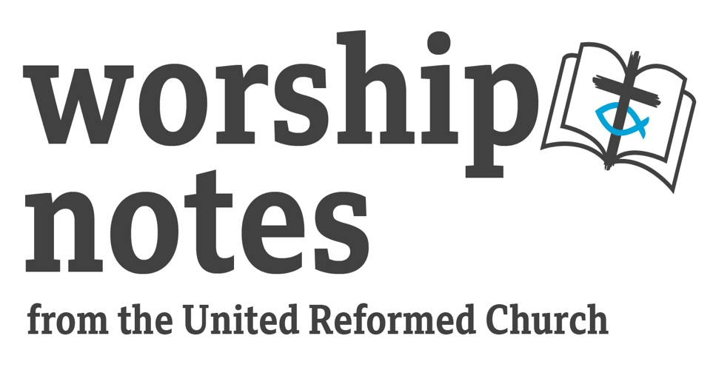

Sunday 25th September 2022
Proper 21 | Ordinary 26
Walt Johnson

Call to Worship

This has been written as a synthesis of Psalm 146 and Psalm 117 in the responses, with the idea that we also praise God in our actions which bring about social justice, and that God’s justice extends to all.

Praise the Lord! We will praise God as long as we live; we will sing to our God all our lives. Praise the Lord, O my soul!

We do not put our trust in human leaders. Happy are we who have the Lord to help us.
Great is God’s love towards all people!

God is on the side of the oppressed and the hungry. God lifts those who have fallen.
God’s faithfulness lasts forever!

We depend on the Lord, our God, the Creator of heaven and earth.
Praise the Lord, all nations! Praise God, all peoples!

Prayer of Approach

This has been written, drawing on some of the imagery in Psalm 91.

All-powerful and loving God, we come before You this hour to spend time in Your presence. We give You thanks, for You are our refuge, the One in whom we can put our trust.

We come to You as we are, with our sorrows and our joys, and the worries for others and for Your world which we carry in our hearts. For surely You are there with us: Your faithfulness covers us.

We come to You, responding to Your steadfast love for us. You save us with a love that overcame death. As the Psalmist called on You, we come to You now: we seek Your blessing on our worship. In Jesus’ name we pray. Amen.

Prayer of Confession

This prayer was written by Janet Morley. It is a strongly worded prayer, one which is not easy to pray, but it is introduced by kind words of Jesus, reminding us of His example. They are also a reminder of God’s grace. In our Reformed tradition, we trust in a God who comes to us and gives of God’s-self with grace: there is no act or good work that we can do to earn salvation.

We bring to God the times when we have failed to love others, failed to love God, and even failed to love ourselves. Listen for the Words of Jesus in the Gospel of Matthew: “Come to me, all you who are weary and burdened, and I will give you rest. Take my yoke upon you and learn from me, for I am gentle and humble in heart, and you will find rest for your souls. For my yoke is easy and my burden is light.”

We take a moment in silence for reflection.

O God, You have searched us out and known us,
and all that we are is open to You.
We confess that we have sinned:
we have used our power to dominate
and our weakness to manipulate;
We have evaded responsibility
and failed to confront evil;
We have denied dignity to ourselves
and to each other
and have fallen into despair.
We turn to You O God;
we renounce evil; we claim Your love;
we choose to be made whole.

Assurance of Pardon

It is a very human trait to perpetuate the guilt we feel. It is important for us to hear again and again the merciful nature of God, that in Jesus, we are forgiven.

Listen for the assurance of pardon, as found in Psalm 103. “The Lord is merciful and gracious, slow to anger and abounding in steadfast love…as far as the east is from the west, so far God removes our transgressions from us.” Thanks be to God. Amen.

Introductory Talk / Children’s Address

Some ideas and thoughts which introduce the idea of choices, and maybe these might inform a discussion in your congregation.

You may wish to find images for the following…
  - A speed-limit sign. What is it telling us to do? What are the consequences of not obeying the sign? Fines; penalty points; danger to other road-users and pedestrians; injury and death.
  - A large packet of biscuits. Who would like a biscuit? Who would like to eat them all? While a parent might allow one or two, they would not allow eating them all at once. What are the consequences? Obesity; increased risk of diabetes.
  - A young puppy or kitten. Young animals tend to bite instinctively. Should you encourage or discourage this behaviour? How would go about training your pet not to bite?
  - Some notes of money found in the street. What choices do you have when you find the money? It depends on the lucky-finder’s circumstances. Try to find the one who lost it? Keep it, or give it away, or do both?
  - A homeless person stood at the traffic-lights, or sat outside your local supermarket. Would you give any money? Would you give anything else? Is there anything you could do?

Is there a pattern to way in which we have responded to each of these example situations?

Prayer of Illumination

Based on verses from Psalm 119.

Loving God, Your word is a lamp to our feet, and a light to our path.
You are our hiding-place and our shield: we hope in Your word.
May our cry come before you: give us understanding according to Your word.
May we listen, and may You speak to us. Amen.

Readings

Amos 6:1-7 | Psalm 91 | Psalm 146 | St Luke 16:19-31 | 1 Timothy 6:6-19

Notes for a Sermon

Amos 6:1-7 – in keeping with the harsh tone throughout Amos’ book of prophecy, words of condemnation for those who indulge in riches without regard for the fate of others. Psalm 91 - broadly speaks about God’s protection. Psalm 146 - a song of praise for all creation with a clear strand about social justice. St Luke 16:19-31 – Jesus’ parable of the poor man Lazarus and the rich man (not to be confused with Lazarus in John 11 whom Jesus raised from the dead). 1 Timothy 6:6-19 – advice regarding modest living, and the source of the well-known adages “the love of money is the root of all evil” and “fight the good fight. ”

There is a theme throughout today’s readings: how we deal with our wealth in respect of those who are less fortunate. The Gospel reading extends our thinking about the decisions we make about using our wealth in this life and the consequences of them. This Parable of Jesus and the projection He makes into the afterlife regarding our decision-making has affected thinking for many centuries, and it has been the inspiration for many well-known stories.
Below is an exemplar sermon. Please feel free to use and adapt it, as you wish. Depending on your reading speed, it will take 8-10 minutes.
It has been deliberately crafted to offer a range of ideas arising from the text, rather than focusing in detail on any one verse. As you prepare for your service, you may wish to develop some of these ideas for yourself with your own thoughts, and omit others.
Whenever I hear a reading which begins “Jesus said…”, I always wonder who was there, listening to His words. If we read back, the last clue as to where Jesus was at the time is found Luke 14:1, an occasion where Jesus went to eat in the house of a prominent Pharisee. Later, in Luke 14:25, we are told large crowds were travelling with Jesus. And in Luke 15:1, we learn that tax collectors, anonymous sinners, Pharisees and teachers of the Law were also present. Today, we are included in that large, diverse group of people listening to Jesus’ words.
Jesus had just told them the Parable of the Shrewd Manager, which had not gone down well with the Pharisees. Luke tells us that they were sneering at Jesus. He told a lot of parables about money and wealth. This one is unique: it is the only parable where a character is named: Lazarus, the poor man. In a reversal of roles, it is the rich man who goes unnamed.
This man is a different Lazarus to the one in John chapter 11, the one whom Jesus raised from the dead. The name comes from the Hebrew Eleazar, meaning ‘God has helped’. In different ways, when it came their time to die, God came to help both men called Lazarus.
When we read Luke’s Gospel, we encounter a recurring theme of turning the world upside-down. The King of Kings, Jesus, was born to a lowly peasant woman. Mary prophetically sang in her Magnificat: “He has filled the hungry with good things but has sent the rich away empty.” (Luke 1:53) In this parable, we see the outworking of those words.
In this story, Lazarus speaks no words. We may see this as a metaphor for how the downtrodden and oppressed in society - those like Lazarus – have been treated throughout the ages.
Lazarus’ painful skin condition would have caused him to be excluded from mainstream society for fear of cross-infection, also making him unemployable. With no welfare state to assist him, Lazarus had to resort to begging. The Gospel writer comments that Lazarus received greater compassion from the dogs, than from his fellow humans.
Lazarus might not have spoken, but his presence did not go unnoticed by the nameless rich man, for he calls on Abraham to send Lazarus to his aid his suffering. In life, the rich man would never allow Lazarus near him; but in death, he is willing for Lazarus to touch his tongue, a very intimate act in itself.
This Parable also offers us an insight into a First Century Jewish understanding of what happens after death. Some Bible commentators point to the book 2 Esdras, found only in Catholic and Orthodox bibles. In some church traditions, this Parable’s description of the afterlife has been taken very seriously.
We see an outworking of this Parable in Charles Dickens’ “A Christmas Carol”. Like the rich-man, Marley’s ghost is forever in torment because of his shortcomings in life. In a way, the change which takes place in Scrooge is the change which the rich man in the Parable wants for his surviving five brothers.
Or we can read this Parable as an allegory which teaches us about the temporary nature of wealth. We all know people whose attitude to money differs: some spend it at once; others hold on to it, reluctant to spend. Most of us are probably somewhere in between.
There is an element of the eternal in this Parable regarding the decisions we make in life in how we treat others. It is only in death that the rich man reconsiders how he ought to have lived his life.
Speaking prophetically into this Parable about His own death and resurrection, Jesus’ concludes somewhat pessimistically that even someone rising from the dead will be insufficient to convince some people to change their ways.
The human trait of stubbornness remains with us: whether it is the sign which states “30mph”, or the warning-signs our bodies give us that we may be unwell, or the extreme weather events alerting us to climate catastrophe.
This Parable calls us as a church to be a sign for change. We live in God’s world where there is much that is broken, and there is much that is good. Our mission is a personal one, as we are called to change our hearts and to be an example to others. Our mission is also local and global, where we can be a voice for change in our communities and become involved in kinder ways of being human.
Elsewhere, in Matthew 9:12, Jesus says to us: “Those who are well have no need of a physician, but those who are sick.” May God grant us the humility to acknowledge that we, too, can be among the sick, and to recognise our shortcomings and frailty, and even the need for change.

Music for Reflection
You may wish to use the following secular song which reflects on our broken world, which is broken largely due to the poor choices humans have made. It is from Coldplay’s 2005 album “The World Turned Upside Down”. Its lyrics speak for themselves. You could find it on YouTube and play in worship – the Performing Rights Society give a waiver for material played in worship. https://www.youtube.com/watch?v=k4V3Mo61fJM

Affirmation of Faith

This affirmation of faith was published in 1997 by the URC, entitled an “Alternative Statement of Faith”, adapted here for use for a congregation with a response.

Together, let us affirm our faith in God:

We believe in the one and only God, Eternal Trinity,
through whom we and all created things exist.
God alone we worship: in God we put our trust.

We worship God, Source and Sustainer of creation,
whom Jesus called Father, whose children we are.
God alone we worship: in God we put our trust.

We worship God, revealed in Jesus Christ,
the eternal Word of God made flesh:
who lived our human life, died for sinners on the cross,
and who was raised from the dead, and proclaimed by the apostles - Son of God.
God alone we worship: in God we put our trust.

We worship God, ever present in the Holy Spirit: who brings the Gospel to fruition.
assures us of forgiveness, and strengthens us to do God's will.
God alone we worship: in God we put our trust.

We believe in the one, holy, catholic and apostolic Church,
united in heaven and on earth.
We rejoice in God, who has given us life and shares our humanity.
To God be glory, praise and adoration, now and evermore. Amen.

Prayers of Concern

These prayers are written using the Beatitudes and a response from Psalm 102:1. They have been generalised, as global, national and local circumstances will have changed from the time of writing.

We bring our concerns before God in prayer…
O Lord, hear our prayer. And let our cry go unto You.

Lord Jesus, you say to us, “Blessed are the peacemakers.” We pray for the world where there is no peace and where peace is threatened. O Lord, hear our prayer. And let our cry go unto You.

Lord Jesus, you say to us, “Blessed are the meek.” We pray for local, national and international leaders, for business-leaders and decision-makers. O Lord, hear our prayer. And let our cry go unto You.

Lord Jesus, you say to us, “Blessed are those who hunger and thirst for righteousness.” We pray for all refugees, asylum-seekers, political-prisoners and all who work to support them. O Lord, hear our prayer. And let our cry go unto You.

Lord Jesus, you say to us, “Seek first the Kingdom of God.” We pray for your church and for its leaders; we pray for the URC in its Jubilee year. We pray for those taking the first steps in faith. O Lord, hear our prayer. And let our cry go unto You.

Lord Jesus, you say to us, “Blessed are the poor in spirit… blessed are those who mourn.” We pray for all those who are unwell in body, mind or spirit. We name them before God in a moment of silence…O Lord, hear our prayer. And let our cry go unto You.

We remember before you those recently bereaved, and those for whom anniversaries of loved ones occur at this time. O Lord, hear our prayer. And let our cry go unto You.

Lord, you say to us, “I came that they might have life.” We bring before God our own prayers in a moment of silence…O Lord, hear our prayer. And let our cry go unto You.

The Lord’s Prayer
Not everyone who comes into our churches knows the words of this prayer. Please do not assume that they do. Please consider putting this prayer on your service sheet or on the projection screen.

Blessing and Benediction

To finish the service, you may wish to use these words of Scripture and/or sing a blessing to one another.

Spoken:

Jesus said, “Peace I leave with you; my peace I give to you.”
May the Lord bless you and keep you.
May the Lord make His face shine upon you and be gracious to you.
May the Lord turn His smile towards you and give you peace. Amen.

Sung

May God’s blessing surround you each day
As you trust Him and walk in His way
May His presence within guard and keep you from sin,
Go in peace, go in joy, go in love.
Cliff Barrows © 1982

Hymn Suggestions
R&S – Rejoice and Sing, StF – Singing the Faith, CH4 – Church Hymnary 4/Hymns of Glory, Songs of Praise, MP – Mission Praise
 | R&S | StF | CH4 | MP
For opening
Praise To The Lord, The Almighty | 74 | 88 | 124 | 564
Praise, My Soul, The King of Heaven | 104 | 83 | 160 | 560
Praise and Thanksgiving | 48 | 125 | - | -
After prayers
A Mighty Fortress Is Our God | 585 | 623 | 454 | -
Blessed Assurance | - | 548 | 561 | 59
Jesus, Lover Of My Soul | 332 | 355 | 490 | 372
After the sermon
O Lord, All The World Belongs to You | 90 | - | - | -
O Jesus, I Have Promised | 509 | 563 | 644 | -
I Danced In The Morning | 195 | 247 | 404 | -
To close
Tell Out My Soul | 740 | 186 | 286 | 631
Heaven Shall Not Wait | - | 701 | 362 | -
At The Name of Jesus | 261 | 317 | 458 | 41

