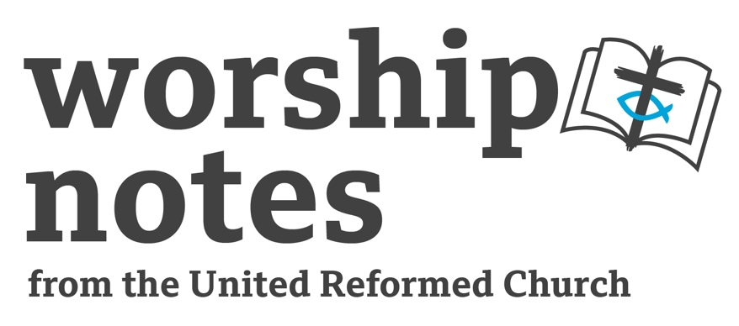

Sunday, 4th September 2022
Proper 18 | Ordinary 23
The Rev’d Jonnie Hill

Call to Worship

The eternal God,
who is beyond us, yet within us
calls us, and the whole of creation
into the divine dance
of mutual delight and self-giving love,
now, and in each moment of every day.
So, may we delight now in our worship of the living God. Amen.

Prayer of Approach

Creator God,
at the very beginning,
you formed humankind from the clay of the earth
and breathed your life into our inmost parts.

In Jesus,
you revealed your truest likeness
loving, healing and forgiving
– showing us all we can be when we put love first.

Your Spirit,
like a potter at the wheel,
continues your artistic work today,
shaping and moulding our clay-like form
prompting and drawing us
ever more toward love and beauty, justice and peace.

As we gather,
may we centre ourselves in you,
may we be drawn into the great mystery and wonder
of your Holy Trinity,
may we be refreshed and renewed
as we encounter divine presence here in our midst. Amen.

Prayer of Confession

Holy One,
fearfully and wonderfully made as we are,
we struggle to live from the truth
of our infinite worth in your sight.

Short silence

We have failed in the cause of self-giving love,
valuing our own comfort and security
above that of the common good.

Short silence

We have ravaged our beautiful earth,
trading the integrity of creation
for material goods and wealth.

Short silence

We have judged harshly,
excluding those who do not fit
our predetermined and partial expectations.

Forgive us.

Short silence

God of grace and new beginnings,
heal us,
make us whole,
free us to live ever more in the likeness of Christ
we pray in Jesus’ name, Amen.

Assurance of Forgiveness

Friends,
let us proclaim good news to one another.
In Christ we are forgiven,
thanks be to God.
Amen.

Prayer of Illumination

Spirit of God,
present now in each of us,
bring forth truth
from ancient words spoken and heard,
as we seek to follow in the way of Christ
the eternal living Word. Amen.

Readings

Jeremiah 18:1-11 | Psalm – 139:1-6, 13-18
Sermon Notes

Jeremiah 18:1-11

God chooses to speak to Jeremiah through what would have been a very every day sight – seeing a potter at work. Are we open to encountering God in our everyday lives, and if so, how can we cultivate a spirituality that enables us to encounter God in the ordinary?

The potter needs to rework and remould the clay, and this speaks of the 'House of Israel's' need to be renewed. How might this speak into the lives of our church communities? Are we open to the Spirit leading us to work out our faith in new or different ways? How can a church community make sure it is open to God' remoulding?

The second half of the passage (verse 6 - 11) offers a disturbing insight into how those in Jeremiah's time made sense of what was happening around them believing that God used war and oppression to teach people a lesson (the lesson being that they should choose good). But, in the gospel stories of Jesus we are confronted with a God who is willing to suffer for love, rather than to cause suffering. What messages about God' love and judgement have we been told? Do we live in fear of God, or do we live in the fullness of God? This might not be a straightforward sermon, and may require a good commentary.

Psalm 139: 1 - 6, 13 - 18

This Psalm offers us the opportunity to remind people that they are created by God and loved by God. How could working through each line of this Psalm be used to comfort and nurture the faith of those listening? Maybe the sermon could be offered as a guided meditation or Lectio Divina?

Psalms such as this can offer great comfort to people of faith. However, there is a lot of suffering and hardship in our world right now. This Psalm could easily be used as a platitude, rather than offering actual hope. How could we make sense of this Psalm so it offers something to those who are suffering and may feel disconnected from God? Verses 18 and 19 may provide a way forward with this sermon.

Verse 14 is a well-known verse which speaks of the nature of humanity – that we are fearfully and wonderfully made. How could this theological truth be preached in order to help those who feel bad about themselves see the reality of who they are in God? The Psalm does not say that only people of faith are 'fearfully and wonderfully made' but 'all' God's works. How can we remind others that they are wonderful works of God, and treat them as such?

Affirmation of Faith

We are not alone, we live in God’s world.

We believe in God:
who has created and is creating,
who has come in Jesus,
the Word made flesh,
to reconcile and make new,
who works in us and others by the Spirit.

We trust in God.

We are called to be the Church:
to celebrate God’s presence,
to live with respect in Creation,
to love and serve others,
to seek justice and resist evil,
to proclaim Jesus, crucified and risen, our judge and our hope.

In life, in death, in life beyond death, God is with us.
We are not alone. Thanks be to God. Amen.

‘A new Creed’ from the United Church of Canada
Offertory Prayer

Just as we are called to love, because God loved us first, so too are we called to give,
because God has given first.

Generous God, as we acknowledge that all we have is from you,
accept our gifts of money, and the gift of our lives,
so that we might be instruments of love, justice and peace
– kingdom builders in Christ’s name,
and in the power of the Holy Spirit, Amen.

Prayers of Intercession

Loving God,
your triune nature is relationship,
and you have created us for loving relationship
with you and with one another.

Help us always to see your image reflected in every human face,
that as we seek the good of our neighbour,
we also express our love for you.

Short silence

There is much happening in our world that concerns us
and which we bring to you in prayer:

Short silence

the armed conflict in places like Ukraine and Yemen
displaced people who have already lost everything

Short silence

the cost-of-living crisis raising food prices
impacting those across our world who can least afford it

Short silence

rising fuel prices
with the threat of a very cold winter for some

Short silence

God, not only do we cry out
for justice and fairness,
equity and enough for all people
– we pray also that you would show us,
how we might be agents
for the kind of change our world needs.

Grant us boldness and courage,
as we seek to live out the call of the Gospel,
and follow in the way of Jesus,
our guide and our goal. Amen.

Blessing

May the God who is faithful uplift you this day
May the God who assures freedom accompany you on the way
May the God who above all else seeks love enfold you always.
And the blessing of God,
Creator, Christ and Spirit
be with you and all whom you love,
this day and always. Amen.

Hymn | RS | StF | CH4 | MP
Faithful One, So Unchanging |  | 628
O God, You Search Me and You Know Me |  | 728 | 97
O God Our Help in Ages Past | 705 | 132 | 161 | 498
O Lord All the World Belongs To You | 90
Lord, You Have Searched and Known My Ways | 70
Have You Heard God’s Voice, Has Your Heart Been Stirred? |  | 662
O Jesus, I Have Promised | 509 | 563 | 644 | 501
Sometimes A Light Surprises | 595
Key:
RS = Rejoice and Sing, StF = Singing the Faith, CH4 = Church Hymnary 4, MP = Mission Praise

