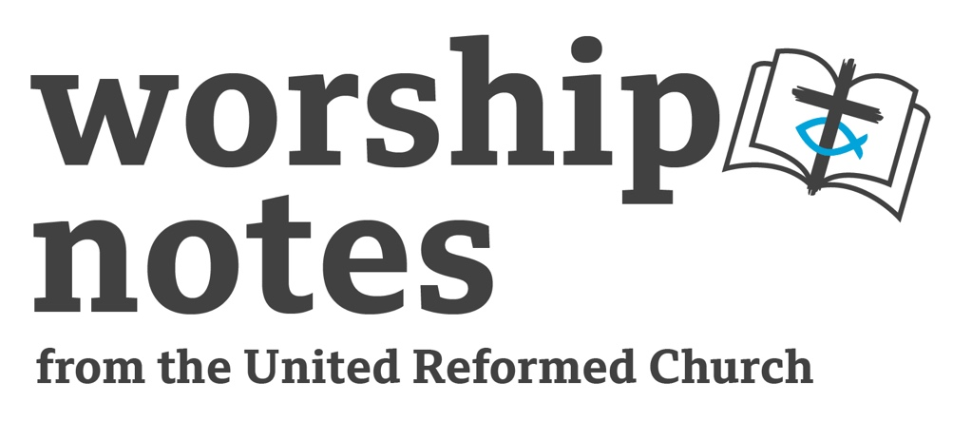

Proper 13 | Ordinary 18

31st July 2022

The Rev’d Jenny Mills

Call to Worship

Come, let us ring out our joy to the Eternal One; hail the rock who saves us. Let us come into God’s presence, giving thanks; let us hail the rock of our salvation with a song of praise. A mighty God is the Most High, a great king above all gods. In God’s hands are the depths of the earth; the heights of the mountains belong to God. To God belongs the sea, made before time began; to God belongs the dry land shaped by God’s own mighty hands. O come; let us bow and bend low. Let us kneel before the God who made us, for the Most High is our God and we the people of God’s pasture, the flock that is led by God’s hand.
From the Grail version of Psalm 95

Prayers of Approach, Confession and Forgiveness

Loving God,

as we sit here and try to let go of some of the anxieties we have

and focus our minds and still our thoughts,

we come in grateful thanks for your love in our lives

and for your presence within, around, beside and beyond us.

You are more than we can ever imagine.

You are bigger than the universe and all that is,

your love is greater than anything we can even begin

to envisage and understand.

You commanded the world into being

and blessed all that you had made - every single thing.

You showed your love for us all through prophets and peoples,

words and actions, hopes and dreams.

We see glimpses of your kin-dom:

in a gentle touch,

a kind word,

a symbolic handshake

or a uniting event;

in a relationship that affirms

and in love given that does not expect anything in return.

In Christ you showed us how we are to live and love and be

and what your world should be about:

justice, wholeness, peace, joy, care-fullness,

challenging that which oppresses,

celebrating that which enables and builds up,

walking with those we have nothing in common with,

accepting all as fellow human being journeying on

and limiting our judgment.

And yet, even with a teacher as amazing as Jesus, we struggle;

even with prophets as blessed as Elijah, we fail to listen and respond; even with all the evidence we can see before us and all around us,

we fail to live your way.

God who wills good for us despite our shortcomings, we are sorry.

For the times our words and actions have divided,

have been selfish, have worked against your will.

For the times our ideas have taken over and stifled

the blowings of your Spirit.

For the times when our sense of what is right and good,

successful and best have strayed from your ideal and your way.

For when what we have has become more important than who we are.

For our self-absorption and need for control.

As individuals and as members of the one common humanity,

we confess our sins, our shortcomings, our failings.

We are sorry that this world does not look as you would want

and for our part in that.

We seek your guidance to make changes –

personally, locally and globally,

so we can work more faithfully

to be bringers of your word, will and way.

SILENCE

Jesus said: Do not let your hearts be troubled.

Let us lose the anxiety, embrace the future and trust in God.

Let us turn again to Christ and commit to live love.

We wrap this all up by saying the Lord’s Prayer…

A Prayer of Illumination

God our guide and goal,

may your Spirit touch our hearts

so that as we listen for your Word in Scripture,

we may open our minds to you

and find inspiration to follow you more closely.

This we pray, as your people, blessed by you,

through Jesus Christ our Lord. Amen.

Readings

Ecclesiastes 1:2, 12-14, 2:18-23 |St Luke 12: 13-21

Sermon Notes

Get the congregation to think about the TV show Play Your Cards Right Higher or lower - skill or luck? (Get a pack of cards- big ones if possible but ordinary sized are OK- ask someone to help you, they have to guess whether the next card is higher or lower. Turn over the first card and ask: Higher or Lower? They guess and see if they are right. See how many they can get without being wrong. Do this with 2-3 people.)

Then pose these questions: Do you have any control over what cards come up? Is it just chance? Some card games require skill and remembering what cards people have put down or picked up. This one is totally random (unless you cheat!).

In life we can plan, we can learn and apply that learning, we can develop skills and use them but sometimes things happen over which we have no control, they happen by chance, randomly and often with no reason. They can feel unfair and unjust. This is the reality for many people in our world today, by chance of birth, their lives are unfair and tough. Question to ask, if desired: How do we think about the issues of injustice and privilege in our churches?

Our first reading comes from the book of Ecclesiastes and only appears twice in the Lectionary, here and on New Year’s Day! So it is with joy that we take a glimpse into the world of this book known as Qoheleth; this can be translated as ‘Teacher’ or ‘one who speaks to an assembly’. This Teacher gives us an honest reflection on life from someone who is learned in wisdom, having been devoted to study, offering some words reflecting on life, from a position of authority. The text opens with the word translated here as vanity, which is difficult to translate from the Hebrew ‘hevel’ or ‘hebel’ but gives an impression of something that does not last, is passing and lacks permanence or enduring meaning. And it is from this place that the rest of our reading emanates.

Our second reading is from the Gospel according to Luke and this text speaks of power, privilege and wealth. In this story, Jesus is interrupted and his advice sought on a family squabble about inheritance. He refuses to get involved but takes the opportunity to offer a parable about the allure of wealth and the accumulation of possessions. Jesus speaks reality, hard hitting honesty, into this challenge.

An Affirmation of Faith

We believe in God the creator,
maker of sea and sand,
of waterfall and winding pathway,
bringer of apples on trees and carrots in the ground.
Who breathed life into birds, fish, animals and insects,
who equally loves us, starfish, fir trees and slugs.

We believe in Jesus Christ,
who lived on earth to show us how to live.
Who taught love, patience, peaceful protest and compassion.
Whose way is open to all, encouraging welcome, inclusion, diversity and justice.
Who gave of himself
so that God’s love may be seen, heard, felt and known in this world.

We believe in the Spirit
that blows wherever there is life.
That touches hearts and inspires minds,
that encourages creativity and dance,
laughter and uncontrollable giggles,
silly faces and simple paintings.
We trust in the Spirit to
guide, trouble, challenge, lead, enable and comfort.

We believe in God: community three in one
showing us the need for relationships, communication,
tolerance, accepting difference,
valuing each other and trusting one another.

We believe in heaven on earth, here and now.
We believe we all have a part to play
in being, bringing and celebrating the love of God,
joining in with where God is already at work.
This we do because of all we have received and all we know.
This we do as we anticipate the world finally becoming true to the vision
of ultimate peace, joy and love being the way of the world.
This we do because God is.

Prayers of Intercession

God of grace, love, peace and joy.

We come to you now with our hearts heavy when we look at the mess we are making of your world. We see sadness and pain, hurt and damaging relationships, selfish people with power that threatens to become dangerous and dangerous people desiring power that threatens our world. We see things that make us fearful and concerned and make us think that life will never be the same again; we also see things that are happening that threaten the very existence of our planet and so few people are taking notice and it feels like nothing is being done to address them.

And yet with all this, plus our own concerns, worries, lives and situations, we come to worship and hear ‘Do not be afraid…I have called you by your name, you are mine’. This goes against all the terror, anguish, pain and greed we see around us. Do not be afraid. So often we hear this from people throughout the Bible and yet our first response when things get tough is to worry and be fearful and try to control and manage things. We know your way goes against the ways of the world. That you turn around expectations and surprise, excite, amaze and confuse us even when we know what can happen.

You have shown us your desire for the world, you have promised us more than we can ever imagine, you have shown us a different way to be. So we come, stilling our hearts, holding our fears before you and seeking your way.

We hold before you a broken and hurting world, people fearful and anxious, a world of hunger and pain, a world of grief and anger, a world where conflict abounds, with twisted ideologies and misguided beliefs, a world where leaders appear more concerned about serving their own interests than those of the people they are called to represent and be serving. This is your world, damaged and destroyed by us, corrupted and claimed by us.

But we know this is not the end, this is not how you intend it to be and so we pray for this world, in its diversity and delight, its random colours and shapes, sizes and personalities and we pray for the good of your love, the blessing of your presence, the power of your Spirit, to come. Through words and actions, events, activities, protests and petitions, rallies and relationships. This we pray for all those people, places and situations that need peace, justice, equality, hope, love and light and renewal.

SILENCE.

We hold before you those people, places and situations known to us and those things that trouble us and we offer them to you in prayer. We think especially of our those for whom we have concerns and for whom we care.

SILENCE.

Help us, in our own little ways, be bringers of hope, messengers of love and fear busters. Help us to lose the anxiety and live love. Help us to put aside material gain and focus on the best for the common good, to manage well all that we have but not to let it become our purpose in life. May our lives reflect your glory, be glimpses of your love and bring little nuggets of your kin-dom to the places we are and the people we meet.

All this we pray through Jesus who knew our fallibility and showed us that you can work with us and through us, so that your kingdom may come and your will be done here on earth, as is already happening in heaven. AMEN.

Offertory Prayers

God calls us to think about how we use all we have. So, we come as people of faith, bringers of God’s kin-dom, called to share with others that which we have received. Through our giving God’s love can be more clearly seen, known and experienced.

Come, let us pray:

Gracious God, we are fortunate to have shelter, warmth, food and freedom.

As you give to us, so we respond, with our lives, our time, our hearts.

We offer our gifts, talents and money to be used for your purposes in your world.

May all we offer bring light and love as it is shared.

May all we offer be a force for good.

May all we offer be a blessing.

In your world, for your people, until your kingdom come. Amen.

Blessing

May God bless us with discomfort
at easy answers, half-truths, and superficial relationships
so that we may live deep within our hearts.

May God bless us with anger
at injustice, oppression, and exploitation of people,
so that we may work for justice, freedom and peace.

May God bless us with tears
to shed for those who suffer from pain, rejection, hunger and war,
so that we may reach out our hands to comfort them and turn their pain to joy

And may God bless us with enough foolishness
to believe that we can make a difference in the world,
so that we can do what others claim cannot be done
to bring justice and kindness to all our children and the poor.

And the blessing of God,
who creates, redeems and sanctifies,
be upon us and all those we love,
and also on those we struggle to love,
now and forever more. Amen.
Adapted from a Franciscan source

Hymn Suggestions

Hymn | RS | StF | CH4 | MP
The love of God is broad like beach and meadow | 108
When, O Lord, our faith is tested. | 343 | 643
Do not be afraid, for I have redeemed you | 591 |  |  | 115
Lord Christ, we praise your sacrifice | 611 | 359
Key:
RS = Rejoice and Sing, StF = Singing the Faith, CH4 = Church Hymnary 4, MP = Mission Praise

The Rev’d Jenny Mills
Secretary for Education and Learning

