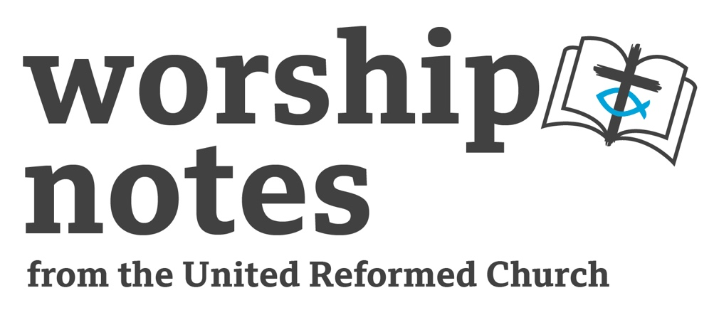

Pentecost

5th June 2022

The Rev’d Ruth Whitehead

Call to Worship

Today we celebrate the coming of God’s Holy Spirit,
Bringing life, strength and unity!

Prayers of Approach and Confession

We praise you, mighty God, for the Spirit which moved over the deep and helped bring all things into being.
You are our creator, and we love you.
We praise you, serving God, that you came to us in flesh in Jesus Christ, teaching, healing, living, dying and rising to show us the deep power of your love.
You are our saviour, and we love you.
We praise you, empowering God, for the gift of the Holy Spirit, promised by Jesus, sent from above to share your power and bring your church to life.
You are our inspirer, and we love you.

Loving God, we confess to you that we know you have made us in your image,
but we fail in our efforts to be like you.
We destroy when we should create.
We curse when we should save.
We exploit when we should comfort.
Through your Holy Spirit, cleanse us and make us new,
So that we may live the love we declare with our lips, as Jesus did. Amen.

OR

Loving God, we praise you because you are our Father & our Creator.
You made everything there is,
This world with all its beauty and wonder
Each one of us and all the people who love us
And so we come to praise you

Living God, we praise you because you are our Lord and our Saviour
You came to us in Jesus Christ
You touched and healed
Taught and challenged
Died and lived to bring us new life
And so we come to praise you

Enlightening God, we praise you because you are the Holy Spirit, the Comforter.
You make frightened fishermen into great apostles
You fill people and give your power
You guide us and guard us
And so we come to praise you Holy God – Father Son & Spirit – one God
As we praise you today come near to us
And help us to hear that we are your people
And hearing it to believe it
And believing it to live it
Today and forever. Amen

A Prayer of Inspiration

May the Spirit who played at the dawn of time
And who inspired people to declare and write down God’s Word
Bring God’s Word to life for us this day. Amen.

Readings

Acts 2:1-21 | Psalm 104:25-35, 37 | Romans 8:14-17 | St John 14:8-17 (25-27)

Sermon Notes

In many churches people will talk of Pentecost as being “the birthday of the Church.” There is certainly little doubt that without the action of the Holy Spirit, the followers of Jesus might never have found the courage to speak out about their faith – after all, they were following a man who had been murdered by the state. As with all birthdays, we want to celebrate, but we also look forward to gifts! It might be good to look at the readings and ask ‘what are the ‘birthday gifts the Spirit brings?’

The account from Acts tells of the sound of the wind & appearance of tongues of fire – there are clear signs of the Spirit’s presence. The disciples can then speak other languages – meaning that others can understand them. Peter’s ‘sermon’ makes it clear these are gifts for all, which bring salvation.

Psalm 104 states ‘You send forth your Spirit, and they are created; and so you renew the face of the earth’ - after listing some of the many amazing things God has created. So the Spirit brings renewal, growth and fresh creation.

The letter to the Romans tells us that the Spirit within us enables us to cry “Abba, Father” – the Spirit brings the gift of belonging as children of God.

In John’s gospel, Jesus makes it clear to Philip that the Spirit comes as an advocate – one who stands alongside forever, and abides within, so that people will know the truth and know peace.

You could ask the congregation which gifts from the Spirit they most appreciate, which they have seen at work, and which gifts the local church needs most for this particular birthday.

An Affirmation of Faith

We believe in God, whom Jesus called Father,
who created all things in love.
We believe in the Holy Spirit, who was with God the Father from the beginning
who co-created the universe, and holds it in being.
We believe in Jesus Christ – one with the Father and the Spirit –
who came to live a human life and gifted the Spirit as comforter and guide.
We believe in God who is three in one
who was and is and is to come.
Amen.

Outline Prayers of intercession

Come, Spirit of God,
Open our eyes to the beauty of your creation
Fill our mouths with your words,
Burn our ears with your will,
Come, Spirit of God,
Touch our lives with your radiant love,
Enflame our hearts with your passion,
Expand our horizons to meet with yours,
Come, Spirit of God,
Come, Holy Spirit!

Come, Holy Spirit, come,
Breathe into the hearts of your people,
like a dove, like a wind, like a flame.

Like a dove,
find a resting place in our land and around the world, bringing hope and peace.
We pray for …

We pray for all refugees forced from their homes,
living in foreign lands, aching to return.
Come Holy Spirit Like a dove,
hover over them with your hope.

Come Holy Spirit Like a wind,
blow throughout our land and around the world, bringing justice and peace.
We pray for …

We pray for exiles and political prisoners, and for the work of Amnesty International.
Come Holy Spirit Like a wind,
swirl around and among all people with your grace and truth.

Come Holy Spirit Like a flame,
rise up in the hearts of the people of our land and nations around the world,
bringing love and goodness.
We pray for creation, that humanity will become passionate toward protecting
and preserving it.
We pray for those working to eradicate poverty, unemployment, loneliness.
We pray for …

Come Holy Spirit Like a flame,
fuel the passions of your servants,
and make us one in your light and warmth.

Come, Holy Spirit, come,
Breathe into the hearts of your people,
like a dove, like a wind, like a flame.
Fill us with your empowering strength, even when we feel at our weakest,
When we are sick, or sorrowful or weighed down with cares.

Come Holy Spirit, come, and send us into the world proclaiming your truth
in every tongue, helping those in need,
protecting the discriminated and scorned.
Make us a church of disciples
overflowing with your love and hope.
Come, Holy Spirit, come,
Breathe into our hearts this day. Amen.

An introduction to and an Offertory Prayer

Through the Holy Spirit God has blessed us in many ways, we bring our gifts as a sign of our gratitude.

Lord, receive our gifts, and bless your church with the wisdom to use them wisely to further enrich your world with gifts of love, joy and peace. In Jesus’ name. Amen.

Blessing/Sending Out

Light of lights
Fire of fires
Power of powers – strengthen us

Inspiration of the tired
Spirit of all holiness
Comforter of the weak – heal us
Calling Spirit – send us out
Holy Spirit of God – come this day
And fill us with love joy and hope. Amen

Hymn Suggestions

Hymn | RS | StF | CH4 | MP
Come to us creative Spirit |  | 726 | 612
Spirit of God unseen as the wind |  | 394 | 600
When deep despair casts out all light |  | 399
There’s a spirit in the air | 329 | 398 | 616
She sits like a bird (Enemy of Apathy) |  | 393 | 593
God to enfold you |  | 648
Loving Spirit, loving Spirit, you have chosen me to be | 326 |  | 597
The Spirit lives to set us free (walk in the light) |  |  |  | 664
Key:
RS = Rejoice and Sing, StF = Singing the Faith, CH4 = Church Hymnary 4, MP = Mission Praise

The Rev’d Ruth Whitehead is the Moderator of the South Western Synod

