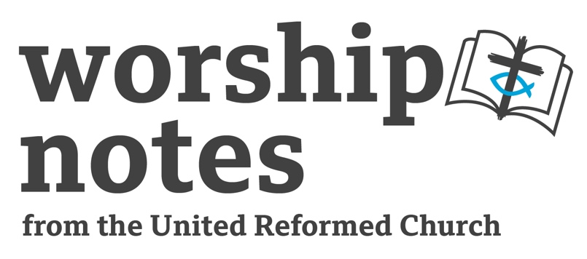
Sunday 14th July 2024
Proper 10 | Ordinary 15
The Revd
Wayne Hawkins

Call to Worship

Creator God for the wonder of your world, we praise you,
with hearts and hands and voices.

Compassionate Jesus for your unconditional love, we praise you,
with hearts and hands and voices.

Cajoling Spirit who unsettles and challenges us, we praise you,
with hearts and hands and voices.

With hearts overflowing with gratitude,
with hands active in care for others,
with voices raised in praise and worship

We meet together in your name.

Prayer of Approach and Confession

Loving and faithful God,
we come into your presence rejoicing.
To sing your praise,
to hear your words of acceptance
to share your all-inclusive love.

Be present with us in this time together as we come to worship you.
Knowing that we are called to walk the way of Jesus
we come just as we are and experience your welcome here.

Living Jesus, You show us that God is love:
You love with a love which reaches to all people;
with a love which keeps no record of wrong;
with a love that never ends.

Console us where we feel sad;
come close where we are lonely;
forgive us where we are feeling guilty;
reassure us where we are anxious.
Speak our names in the voice we recognise as the one who made us,
who knows us inside out;
and cares for us more than any other,
the one who has promised never to leave or let us go.
So that in this we may go from here comforted, pardoned,
strengthened and cheered, better able to serve you in your world
and to live in the fullness of life that you give us and all people everywhere.

Reading

St Mark 6:14-29

All Age Activities

Note: Depending on your group you might think that the gospel reading set for today is inappropriate. If so, you should select another Bible reading that focuses on bullying or situations when someone is made to feel small by someone with power or authority. One obvious example would be the story of David and Goliath or a Psalm which talks about unfairness e.g. Psalm 37:1-4.

Another possibility would be to explore the ways in which we use words to share kindness with others but also say unkind things, you might connect this with James 3:1-12.

Opening Discussion: Talk about times when someone has used encouraging and kind words about us and the ways that has made us fee. Talk about times when someone has said unkind things about us and how that makes us feel. Have we ever said something unkind? Have the children ever experienced bullying – what is bullying? How does it make us feel?

Activity: Wrinkled hearts

Using some cut out heart shapes think about how we feel when someone is unkind to us. When everyone has written some words then screw up the hearts until they are all wrinkled. Talk about the ways in which unkind words diminish us and make us feel less than God made us to be.

Activity: Poster

Encourage a discussion about how we need to think about the things we say, bullies can use words to have power over us. Create a poster about words for display in and around church, to encourage everyone to think carefully about the words we choose.

To encourage mindful communication children might use these five questions:

Is it
True?
Helpful?
Important?
Necessary?
Kind?

Notes for a Sermon

Rejection - The story of Herod beheading John the Baptist is preceded by the rejection of Jesus in his hometown. Herod hears about Jesus’ fame spreading and believes that he is John come back from the dead – this gives Mark the opportunity to tell the story of John’s murder. Jesus hometown are unable to accept him because of their assumptions about Jesus’ family and background, Herod is unable to respond to Jesus because he is caught up in his guilt-ridden past.

The stories of rejection are the stepping blocks towards a confrontation between Jesus and entrenched powers of convention and tradition that cannot or refuse to see the signs of the kingdom among them. Mark’s construction builds up to and defends the need of the cross and the seeming failure of Jesus, but this is to miss what God is doing in secret. While Jesus is always being rejected and that this confrontation eventually leads to Jesus’ death, along the way, the message of the kingdom is taking root in some and participation in the life of Jesus is the seed that becomes the new life of the resurrection.

Vindication - The affirmation God is love does not make any sense unless someday God sets right all that has gone terribly wrong in our broken world. Too much wickedness is unanswered and overwhelming injustice which seems to carry the day. But Jesus is not only the shape of God’s vulnerability and helplessness but also the shape of God’s future. John’s disciples, confused and broken, bury their master, but this is not the end of the story. Soon, other disciples will fret about the body of their Master. But in Jesus God will be mysteriously present, bringing about resurrection and setting straight and re-creating a whole new world.

Setting – the story of John the Baptist is placed between the story of the disciples being sent out on their mission and returning. Such placing of the story is intentional to make a point. It serves as a remind to Christians – Mark’s first audience were experiencing persecution and dispersal because of their faith – who find themselves under political or religious oppression to remain committed to God’s call. Like the prophets before him, John will risk his life and not give into pressure.

John’s murder interrupts the main story – despite any success the apostles might have, this story declares that the inbreaking of God’s reign continues to provoke defensive and dismissive responses. Struggle, opposition and violence answer back to those who announce God’s word. Jesus is rejected in his hometown but his popularity continues to grow, which comes to the attention of Herod. Herod ruled Galilee as a Roman client. This Herod plays a larger role in Luke. Only in this setting does Herod show any interest towards Jesus in a positive way.

Jesus’ invitation to participate in his life can be personally costly. And while it is easy to speak up for justice in safe environments there are conditions and circumstances when it can be dangerous. A sermon might focus on those who are persecuted or imprisoned for their faith or political ideals. Furthermore, bring to mind the call to speak up for justice as the church is also sent (apostello) to live out the good news.

Prayers of Intercession

We pray for all who speak out fearlessly
for truth and justice, knowing that they may pay a heavy price.
Be with them, Lord, as inspiration and friend.

We pray for those who recognise what is just and true,
yet succumb to pressure
from those who would see goodness destroyed.
Be with them, Lord, as encourager and beacon of truth.

We pray for those who are overwhelmed
by a thirst for vengeance,
and seek a violent solution.
Be with them, Lord, as prick of conscience and victor of evil.

We pray for the friends and families
who grieve,
when the courageous voice of truth is silenced.
Be with them all, Lord, as fellow sufferer and eternal comforter.

We pray for our church communities
that we might shine with kindness and love,
acceptance and welcome,
for all who serve
and discerning your future.

Lord hear us, Lord graciously hear us.

We pray for people of peace and good will
to resist and fight against all that divides us,
to see goodness and love
and much to applaud in your world.

Lord hear us, Lord graciously hear us.

We pray for our homes and neighbourhoods,
our workplaces and streets,
remembering especially those who are struggling,
experience difficulties and go unnoticed.

Lord hear us, Lord graciously hear us.

We pray for our world,
for places of conflict,
for those leading cruel and unjust regimes,
for all who work for peace and fairness.

Lord hear us, Lord graciously hear us.

We pray for overflowing hearts, hands and voices,
filled with thankfulness and praise.
Hear our prayers as we join together in saying:

Our Father…

Blessing

We go into God’s world to resist injustice.
We go into God’s world to speak of peace.
We go into God’s world to walk gently.
We go into God’s world to discover Jesus all around us,
in the life we live and share together.

Hymn Suggestions
 | RS | CH4 | StF | MP
Now thank we all our God | 72 | 182 | 81 | 486
Give thanks with a grateful heart |  | 180 | 78 | 170
Ye Holy Angels Bright | 125 | 179 | 69 | 783
God is good we sing and shout it |  | 178 |  | 185
Inspired by love and anger |  | 253
O God We Bear the Imprint of Your face |  | 254
Jesus Christ is waiting |  | 360 | 251
He Came Down that we may have love |  | 359
Longing for light, we wait in darkness |  | 543 | 706
Lord You have come to the seashore |  | 532 | 558

RS – Rejoice & Sing | CH4 – Church Hymnary 4 | StF – Singing the Faith | MP – Mission Praise

Pat Stannard, URC Prayer Handbook “Listening for the Whisper” 2015 © The United Reformed Church 2024

