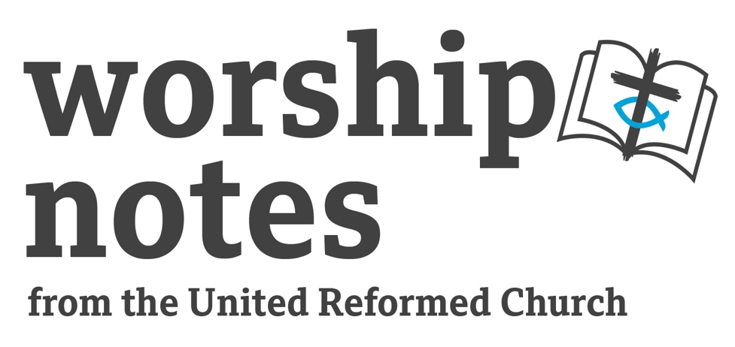
Sunday 17th

March 2024
The Fifth Sunday
of Lent
The Revd
Catherine McFie

Call to Worship

Our call to worship comes from Psalm 51 and as we gather to worship God may this be our prayer

Create in me a clean heart, O God, and put a new and right spirit within me.
Do not cast me away from your presence, and do not take your holy spirit from me.
Restore to me the joy of your salvation, and sustain in me a willing spirit.

Prayers of approach and confession

Creator God,
how wonderful it is to be in your presence,
to come as your people,
gathered from the north and the south, the east and the west,
with the sole purpose of spending time with you in worship.
As we open scripture together,
as we pray, and declare our faith,
receive our worship,
and may all we say and do in this time,
bring glory to your name.

Saviour God,
we come seeking to know you better,
we are amazed by the miracles you performed
we are challenged by your teaching,
we are humbled by your willingness to die for us.
Walk alongside us today and in the days ahead,
show us how we can best live our faith, and work through us
so that others can come to know you as Saviour.

Spirit God,
in the presence of our triune God,
We become aware of the times
when we have not lived into our calling.
Forgive us for the times we have hurt rather than encouraged.
For the times when we have ignored our neighbour and thought only of ourselves.
For the times when we have followed our own path and ignored you will.
Create in us a clean heart, we pray. Amen

Declaration of Forgiveness

Friends hear these words and know them to be true
by the faith of Christ, your sins are forgiven.
May you delight in the joy of your salvation. Amen.

Prayer of illumination

Your Word, O God,
holds words of promise and challenge,
and stories that inspire and give hope.
As we read and meditate on your word,
fill us with your Spirit,
that the words we read will change us and prepare us
to be your hands and feet in our communities.
In Jesus name we pray Amen.

Readings

Jeremiah 31:31 – 34 | St John 12:20 – 33

All Age Activities

Two ideas come to mind on the subject of change and how change is a good thing.

1. A caterpillar changing into a butterfly or tadpoles into a frog. The change in these cases enables to new incarnation of the insect/animal to do more. A caterpillar can’t fly but a butterfly can. A frog can jump and go on the land while tadpoles are stuck swimming in the water. You might find videos of these to show on the screen or bring some tadpoles or caterpillars in (and release them carefully afterwards)

2. Cress grows very quickly so to set up a series of trays with seeds in different stages of germination to show that the seed becomes more when it germinates and grows. You could give the children a small pot with a seed / bulb planted away with them to care for at home and watch what happens as it grows.
Sermon Notes

Jeremiah 31:31 – 34

- Think about who Jeremiah is speaking to. The people are in exile – will that make a difference to how they hear Jeremiah’s words?
- The new covenant is for Israel and Judah. What were the previous covenants that God had made – how were they broken and does that have any bearing on their current situation?
- What is this new covenant and what difference will this make to the may they practice or experience their faith?
- This new covenant is for everyone – from the least to the greatest “I will forgive their iniquity and remember their sin no more” – how do you think these words would be heard by the people listen and what hope would it have given them?

St John 12:20 – 33

- Where are we in the life of Jesus and is that significant?
- “The hour” is a theme that runs through John’s gospel as a pointer towards Jesus death – until this point references include “My hour has not yet come (John 2:4; John 7:30; 8:20), or “the hour is coming” (John 4:21, 23; 5:25, 28), Now the hour has come – how does this help us understand what follows?
- What does the story of the grain have to say to us about Jesus life and mission?
- V25 – 26 speak about discipleship, what do they mean in practice?
- V27 – we see the very human side of Jesus, reflects the scene in Gethsemane
- Voice from heaven – also in Jesus’ baptism and in the transfiguration, what is the significance?
- Verses 31 – 32 give us some insight into what a difference Jesus’ death is going to make, how can we interpret this today if we were to talk about rulers of this world being driven out and Jesus drawing people to him?

Affirmation of Faith – The Apostle’s Creed

I believe in God, the Father almighty,
creator of heaven and earth.
I believe in Jesus Christ, his only Son, our Lord,
who was conceived by the Holy Spirit,
born of the Virgin Mary,
suffered under Pontius Pilate,
was crucified, died, and was buried;
he descended to the dead.
On the third day he rose again;
he ascended into heaven,
he is seated at the right hand of the Father,
and he will come to judge the living and the dead.
I believe in the Holy Spirit,
the holy catholic Church,
the communion of saints,
the forgiveness of sins,
the resurrection of the body,
and the life everlasting. Amen.

Prayers of Intercession

Lord, we come before you with our prayers for others, write on our hearts the names of people, places and situations that are in need of change, so we can pray with hope.

Lord we pray for those for whom even the smallest change is difficult and upsetting…

(brief pause)

We pray for those whose lives have been changed because of illness…
(brief pause)

We pray for those whose who want to change but find taking those first few steps difficult…
(brief pause)

We pray for those who make changes to policies and laws…
(brief pause)

We pray for ourselves that we will be embrace the change you bring in our lives…
(brief pause)

God of hope, we offer up our prayers in the name of Jesus as we pray together the words he taught us saying:

Our Father…

Offertory prayer

Unless a grain of wheat falls to the ground
and takes on new life, it remains just a single grain.
With grateful hearts,
let us bring the fruit of our lives to God.

Dedication of Offering

Generous God,
thank you for all that you have given us,
as a token of our love and appreciation we bring you our offering,
use our money along with our time and talents,
to change the world by building you kingdom.
In Jesus name we pray Amen.

Blessing

People of God, go out into the world
as agents of change
as bringers of hope
as beacons of God’s love
and the may the grace of our Lord Jesus Christ,
the love of God and the fellowship of the holy Spirit
with you now and forevermore, Amen.

Hymn Suggestions
 | RS | CH4 | StF | MP
Hear the Call of the Kingdom |  |  | 407 | 1282
Abba Father |  |  | 439 | 3
He is Lord | 264 | 443 | 348 | 220
God is love His the Care | 274 | 193 | 403
Jesus Take Me As I am |  |  |  | 382
Make Me A Captive Lord | 505 | 534 |  | 455
One more step along the world I go | 549 | 530 | 476 | 1346
The King of Love My Shepherd is | 552 | 462 | 479 | 649
To Abraham and Sarah the call of God was clear | 553

RS – Rejoice & Sing | CH4 – Church Hymnary 4 | StF – Singing the Faith | MP – Mission Praise

