25th February 2024
The Second Sunday
of Lent
The Revd Paul Robinson

Call to Worship

As we come to worship, let still our hearts and minds. Psalm 19 says, The heavens declare the glory of God; the skies proclaim the work of his hands they have no speech; they use no words; no sound is heard from them. Yet their voice goes out into all the earth, their words to the ends of the world.

Prayer of Approach, Confession and Forgiveness

Almighty God,
we come to worship your holy name.
You are worthy of our praise, adoration and thanks.
We rejoice in the beauty of the world you created,
the wisdom of your sovereign will,
the power of your presence,
and the incomparable love and grace you show us.
We know you to be perfect in every way.
And so as we bring you our worship today,
so your perfect faithfulness illuminates all the more clearly for us
our own failings and short-comings.
We have sinned against you and others,
in thought, word and deed.
We have no other hope than to seek forgiveness
through the grace of the Lord Jesus Christ,
who died to redeem us and show us grace.
In repentance we seek the faith to trust
in his unfailing love and ask that you would once again,
meet us with your Spirit to transform and renew us
into the people you would have us be.
May our reflection and our thinking in your presence
lead us into that which you have prepared for us in the days ahead.
And so, humbly, we offer ourselves once more in service and praise,
to you, almighty God. In Christ’s name we pray. Amen.

All Age Activity

Hand everyone an A4 piece of paper - different colours is good, but not too thick because you’ll have to fold and tear it…. (It can be an A5 piece, you might like to use an A3 piece at the front….the important thing is the ratio of height to width)

Explain how Mark 8 gives an indication of what people need to go after to have life, and enjoy life…

We’re going to use the piece of paper to explore different things we might think bring us life…

Fold the paper like this

At this stage - you could talk about how this shape look like a mountain - get people use their fingers to climb up the slope explain how we can think that life is all about getting on - being the best - career ladders, success in sport etc….

So get people to think of this shape as a house - you could get people to share with each other where the roof, windows and doors would be…. How you would make it a lovely place to live…. Talk about how we can think that life is all about building a perfect home, where everything is just right, and perhaps better than our neighbours…

This piece of paper looks like rocket (OK a bit of imagination needed here…) - perhaps get people to go whizzing around in their rockets… we can be tempted that life comes from having all the modern technology and gadgets - the next generation of phone / tablet / laptop etc…

The next one has two folds to make what looks like a paper airplane… you’re just folding down the wings at this point…

So you can fold the ‘wings’ out for a bit and get people to thing about the wonderful places they might like to go around the world. We can think life is all about exploring the world, living in luxury and having fab experiences.

You might like to suggest though that if these really are our dreams - and we go after them - eventually we will either find that its too hard to achieve them all and we feel broken by the pressure of going after them, or we’ll discover that each thing is not as wonderful as we thought it was…. At which point you encourage everyone to carefully tear their piece of paper….

So with the wings folded down… tear through all the folded piece from top to bottom…

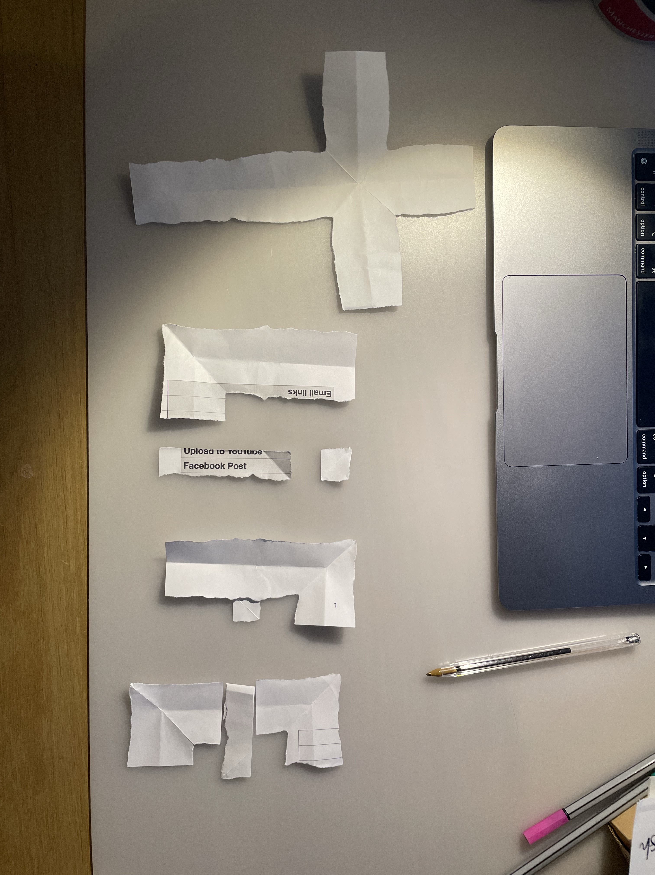
This will create a handful of pieces for everyone…. There is one big piece, that if you unfold carefully will be in the shape of a cross. The other little bits can be arranged (on a spare seat, or a pew bible shelf..) to spell the word ‘Life’…. (here’s one I made with some scrap paper…)…. You can explain how Jesus said that life in all its fullness would come, not through any of these other things we’ve thought of, but by ‘picking up our cross’. Jesus also said to follow him (like how everyone has followed you to fold the pieces of paper in the right way to reveal the cross and life)….

Prayer of Illumination

Psalm 19, which we used as our call to worship goes on to say,

The law of the Lord is perfect, refreshing the soul.
The statutes of the LORD are trustworthy, making wise the simple.
The precepts of the LORD are right, giving joy to the heart.
The commands of the LORD are radiant, giving light to the eyes.

The psalm concludes with a word of prayer that we use now as we turn to hear God’s Word proclaimed and then reflect upon it.

May these words of my mouth, and this meditation of my heart, be pleasing in your sight, Lord, my Rock and my Redeemer. Amen

Reading

St Mark 8:31-38

Sermon Notes

It’s important at the outset to acknowledge the key role this passage plays at the heart of Mark’s Gospel. Most commentators acknowledge a change in direction of the narrative at this point

The first half of Mark’s Gospel, chapters 1-8 (and a bit, at least to v.26), take the reader on a fast pace account of the things Jesus did and said amongst people. Mark is laying out for his readers, this is who Jesus is. That all leads up to the climax of the narrative with Peter’s declaration in 8:29, “You are the Messiah!”. Mark wants to take his readers on the same journey as Peter.

The start of this passage then is the beginning of the second section of Mark gospel. Commentators take slightly different tacks depending upon their understanding, but the general understanding is that the second half of Mark’s Gospel addresses the response - ‘So what?’ What does it mean that Jesus is the Messiah, and how should his disciples respond. Mark 8:31-38 could be seen as the overture to the narrative that emerges:

V.31-32.... Jesus is the Messiah, but that will involve rejection, suffering and death v.33.... Jesus is the Messiah on his terms to fulfil his vision, not his disciples V.34... Jesus is the Messiah and it will cost people their all to follow him v.35-37... Jesus is the Messiah and following him brings life.

v.38... Jesus is the Messiah and will bring glory to those who are faithful.

It was my thought that each of these overture bullet points, would provide sufficient reflection for a single service or sermon. Each could match the reflective journey through Lent too.

I was led in the sermon I prepared for this day to focus on v.34. It may the be the most well- known of these verses, but as I explore, the depth of the challenge of these words still resonates deeply with the commitment to Christian living today.

You may also wish to note that in verses 31-33 Jesus shares with his disciples alone but in verse 34, the wider crowd are listening in. The words, ‘Whoever wants to be my disciple...’ is then a general broad invitation to the entire world - for any one can respond to the challenge Jesus lays before them.

Prayers of Response and Intercession

Loving God,
we have heard again the challenge of the call of Christ
to live as his disciples, with faith and humility.
In the quiet we ask Holy Spirit that you
Would personally prompt us in how we might respond to this call.

Silence

Jesus Christ, take myself,
and I will be ever, only, all for thee.
We have heard again the call to play our part
in building your kingdom.
The good news of Christ is for all the world,
and so we lift to you now places and situations
that we know, where the goodness of your love and peace
is needed today.
We pray for those places in our world that are torn apart
by hatred, violence and war.
We pray for all those who have denied themselves
and placed themselves in dangerous places
as they work and strive for peace.

We pray for those who are sick and unwell,
facing daily struggles or life-changing diagnosis.
We pray for all those who have denied themselves
to offer care, support and love.
We pray for those who are grieving for loved ones,
mourning for shattered dreams or watching hope fade.
We pray for all those who have denied themselves
to stand with broken-hearted and forlorn.

We pray for our communities and towns,
our nations and society.
We pray for all those who have denied themselves
to see the lives of other thrive
and to usher in your Kingdom of love and grace.
We pray for your church,
and for the United Reformed Church.
We pray for all those who have denied themselves
to serve and give that the Gospel may be known
and the light of Christ seen in our world

Lord God,
we ask that you would hear our prayers,
that you would move by your Spirit,
and that we would be humble
to follow the call of Christ
upon our own lives.
We ask these prayers in his name and for his sake. Amen.

Offertory Prayer

And so as offer ourselves in service to the work of the Kingdom,
so we bring our gifts of money, time and energy,
offering all that we are, for the sake of Christ. Amen.

Blessing

And so may the loving presence of Almighty God be with us,
remain with us and sustain us, this day and forevermore. Amen.

Hymn Suggestions
 | RS | CH4 | StF | MP
To God Be The Glory | 289 | 512 | 94 | 708
I Want Jesus to Walk With Me |  | 539
I Want to Walk With Jesus | 367 |  |  | 302
My hope is built on nothing less |  |  |  | 473
My Hope is built (cornerstone) |  |  |  | 1334
Take my life and let it be | 371 | 502 | 566 | 624
Hear the Call of the Kingdom |  |  | 407 | 1282
When I Survey | 217 | 392 | 287 | 755
Will You Come and Follow Me | 558 | 533 | 673

RS – Rejoice & Sing | CH4 – Church Hymnary 4 | StF – Singing the Faith | MP – Mission Praise

Paul also suggests https://www.praise.org.uk/hymn/what-gift-of-grace-is-jesus-my-redeemer/

