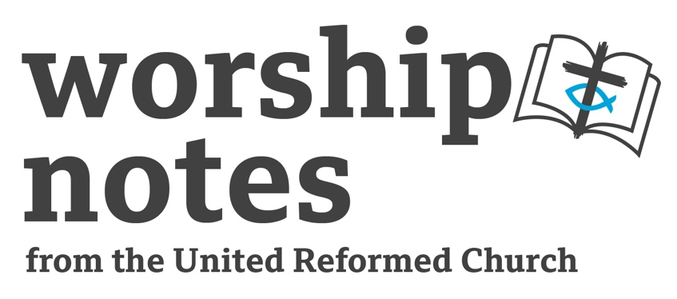
Sunday 24th

December 2023

Advent 4
The Revd Sarah Moore

Call to Worship

From you shall come forth for me one who is to rule in Israel,
whose origin is from of old, from ancient days.
Therefore, he shall give the up until the time
when she who is in labour has brought forth;
and he shall stand and feed his flock in the strength of the Lord
and he shall be one of peace.
Micah 5: 2 - 5
Prayers of praise and confession

We praise you, God of the unexpected,
standing ahead of us, beckoning us towards your future,
approaching us from eternity so we can know you here and now.
You blessed Elizabeth, surprising her in old age.
You called on Mary with astonishing news.
You came in Jesus and disturbed the world.

In the midst of Christmas celebration,
shake us from the sense that we know you and are used to you.
Challenge us again with the news of your coming,
the holy, righteous, loving God,
a human being in Jesus of Nazareth.
Challenge us again to know that justice should rule and love should reign.
Challenge us again with the words of Mary
to think what it means to raises the lowly,
and to fill the hungry with good things.

Bless us with the fullness of life that Jesus spoke about
and fill us with passion for your rule in our lives,
in our communities and in the world,
that we may be inspired to know
the meaning of your coming among us:
‘Peace on earth and good will to all’.
Robert Pope, ‘God of the unexpected’,
in Susan McCoan and Stephen Ansa-Addo (eds.), Cities of Sanctuary, London, The United Reformed Church, 2023

The Lord’s Prayer

All age activity and ideas

Look for a children’s book that tells the Christmas story or one that picks up the theme of travelling and read this aloud in worship. Ideas are available using the search function on the Storypath website that matches children’s literature to the lectionary. Many children’s books are available on YouTube as videos (of varying quality) so if you have access to the relevant copyright licences and audio-visual equipment available this might be an option if reading a book directly in worship is not preferred.

Alternatively, to focus more specifically on the Mary and Elizabeth story have a conversation with the congregation about travel. What journeys do folk make regularly, sometimes or occasionally? Do folk enjoy travelling, why or why not? If people present have or are travelling over the Christmas season perhaps have a map (of Britain, of the world) and point out where people are going or have come from. Talk about what it might have been like for Mary to travel from her home in Nazareth to Judea remembering that she might have travelled on foot or maybe by donkey. How long might it have taken? Would she have been able to tell Elizabeth she was coming? How might we respond to an unexpected guest, even a family member or friend?

Another option if there are teenagers and adults as the focus think about who we might go to in the event of a major issue occurring in our lives. Mary had an unexpected pregnancy. It would be wise to ask folk to reflect upon for themselves rather than say aloud for safeguarding reasons irrespective of how we you know a congregation in case someone present is at risk. Mary’s life might have been in danger in her home community with the Judean hill country a place of refuge. If you wish to focus on a refugee theme, consider obtaining the children’s book, ‘My name is not refugee’, talk about how people who do find themselves away from home with very few possessions might be supported both at Christmas and throughout the year.

Advent Candle Lighting

Ask a younger person to light the candles as you pray:

O God you journey with us,
in good times and bad,
holding us when we are sad,
dancing with us when we rejoice.
Be with us now as we prepare to celebrate Your birth amongst us,
that we may dance with You
and hold others in Your love, Amen.

Reading

St Luke 1.39-56

Sermon Notes

The visit of Mary to Elizabeth is a part of the Advent/Christmas story that can get forgotten in the melee of nativity, carol and other events and services in the preparation for Christmas.

The sermon prepared for this service focusses on themes of travel and the contrast of old and new ways of encountering God as illustrated by the mothers of John the Baptist and Jesus. A sensitive focus on family links could be explored in a sermon or reflection but mindful of the importance of remembering that relationships with family including extended family can be difficult for some people due to past or present abuse, painful memories, or other toxicity.

This passage could be an interesting way of reflecting on the person of Mary and her life. What might it mean for us as Reformed Christians to say ‘Blessed are you among women’; what do we mean when we say someone is blessed or pray that they might be so? An easy life? Or something else?

Again, with a note about the importance of pastoral sensitivity, this story could be a way into reflecting on approaches to family and children. The adage ‘Christmas is for children’ is a well known one and can be difficult for those who are childless not by choice. Pregnancy in riper years or in youth both bring particular challenges to those who find themselves in such a situation. Consider that this story could be particularly challenging for those with infertility and/or fertility treatment in their life experience, and that not everyone who hopes gets the outcome that they desire. Remember too that childlessness can be choice, not by choice or for a multiplicity of reasons in between. It isn’t just about not having a child or children but means that adults in such a situation also miss out on the other family-related milestones of adult life e.g. a child starting school, having the joy of sharing interests, a young adult child going to university, forming their own relationships, becoming a grandparent. This note isn’t to say to avoid these issues but to include with care and sensitivity and avoid cliches and humour in relation to this topic.

The second part of this passage, in Luke 1.46-56, is Mary’s song, known as the Magnificat, which is an almost direct copy of Hannah’s song in 1 Samual 2.1-10. Most folk in the United Reformed Church are probably most familiar with this passage in Timothy Dudley-Smith’s paraphrase in the hymn Tell Out My Soul. This too would be worthwhile reflecting upon through the lens of Advent and Christmas; Mary (or according the footnote in my Bible, perhaps Elizabeth) sings a powerful song of justice, of the scattering of the proud and the powerful brought low, of the hungry being given good things and the rich sent away empty. That this song was sung by two pregnant women gives a further alternative perspective to how we might otherwise read this passage.

Prayers for the World

Lord of the journey,
we gather on the path, road and voyage
in response to your invitation and call.

Lord of the journey,
as the pregnant Mary travelled to the Judean hill country,
Mary and Joseph to the stable and onwards with the infant Jesus as refugees to Egypt
we pray for the world.

We pray all whose job is travel or connected to travel.
Itinerant staff, those who are in different places for meetings,
preachers travelling from place to place.
Those who are ‘crew’ on planes and ships,
who work at ports and airports, on the railways or on the roads
and others in this sector.

Lord of the journey,
we pray for travellers this Christmas,
to or from where they need to be.
May journeys be a time of blessing,
may the in-between an opportunity for reflection.

Lord of the journey,
we remember those who are not where they would choose to be
or who are separated from loved ones this Christmas.
May they know your love and peace.

Lord of the journey,
we pray for your Church, ever travelling onwards
though tempted by the attractions of the wayside.
Show us how to hold the best of what we have inherited
as you lead us onwards into the land and place you shall show us.

Lord of the journey, we pray for ourselves and for our own needs.
Give us this day our daily bread, and forgive us our debts.

In the name of the travelling one, Amen.

Offertory Prayer

In this season of giving and receiving
we bring our gifts to the table
that God’s love may be known in our world.

Generous God,
we thank you for the outpouring of blessings we have received
and for the ones for which we hope.
We offer something of what has blessed us that it may bless others. Amen.

Sending Words and Blessing

Go in peace to whatever
the Christmas season will offer to you.

Go sharing peace to all you meet.
In the name of the babe who shall be the risen one.

May the blessing of God,
Creator, Christ and Holy Spirit
be and remain with you,
with those you love,
and those you are called to love.
Amen.

Hymn Suggestions
 | RS | CH4 | StF | MP
If keeping Advent to the bitter end….
Tell out My Soul | 740 | 286 | 186 | 631
The Angel Gabriel from Heaven Came | 139 | 285 | 187
Of the Father’s Love Begotten | 181 | 319 | 181
O Come O Come Emmanuel | 126 | 273 | 180 | 493
Hark the Glad Sound the Saviour Comes (try it to the tune Antioch) | 137 | 277 | 171 | 210
If starting Christmas…
People look East. The time is near |  | 281
It came upon the midnight clear | 144 | 303 | 205 | 345
Who would think that what was needed | 178 | 295 | 222
On Christmas night all Christians sing | 153 | 294 |  | 537
RS – Rejoice and Sing | CH4 – Church Hymnary 4 | StF – Singing the Faith | MP – Mission Praise

