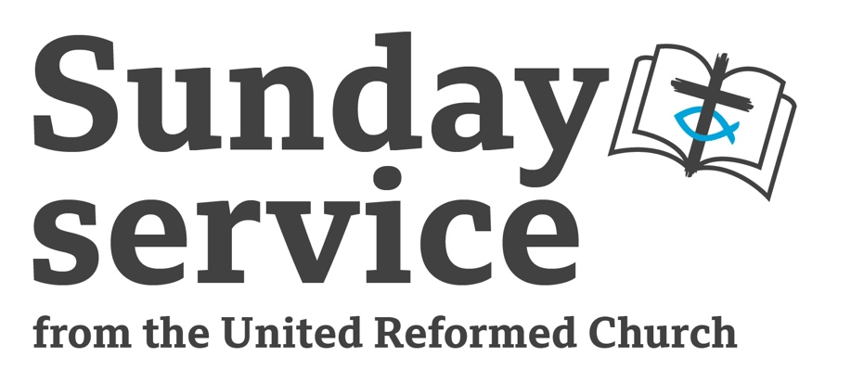
Sunday 17th
December 2023
Advent 3
The Rev’d Paul Whittle

Call to Worship

The Psalmist wrote: Remember feeling amazing! Remember a time of celebration – that was the Lord God at work! Laughter rang out, everyone was happy, everyone laughed till they shook with joy! The Lord has done great things for us and we reply with shouts of joy!

(Psalm 126:1-3, Let’s Say a Psalm, Sylvia Purdie)

Prayers of Approach, Confession and a Declaration of Forgiveness

Living God, in this season of Advent, we wait on you.
We are expectant, getting ready.
We are looking for something special.
Help us, as we look and listen for what you are doing and what you want to say to us, to see those moments of incarnational joy that contribute to a transformed world.
Accept our offering of worship.
May those who sow in tears reap with shouts of joy.
Open our eyes that we may see the great things that you are doing.

Loving God, forgive our frequently shabby response to your love.
Forgive our failing to be your people,
living and loving in the way that you have called us to walk.
Remind us to live out our baptism.
Remind us that we are forgiven people.
Remind us that we are called to be your people.

So, help us to leave behind all those things that take us in wrong directions
and rather to shine as your light, to offer influence for good, just as salt makes food tasty. We ask it for your love’s sake. Amen.

The Good News is that we are forgiven.
The promise is that in Christ all things are made new.
God’s love is freely given.
And it’s abundantly generous.
You are invited to make the words of the Psalmist your own, words offered to God:
I know that your goodness and love will be with me all my life;
and your house will be my home as long as I live.

Prayer for Illumination

Lord, speak to us through your Word.
As we prepare ourselves this Advent to, once again,
celebrate the wonder of the Incarnation,
may we, in these moments, prepare ourselves to hear your words
and your call to us, just for today.
In Jesus’ Name we ask it. Amen.

All Age

One of the things I often do in an all-age situation is simply read a story. I have built up a collection of books aimed at young children, and I find that reading the right story can catch everyone because everyone takes it at their own level. Obviously it doesn’t work with just any story, but I think there are some great ones around. Sometimes I say just a little to bring out a meaning but, most often, I simply let the story speak for itself, though I do always some idea, however loose, as to how it fits the day’s theme.

A story for today might be ‘Lost and Found’ by Oliver Jeffers (available on kindle if this is last minute preparation). What it says about losing and finding the way fits with what I want to consider around John the Baptist preparing the way.

An alternative would be to have a rucksack packed with stuff for a day at the beach (picnic, swimming costume, sun cream, bucket and spade, camera, rug, towel, perhaps a sun umbrella). You could then develop a conversation about planning for different events, perhaps using Christmas as an example. Then, you might say something about John preparing the way, and how we can prepare to be good disciples, walking the way of Jesus today.

Candle Lighting

Journeying God,
be with us as we journey through Advent,
help us to prepare not only for Christmas but Your return,
that we may be ready for Your coming amongst us. Amen.

Reading

St John 1:6-8, 19-28

Sermon Notes

INTRODUCTION – Talk about preparing, perhaps citing examples of things for which you (or the congregation) have had to prepare. Talk also about waiting, seeing it as an element of preparation, but also something that can test us when we don’t want to wait.

JOHN THE BAPTIST – Talk about John the Baptist as God’s messenger. John thus stood in the tradition of the prophets, but he doesn’t identify as a prophet. His role is simply to point to someone else, and he is happy to just do what God wants.

JOHN’S INDIVIDUALISM – You might want to talk about the things that made John different. He was definitely not one to conform. John’s Gospel doesn’t actually carry a lot of information but, if we supplement it with the descriptions in the other gospels we can identify at least four unusual things about John – his choice of clothing (made of camel’s hair), his diet (locusts and wild honey), his preaching location (the wilderness), and his provocative preaching (addressing his congregation as ‘snakes’),

JOHN’S ROLE – However, John has a God-appointed role. He is a voice shouting in the desert. He is a preparer of the way. You could compare other folk, Biblical or otherwise, who have either similarly responded to God’s call, or who have tried to avoid it.

AND US? – The call is always to do what God asks, not what God is asking someone else to do, not what we think God should ask us to do. As we get near the end of this season of Advent (preparation), and as we make sure of all our domestic and churchly preparations for Christmas, are we listening for anything God may be wanting to say to us about our discipleship, about God’s light can come into our lives, and how we can share that light?

Affirmation of Faith

Let us affirm our faith.

We affirm our faith that God rules the world in wisdom and goodness,
and that we are called to be God’s servants.
Through Jesus Christ God has shown us the truth
and set us free from evil.
We believe that God’s love will never end,
that God will go on forgiving us,
and will bring us at last to perfect knowledge and perfect fellowship.
We will trust God for ever, and we will prove our love for God
by love for each other and our neighbours;
we will praise God with our voices and our lives for ever. Amen.

Faith adapted from Alan Gaunt, New Prayers for Worship

Intercessions

Advent God, come close to us now.
In this time of waiting, as we look for the Christmas event,
as we prepare ourselves to rejoice
with angels, shepherds and wise men at the news of a birth,
hear our prayers for those places and situations
where so much more good news is needed.

Loving God, we pray for a world that is struggling in so many ways.
We get news of conflict,
of desperate poverty leading to desperate migration,
of the potential catastrophes of climate change,
and so much more that concerns us.
Bless the leaders of the nations.
Give them hearts that will seek justice and peace.
Bless those in the spheres of politics, business,
the media and education
who have great swathes of influence and degrees of power.
May they use that which is given to them wisely and well.
We pray for a better world that reflects your Kingdom values,
asking that you will enhance the efforts
of those who have the gifts and skills to contribute effectively to that.

We pray for the Church.
Help us to proclaim your Gospel in what we do, as well as in what we say.
May we provide good examples of co-operation and reconciliation.

And we pray for our friends, our families, our neighbours,
especially those who will be lonely this Christmas.
Accompanying God,
be alongside those who most need to feel your presence.
Hear our prayers for those who have been bereaved,
those who are ill,
those who are anxious,
those facing new challenges,
those struggling with life.

Help us to love as Jesus loved,
taking special account of those ignored or marginalised by the majority.
As John shouted out, may we ‘shout out’ for those who need our voice of support.

Lord, you know our deepest longings.
You hear our prayers.
Hear now, the prayers spoken aloud,
but also the unspoken prayers of our hearts,
which we bring now in the Name of Jesus,
in whose Name we pray,
and in whose words we further pray now: Our Father

Offertory

We come to our offertory. As we think of all God’s gifts, we offer back what we can.
Let us pray:

Lord, take our gifts, gifts of money that we give in different ways,
but also gifts of time, of service, of talent, of worship.
Use all we bring. Use in your service.
In Jesus’ Name we ask it. Amen.

Blessing

So, wait on the Lord.
Prepare yourselves for what God has in store.
Know that you are loved and valued by God.
You are a child of God.
And the blessing of God Almighty,
God who created all things,
Jesus who came to this earth as a baby,
the Holy Spirit who sustains, guides and empowers us,
one God, but Three in One,
God’s blessing be with you always. Amen.

Hymn Suggestions
 | RS | CH4 | StF | MP
Beauty for brokenness |  | 259 | 693 | 806
God of freedom | 625 | 263
Light of the world | 504
Longing for Light |  | 543 | 706 | 1201
Make way, make way | 141 | 279 | 264 | 547
O for a thousand tongues | 285 | 352 | 364 | 496
On Jordan’s bank the Baptist’s cry | 134 | 334 | 182 | 538
Praise the one who breaks the darkness |  | 348
The race that long in darkness pined | 129 | 290
When out of poverty is born |  | 259
When Zion’s fortunes God restored |  | 86
RS – Rejoice and Sing | CH4 – Church Hymnary 4 | StF – Singing the Faith | MP – Mission Praise

