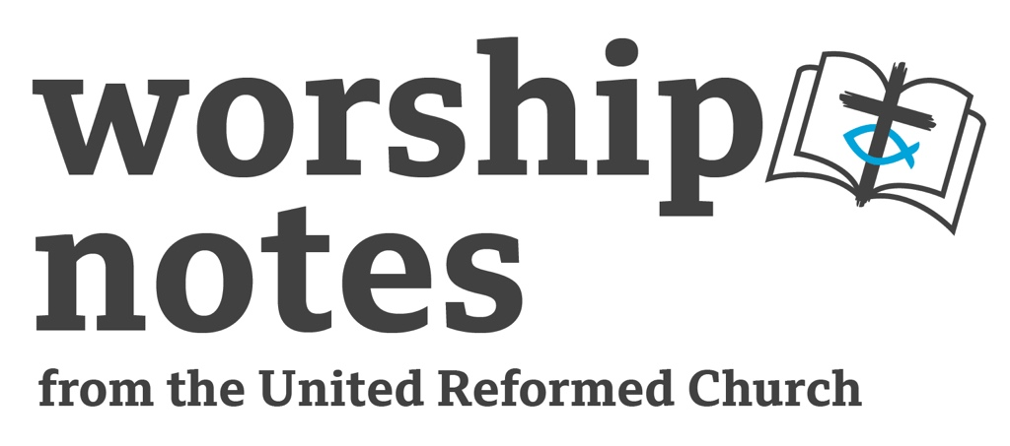

Sunday 25th June
Proper 7 / Ordinary 12
The Rev’d
Ruth Whitehead

Call to Worship

We are always in the presence of God – but when we draw near to God,
we find God draws near to us – in the name of Jesus Christ.

Prayers of Approach, Confession and Forgiveness

God of all love, all truth, all mercy
we come to give praise to you for your love –
the love of Creator for the creation;
the love of Saviour for the broken;
the love of Comforter for the overwhelmed.

We come to spend time in your presence and with your Word.
The Word which is sharper than a two-edged sword –
keen, testing, and trustworthy.
We come to confess to you our failings, our foibles, our faults.

Forgive us, we pray – in your mercy make us new,
in your truth give us strength
and in your love set us on your way once again.

God came to earth in Jesus Christ – to speak words of love, mercy and truth.
He says to us ‘you are a beloved child of God – be made whole’.
Thanks be to God. Amen.

All Age Introduction

Taking up the verse “even the hairs of your head are numbered” – you could grow a “head of hair” with cress seed (look online at https://www.creativekidswork.com/prayer/389-338-all-your-hairs-on-your-head-are-numbered) for instructions.

Either this could be done ahead of time and then ask the congregation ”how many seeds do you think I planted – how many ‘hairs’ have grown”, or in a messy church/activity context, get people to count out and plant 50 seeds.

You have to be really careful to know how many “cress hairs” there are.

How many hairs do you think there are on a real person’s head (choose a younger person with lots!)?

How many hairs are there on the heads of everyone in church today..? – estimates needn’t be accurate (though some might like to do that!) – the point is there are very, very many, but it’s hard to know exactly how many – who would have the patience to check the estimate?

Jesus says that God the Father knows us so well he knows the answer to all these questions – he knows us, each one, so well. God also loves us – each person – perhaps even each hair!

Prayer for Illumination

Loving God we seek your face,
your voice and your way
as we turn to your word.
Shine on us, speak to us and guide us we pray.
Amen

Readings

Psalm 69: 8-11, (12-17), 18-20 | Romans 6:1b-11 | St Matthew 10:24-39

Sermon Notes

There are words of comfort in these readings, but there are also words of challenge. If the congregation to whom you are preaching need to hear words of comfort, you might want to focus on the care of God who has all the hairs of our head numbered, for example, or focus on the phrase “you are of more value than many sparrows”. You might want to think about local concerns in which God’s love is known, or needs to be seen. What sort of God do we worship, who has both the great overview of all his creation, but knows each one of us in detailed intimacy? The letter to the Romans teaches how In Christ we are accompanied through death to life. We live and die in him and we will be raised with him to eternal life. All these words bring comfort.

But there is challenge in the readings, too. Difficult phrases like “I come not bring peace but a sword” and “I have come to set a man against his father..etc” points us to a Jesus who gives his followers hard choices about following or opting for an easier life, following or placing human bonds above the one with God. Psalm 69 is very clear about the reproach the Psalmist faces, and Jesus speaks plainly about ‘those who kill the body’, whilst the Romans reading interweaves talk of life, death and eternal life in Christ. The Psalmist is clear “but as for me, this is my prayer…In your great mercy, O God, answer me with your unfailing help.” Even in the darkest moments, God offers us salvation and life.

Prayers of Intercession

"In your great mercy, O God, answer me with your unfailing help”.

God of all mercy, we bring our prayers to you. You alone can help and save us.

We pray for those who feels their life is lost in deep water and great darkness.
For victims of natural disaster.
For those trapped in debt or addiction.
We pray for all who love and serve those in this kind of need.

We pray for those who fear the deep will swallow them up.
For those facing bullying or oppression
For those undergoing medical tests or treatment.
We pray for those who speak out for justice and kindness.

We pray for those whose distress
leads them to feel that God’s face is turned against them.
For those struggling with lack of self-worth.
For those with poor mental health.
We pray for all who support and encourage vulnerable people.

We pray for those who need to know that you. Loving God, draw near to them.
For those whose lives have just begun, or whose lives have changed dramatically.
For those nearing death
We pray for all those who accompany others and bring deliverance.

Loving God, save us, lift us up, hear us, draw near to us.
That our prayers may be heard and answered,
and we and all your children know your love more deeply. In Jesus name. Amen.

based on Psalm 69
Offertory

God who gives each good gift,
eceive now all that we would offer you with thankful hearts.
Loving God, take all our gifts, given to you today or kept for our use.
Bless us with generous hearts
so that your world may be enriched through our gifts. Amen.

Blessing

May the peace of Christ go with you wherever He may send you
May He guide you through the wilderness, protect you through the storm
May He bring you home rejoicing at the wonders He has shown you
May He bring you home rejoicing once again into our doors

from the Northumbria Community

Hymn Suggestions
 | RS | CH4 | StF | MP
We know that Christ is raised | 426 | 635
Jesus our Lord and King | 429
God’s spirit is in my heart (go tell everyone) | 576 |  | 404
All my hope on God is founded | 586 | 192 | 455 | 16
How firm a foundation, ye saints of the Lord | 589 |  |  | 243
In heavenly love abiding | 590 | 551 | 736 | 331
Do not be afraid | 591 | 191 |  | 115
Peace, perfect peace | 594 |  | 710

RS – Rejoice & Sing | CH4 – Church Hymnary 4 | StF – Singing the Faith | MP- Mission Praise

You might also like Wendell Kimborough Version of Psalm 69 “draw near” https://www.youtube.com/watch?v=LRiAJsVc-Gk

