Sunday 12th November 2023
Proper 27 | Ordinary 32
The Rev’d Andy Braunston

Note

Many ministers and worship leaders seek to observe Advent by having a range of Advent hymns and not having Christmas carols until the Sunday before Christmas (the more liberal ones) or not until the first Christmas service (the more hardcore). This is, of course, correct but can often annoy congregations who are hearing Christmas music everywhere except the Church which starts playing just as society turns it all off! The Lectionary can help us if we wish to keep a good Advent by starting early as the readings for today and the next two weeks show. The Gospel readings are all about Christ’s Second Coming. This is something we want to talk about in Advent, but which gets lost as all talk of Christ’s coming is heard through the prism of the Manger. Hymns have been suggested which have these themes but it’s interesting how few there are in our repertoire which focus on the Second Coming as opposed to other Advent themes such as longing for redemption. The Catholic hymnal, Laudate, however, has some very good material which would be worth learning; two are suggested.

Call To Worship

We seek refuge in the Most High, who is always pleased to deliver us!
We shelter in Christ, our rock and redeemer, who makes haste to help us!
We find strength in the Abiding Spirit, who rejoices in our salvation!
from Psalm 70
Prayers of Approach, Confession & Forgiveness
Eternal Majesty, source of life and love,
help us to rest in Your presence and be ready to hear.

Lord Jesus, radiant wisdom of the Most High,
help us to discern Your call and be ready to serve.

Life-giving Spirit, gracious guide in our paths,
help us to understand Your will and be ready to obey.

Most Holy Trinity,
we come to rest, discern, and understand,
but realise our own frailties as Your wisdom casts our foolishness into stark relief.
We prefer our own ideas to Yours,
we forget to prepare for the future,
failing to replenish the oil of love and service that You require,
ignoring Your warnings and hoping we’ll be let into the feast anyway.

Teach us, O God, to love wisdom,
and to show our discipleship through loving service of others, that,
at the end we may be ready to follow You to the banquet of life. Amen.

My sisters and brothers, God is like
a father who runs to welcome home the estranged,
a mother hen who shelters her chicks, and
a rock behind which we shelter in the storm,
God is gracious, loving, and faithful
and forgives all who truly turn their lives around.
So have the courage to turn back to God,
and the bravery to forgive yourself. Amen.

Prayer for Illumination

As a lamp in the dark,
Your word, O God, gives direction and hope.
Bless us now as we listen for Your truth
expressed in sermon and reading, in song and silence,
that we may hear Wisdom and become wise. Amen.

Readings

Wisdom 6:12 – 20 | St Matthew 25:1-13
All Age Activity

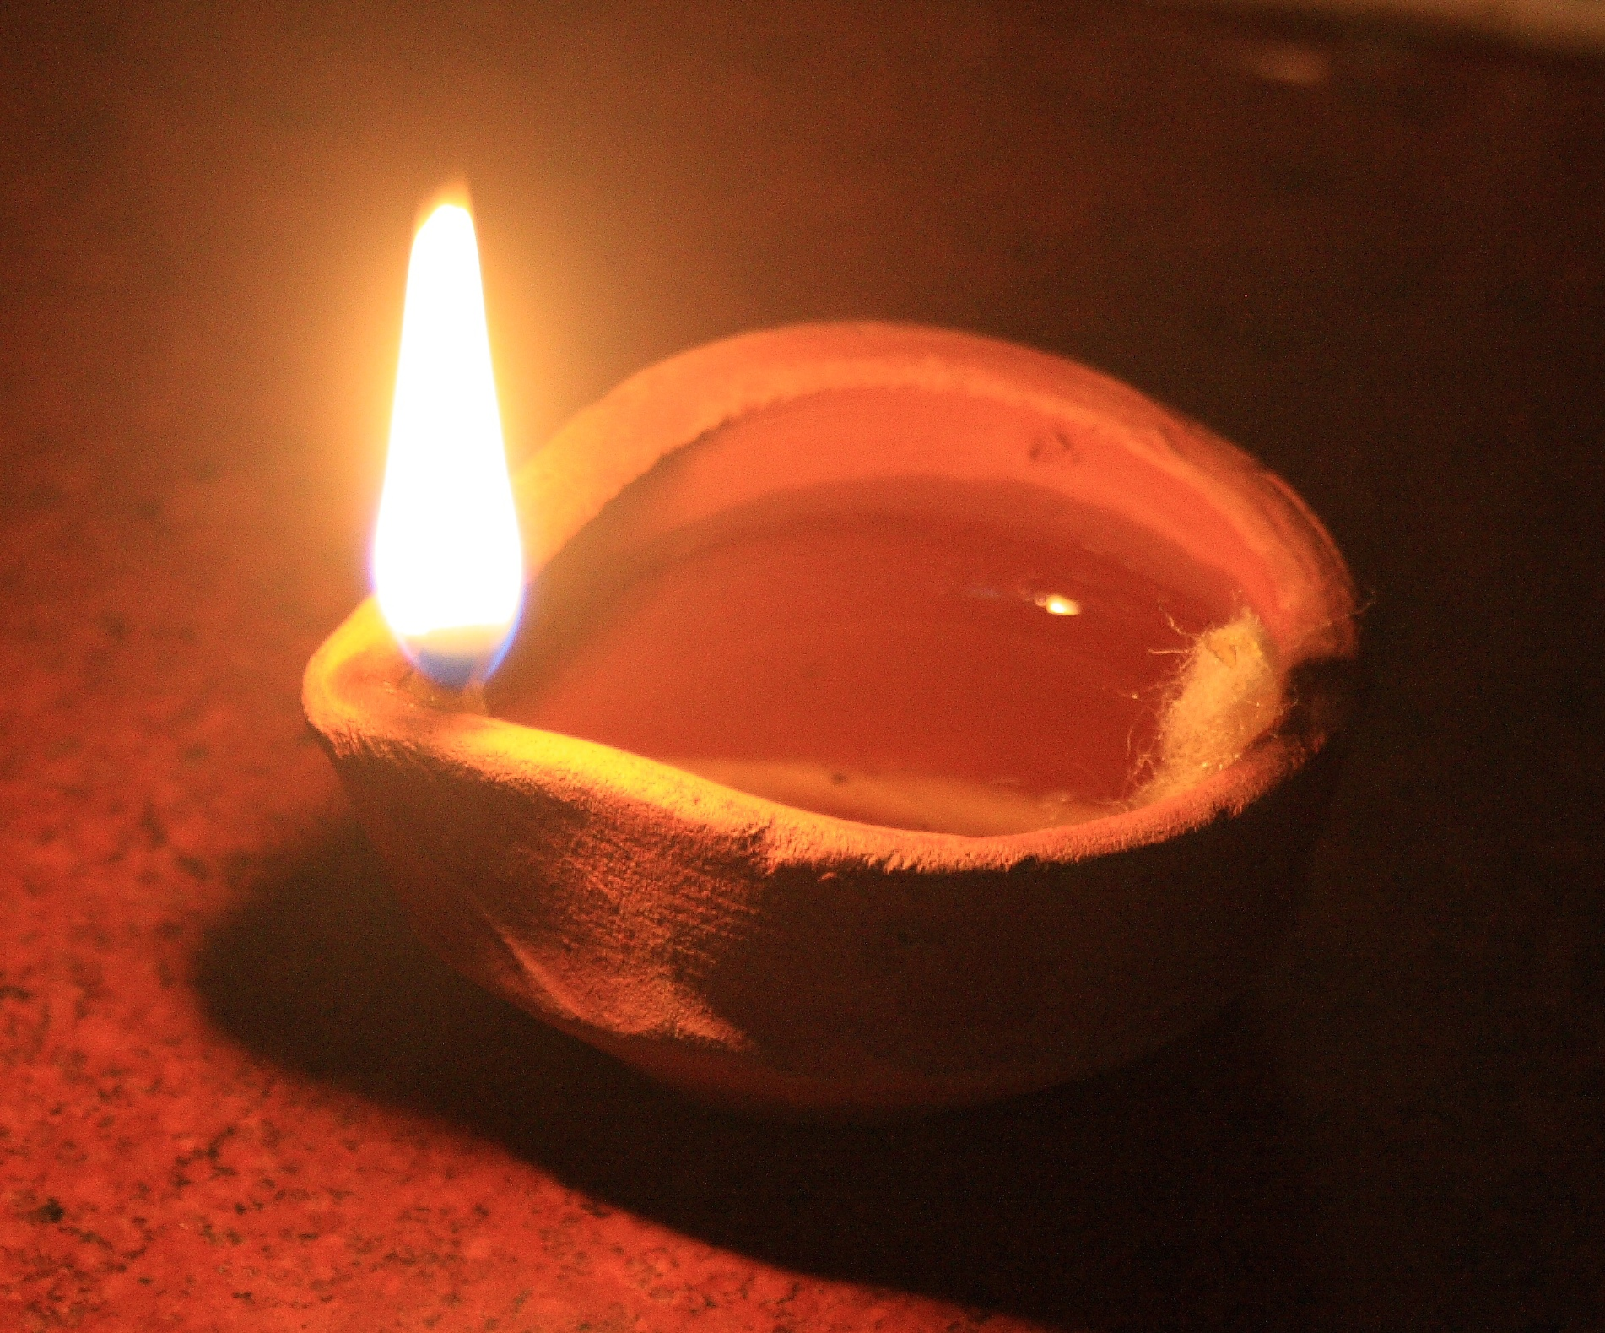
You might want to have an oil lamp – or a picture of one – to help. If you have an old oil or paraffin lamp you might want to light it, you could make one in a jam jar with some oil, not paraffin!, in the jar with some material serving as a wick coming up through a hole in the lid and then lit. Have a fairly small wick for a gentle flame. If you have a data projector you could project pictures of them.

Photo credit Arne Hückelheim, CC By-SA 3.0 via Wikipedia Commons

Today’s readings from the Bible encourage us to be wise. We heard of 10 girls who were bridesmaids at a wedding. They waited for the groom at the bride’s house, but he was very late. The wise bridesmaids guessed this might happen and took extra oil for their lamps so they could light up the procession from the groom’s to the bride’s house. The foolish bridesmaids, however, just hoped they’d have enough oil in their lamps. When the groom came the foolish bridesmaids realised they’d run out of oil! They had to find a shop open late at night to buy some more oil and, by the time they’d got back, everyone had gone to the party, and they were left out.

- If you’d been in the story, would you have remembered or forgotten to take extra oil?
- How would you feel if you were late to the party and couldn’t get in because of your own foolishness?

Jesus told the story to remind us to be prepared for a long wait for him to return. We can be prepared by showing love and kindness to people around us. We can share what we have so that no one is left out.

Sermon Notes

Notes on Wisdom

Wisdom is part of a group of books that Protestants usually refer to as the Apocrypha but which most Christians accept as being part of Scripture. They were found in Greek translations of the Old Testament but not the Hebrew. This led to debates throughout Church history about whether they should be recognised as Scripture. They were rejected at the Reformation giving a propaganda gift to Catholics who would point out that the newfound Protestant commitment to the Bible wasn’t as deep as had been asserted! Until modern times these books were placed in an intertestamental section in the Bible following Luther’s practice but then were missed out of Protestant Bibles. In more recent years these books have started to reappear and some of them are included, as today, in the Lectionary.

Wisdom, despite its full title as The Wisdom of Solomon, is accepted by scholars to be written by a Jew in either the first century BCE or the first century CE who took on the persona of King Solomon as he was reputed to be wise. The author’s style is reminiscent of Proverbs, Ecclesiastes, and Song of Songs – all books associated with Solomon. These books make profound observations of the natural world and human behaviour and highly value wisdom, which is often personified - as in today’s passage. The author is concerned with the righteous being delivered and the punishment of their ungodly persecutors.

The personification of Wisdom in today’s passage as a young woman takes ideas from Proverbs 8: 1 – 21. Wisdom itself is seen as a desirable quality and one which leads to obedience of God’s laws leading, again, to immortality.

Notes on Matthew

The personification of Wisdom as a young woman in the Wisdom passage works well with Jesus’ parable of wise and foolish bridesmaids.

This passage is part of a longer sequence teaching about the end of the age – the Lectionary compilers are getting us ready for Advent! We’ve been told there will be war and persecution, sacrilege and false teachers, and a shaken heaven and earth before Jesus returns at some unspecified time in the future. It is part of a sequence of three other stories (including the Faithful and Unfaithful Slaves, the Talents and the Sheep and the Goats) about the End. It is a story about waiting. The earliest Christians assumed Jesus would return quickly but had to learn how to wait.

Clearly Jesus intends us to live as wise, not foolish bridesmaids but is short on detail as to what that might mean. It’s a brave preacher these days who will ask the congregation if they are wise or foolish virgins!

- Some think it’s not about staying awake – but both wise and foolish became drowsy and slept.
- Some think it’s not about bringing all we need or want – but the feast is provided – the only difference is the wise thought to bring lamp oil.
- Some think it’s about waiting without grumbling – but that’s not part of the story.
- Some think it’s about hope – but they all doze off and all rejoice when the groom comes.

The difference seems to be the wise were prepared for the wait whilst the foolish hoped for a shop open at night that stocked oil.

We’re all waiting for the bridegroom’s return; but this passage doesn’t encourage us to stockpile weapons, food, or righteous indignation. Instead, the text warns us that it’s not about what, or who, we know but about being prepared for a long wait and not relying on what’s already in our lamps. The bridesmaids all waited together, foolish and wise, and stuck with each other; we wait together in church, foolish and wise – faithful and muddled - bearing with each other and seeking to model a new type of community where every time we break bread and share wine, we replenish our oil and anticipate the wedding feast of the Lamb. Every time we engage in works of mercy, in forgiveness, and in working for justice we replenish our flasks of oil.

The text also reminds us that this isn’t as good as it gets - there is a party coming; the groom will return, and things will get better. We too wait until the end of the age but don’t talk about it much – save the acclamation at Communion about Christ coming again – for fear of being associated with the type of Christians who salivate at the idea of God punishing the lost.

We live in hope – the hope that God hasn’t finished with us, that the project started at creation will come to fruition despite our best attempts to frustrate it. Living in hope does not deny the evils of the world with democracy under threat in the much of the West, with torturers enjoying peaceful retirements instead of prison cells, with wars of aggression going unpunished, and with creation groaning not so much with eager longing but tired exhaustion at our rape of the planet. Our task to keep enough oil on hand and roll up our sleeves and work for the coming of the kingdom. Jesus reminds us that it’s not enough to cry, with the foolish, “Lord, Lord.” The banquet is reserved for those who’ve done God’s will and attended to the oil of mercy and love. Being a Christian in name only isn’t enough to secure a seat at the banquet hands need to be dirty, sleeves need to be rolled up, spare oil is needed in abundance!

Affirmation of Faith

Since the earliest days God’s people have waited.
In Egypt we waited for deliverance.
In the Wilderness we waited for settlement.
In the Kingdom we waited for godly rulers.
In the bitterness of exile, we yearned for a return home.
We waited and trusted in the Most High.

In the fullness of time God became one of us.
To a people suffering occupation Jesus promised freedom.
To the poor He promised release. To the sick He gave healing.
Yet the powers of the age were happy with waiting,
struck Jesus down, nailed him to the Cross, and killed him,
hoping that his light would be extinguished.
After three days of waiting in the tomb Jesus was resurrected;
the first fruits of all who wait.
He waited and trusted in the Most High.

Jesus commissioned his friends to preach, teach and baptise,
and to wait for his return. Since then we’ve waited;
empires have risen and fallen,
peoples and species have come and gone,
and now creation still waits with eager longing for deliverance,
Yet still we wait and trust in the Most High.

We wait with hope for Jesus to return,
to reconcile all things with the Most High,
to enable us to live in harmony with each other and creation,
that justice and righteousness might flow like a river,
and for all things to be made new.
For this we wait and trust in the Most High. Amen.

Intercessions

Eternal Majesty,
Your light shines in the gloom of our world
where we wait for things to change.
Bless those who, this day, wait for justice:
those imprisoned without trial,
those tortured by the state,
those who wait in pain for medical treatment,
and those who wait for their poverty to end.
Bring into the light, Most High,
those who operate justice for their own ends,
those who torture,
those who ration health care
and those who exploit the poor,
that, Your Kingdom shall come.
pause
Lord, in your mercy…hear our prayer.

Risen Lord Jesus,
You came to the gloom of our world
and experienced human life in all its complexity.
Bless those who, this day, wait for change:
those who work in and research renewable energy weaning us off polluting fuels,
those who secure the rights of the poor and oppressed,
those who welcome the refugee, the torture survivor,
and the stranger seeing You in them all,
those who seek to learn how to live with creation and adapt to climate change.
Bring into the light, Lord Jesus,
those who greenwash their pollution,
those who wish to keep the poor in their place,
those who seek to divide and conquer,
blaming refugees for their own greed and incompetence,
and those who deny what we are doing to the earth,
that, Your Kingdom shall come.
pause
Lord, in your mercy…

Most Holy Spirit,
Your radiant unfading wisdom enlightens the gloom of our world.
Bless those, this day, who wait in hope:
those worshipping in secret for fear of the authorities,
those aching to love but face legal and social persecution,
those waiting for the birth of a child
and those waiting for life to come to its end.
Bring into the Light, Most Holy Spirit,
those who hate freedom,
those who hate love,
those who harm children,
and those who devalue life,
that, Your Kingdom shall come.
pause
Lord, in your mercy…hear our prayer.

O Trinity of Love,
hear our prayers as we join together
with those who love you throughout space and time
and pray as Jesus taught: Our Father…

Holy Communion

The Lord be with you! And also with you!
Lift up your hearts! We lift them up to the Lord!
Let us give God our thanks and praise! It is always right to do so!

Longing for your light, O God, we wait in darkness.
Before the ages Your Spirit breathed on the waters and brought forth life,
She danced at Creation’s start and sanctified the earth, our mother.
Long ago you called a people to be Your own,
You gave them freedom and law, land and responsibility,
waiting always for them to care for the poor and the stranger.
Time and again You sustained Your prophets
who taught Your people to wait for salvation.
In due course Your Spirit overshadowed Mary,
and, obedient to Your will, she became the God Bearer.
Through nine long months of waiting,
You grew within Her and, in the fullness of time
she was delivered of a vulnerable, fragile, baby,
wrapped in her blood, born poor and exiled.
Jesus grew, gathered friends around Him
and told us to work and wait for the Kingdom to come.
Proclaiming good news to the poor, liberation to the oppressed,
sight for the blind, and healing for the sick,
Jesus showed through word and deed how to live.
Yet those opposed to him waited in the dark,
had him betrayed, handed over, and tried at night,
then tortured and crucified by day.
For three long days He waited in the tomb,
until You raised Him up revealing Your costly love,
Your extravagant yet expensive grace.
Jesus promised he would return at the end of the age,
to separate the sheep from the goats, to put all things right, and make all things new,
and so, with the wise of every age we sing of Your praise and glory:

Holy, holy, holy Lord, God of power and might,
heaven and earth are full of Your glory, Hosanna in the Highest!
Blessed is the One who comes in the name of the Lord,
Hosanna in the Highest.

On the night he was betrayed
Jesus shared in the simplicity of a meal with his friends.
There, with Judas who had betrayed him,
with Peter who would deny him,
with the young man who would run off naked in fear from him
and with all the disciples who’d melt into the night,
Jesus shared his very self with them.

Using the ancient prayers of blessing,
Jesus took bread, gave thanks, broke the bread
and gave it to his friends saying:

“Take this all of you and eat it,
this is my body which is broken for you.”

In the same way, after Supper,
again using the ancient Jewish prayers of blessing,
Jesus took the cup of wine, gave it to his friends and said:

“Take this all of you and drink from it,
this is the cup of my blood,
the blood of the new and everlasting promise of God
for you and for many that sins may be forgiven.
Do this in memory of me.”

Let us remember Jesus as we wait for him to return:

Christ has died! Christ is risen! Christ will come again!

Come now Spirit of our God,
as You danced at creation’s start, dance with us now,
overcoming us with Your gentle power,
transforming these simple things of bread and wine,
into the body and blood of Christ.
Lift us to dance with You in the heavenly places,
that we may be given strength as we wait,
passion as we proclaim the coming kingdom,
and patience to see You at work in our world,
until that day comes when we will share in the great wedding feast of the Lamb.

All praise is Yours O Most High,
through Jesus Your Word made flesh,
in the power and love of the Abiding Spirit,
until the end of the age, Amen.

Post Communion Prayer

Eternal God, for whom we wait,
You have fed us with the bread of eternal life:
keep us ever watchful, that we may be ready to stand before the bridge groom,
Jesus Christ, our Lord, when he returns. Amen.

adapted from material in Common Worship © The Archbishops’ Council

Blessing

May the One who waited until the time was right to shine light into the world,
enlighten you as you wait.

May the One who gives patience to those who work for change,
grant you perseverance as you wait.

May the One who hastens to make Herself known to those who desire Her,
enfold you in love and light as you wait,

and may the blessing of Almighty God,
Father, Son and Holy or Eternal Majesty, Incarnate Word and
Everlasting Flame
be with you and all whom you love,
until the end of the age, Amen.

Hymn Suggestions
 | RS | CH4 | StF | MP
Alleluia! Hurry the Lord is near |  | 280
There’s a light upon the mountains |  |  | 188 | 679
Blessed Assurance |  | 561 | 548 | 59
Mine Eyes Have Seen the Glory of the Coming of the Lord |  | 476
Wake awake | 132 | 278
Our god reigns |  |  |  | 249
Christ is coming let creation |  | 474
Make Way, Make Way | 141 | 279 | 264 | 547
Hark the Glad Sound (try it to the tune Antioch) | 137 | 277 | 171 | 210
Wait for the Lord (Taizé Chant) |  | 276
Alleluia, alleluia, hearts to heaven and voices raise |  | 427
At the Name of Jesus | 261 | 458 | 317 | 411
I Cannot Tell | 265 |  | 350 | 266
Longing for Light We Wait in Darkness
In Christ Alone |  |  | 351 | 1072
Christ is surely coming |  |  |  | 75

RS – Rejoice & Sing | CH4 – Church Hymnary 4 | StF – Singing the Faith | MP – Mission Praise

In addition, these hymns, published by OCP so you’d need a One Licence, are lovely:

In the Day of the lord
https://www.youtube.com/watch?v=-GlDd5wEqos

The King Shall Come When Morning Comes
https://www.youtube.com/watch?v=OQZRRjmIgYQ

