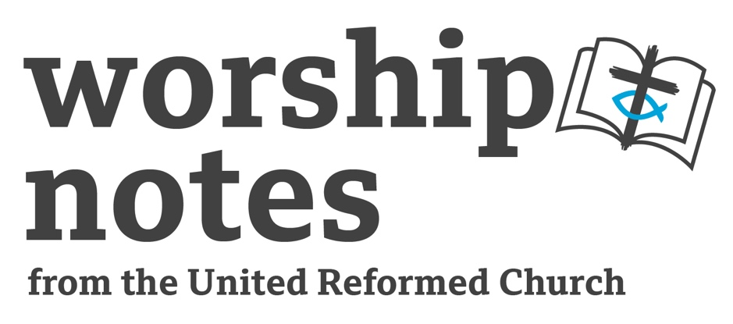
Sunday 22nd October 2023
Proper 24 | Ordinary 29
The Rev’d Fiona Bennett

Call to Worship

The Holy One is here amongst us;
Source of all being, Guide of all hope, Spirit of all inspiration
Holy One we worship and adore you
and raise our voices in praise.

Opening Prayer

God our Creator, Source of all being,
We celebrate this Life you have made,
in all its wonder and interdependence, and we praise you.

Guide of all hope, we celebrate the Way you show us,
in Jesus - our Saviour and Exemplar, and we praise you.

Spirit of all inspiration, we celebrate the goodness you grow
and nurture in our lives and world, and we praise you.

Holy One, awed by your goodness we recognise our own smallness…
we acknowledge the times when our selfishness has damaged this earth.
We acknowledge the times when our prejudice or apathy has injured others.
We acknowledge the times when our fear, isolation or self-loathing
has injured ourselves.

With humility, grace and courage,
we turn to you knowing your faithfulness and love have no limits,
and ask you to transform our despair into new opportunity.
Help us to turn away from our destructiveness
and work with your Spirit to create new life.

We unite our prayers together in the Lord’s Prayer using the form or words
which are most worshipful for us…

All Age Activity

Family Resemblance

Often you can tell people belong to the same family because they look like each other. A similar nose, colour of hair… We call it a family resemblance. Can you think of any family members who resemble each other?

Christian believe we can celebrate that we are all part of God’s family. The resemblance which shows we are part of God’s family is not how we look but how we act, more specifically how we love and allow love to shape everything we do and say and think. Being loving is our family resemblance to God and shows we are part of God’s family.

Activity – showing the love.

Given everyone a sticker and colouring pen. Invite everyone to draw and colour in a heart on their sticker. (The hearts do not have to be the same but each should be recognisable as a heart shape.) Invite everyone to stick the sticker in a visible place on their clothing. Now look around – everyone you see is part of God’s family, and the family resemblance is love.

Readings

Exodus 33:12-23 | Matthew 22:15-22

Exodus

It is perhaps comforting for those of us who struggle with faith to know that even in the midst of an epic adventure of oceans parting, manna and quails, pillars of fire and cloud, the hero of faith Moses was still looking for reassurance. And perhaps even more comforting that God, who has done quite a lot of highly visible things in the adventure so far, and to whom the people have been less that respectful at times, still offers Moses the reassurance he needs. Yet is it reassurance, cloaked in the mystery of faith. God will pass by Moses but Moses will only be able to see God’s back. He will have to trust what he is seeing. Then in subsequent chapters God will provide Moses and the people with a new set of stone tablets; The Law and Rituals offer the people a way to know and remember God is with them, through faith. Moses is seeking reassurance that God is with them, and even though this request may appear almost insulting to the God who has done so much for the people, God responds to Moses need with grace. God’s grace is the ocean of undeserved love and mercy in which all life exists.

Matthew

The coin was a silver Roman denarius depicting the emperor's head and the inscription
‘Caesar Augustus’ and on the reverse ‘Divine Julius’. These both refer to Gaius Octavius, who became Caesar and whose name eventually change to Imperator Caesar Augustus. On 1 January 42 BC, the Roman Senate posthumously recognized Julius Caesar (Gaius’s adopted father) as a divinity of the Roman state (divus Iulius). Gaius was able to further his cause by emphasizing that he was divi filius, "Son of the Divine".
The coin reflects the Roman Empire not just as a political system but as a religious cult, which, from the Jewish perspective of monotheism, was blasphemous. Yet how could anyone function in that world at that time without participating in Roman society?
Can we function in our world today without participating in systems which idolise financial gain above all else and which harmfully exploit people and the planet? If the image of Caesar implies the coin is his, where do we see the image of God to imply what is God’s? Is there a pointing toward Gen 1:26 here?

Prayers of Intercession

Holy One you are the Source and Creator of all life
and you have made humanity in your image.
We are awed by the wonder and intricacy of the planet you have woven.
We rejoice in the beauty and interdependence you have wrought.
We pray for the places where your earth is scarred with global warming
and your carefully crafted species are becoming extinct.
We pray for your creatures who are abused or misused.
We seek to remember at all times that all that is, is yours.

Faithful One, help us to live out your love and hope,
that through our lives and by our prayers, your kingdom may come.

Holy One, you are Christ our crucified and resurrected Saviour.
You have shown us the truth of love and the way of faith.
We pray for all who feel trapped by prejudice and poverty
and for all who seek to build just systems in our world.
We pray for all who live with the challenges of mental and physical ill health
and for all who care for them professionally and personally.
We seek to remember that every life is yours and beloved.

Loving One, help us to live out your love and hope,
that through our lives and by our prayers, your kingdom may come.

Holy One, you are the Spirit of transformation and new life.
You are the breathe of life in each body, mind and heart.
We pray for all who hold leadership in faith communities, government, institutions, businesses, across the world.

We pray for teachers and nurses, artists and inventors, managers and carers.
May all who shape our lives and world be guided by your love and justice.

Gracious One, help us to live out your love and hope,
That through our lives and by our prayers, your kingdom may come. Amen.

Offering & Dedication

Gracious God,
all the we are and all that we have are gifts of love from yourself.
We offer ourselves, our lives and our resources to you,
praying that you would take and use us for the building of your Realm on earth.
In the name of Jesus’ we pray. Amen.

Blessing

May the blessing of God,
Creator, Christ and Comforter,
be with you this day and always. Amen

Hymn Suggestions
 | RS | CH4 | StF | MP
All people that on earth do dwell | 712 | 63 | 1 | 20
or Sing All Creation, Sing to God in gladness |  | 64
or Jubilate Everybody | 713 | 65 |  | 394
Spirit of Truth and Grace |  | 608
There’s a spirit in the air | 329 | 616 | 398
Gather us in |  | 623
Jesu Jesu fill us with your love | 648 |  | 249
Be thou my vision | 489 | 465 | 545 | 51
At the name of Jesus | 261 | 458 | 317 | 41
Christ is the World’s True Light (best to Nun Danket) | 601 | 456 | 346
Christ of God unseen the image |  | 453

RS – Rejoice and Sing | CH4 – Church Hymnary 4 | StF – Singing the Faith | MP – Mission Praise

Fiona also suggests We are One in the Spirit which despite its popularity in the 1970s and 80s is quite hard to find in hymnbooks now. You can find a scan of it here where, if you click the link to p398 on the scan you can see the words have been inclusified to “and we’ll guard each one’s dignity and save each one’s pride”

