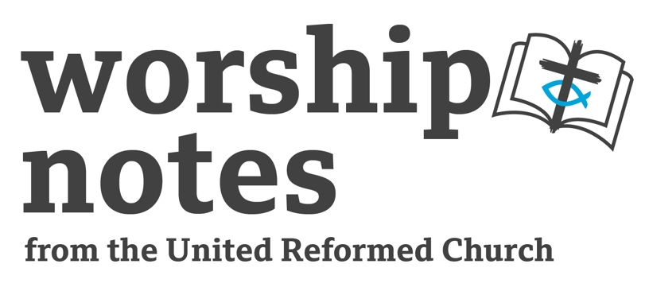
Sunday 1st October 2023
Proper 21 | Ordinary 26
The Rev’d Nicola Furley-Smith

Call to Worship

The Psalmist says:
Teach me your ways and make them known to me.
Teach me to live according to your truth – teach it to me -
because you are my God who saves me.
I put my hope in you all day long.
Remember, your kindness and constant love –
They are forever!.
Forgive the errors of my foolish and childish ways.
Remember me only according to your faithful love
for the sake of your goodness, Lord.
based on Psalm 25vv.4-7

Prayer of Approach and Confession

O God who called the world into being,
who calls us to follow Christ;
close our minds to distractions around us,
open our ears to hear your call,
open our hearts to receive your love,
and open our eyes to the needs of our community.
Help us to find space in our worship
to hear your voice calling to us,
to feel your Spirit present with us
and to know your love's healing in our hearts.
In the name of Jesus. Amen.

For those times when we have blamed others’ actions:
Gracious God: forgive us.
For those times when we have acted from selfish ambition:
Gracious God: forgive us.
For those times when we have been conceited:
Gracious God: forgive us.
For those times when we have regarded ourselves as better than others:
Gracious God: forgive us.
For those times when we have looked only to our own interests:
Gracious God: forgive us.
In silence we remember those times when we have fallen short of the example that Jesus set for us.

Silence

Gracious God: forgive us.
It is God who is at work in you, your sins are forgiven.
Let the same mind be in us that was in Christ Jesus,
so that your love for all people may shine through our words and actions. Amen.

Prayer of Illumination

God, creator and giver of all wisdom,
we thank you for the gift of story in Scripture;
we thank you that Jesus challenged his listeners to think for themselves.
May we be challenged as your word is opened to us
to not only think about your word but apply it to our lives today. Amen.

Readings

Ezekiel 18: 1-4, 25- end | St Matthew 21: 23-32

An All Age Activity

Making Good Choices

Play ROCK, PAPER,SCISSORS
This is a simple game involving random choices. Ask for a volunteer(s) to play the game of rock, scissors, paper. They pair off and face their partners with their left palm open flat and their right hand made into a fist. As you give the signal 1, 2, 3, everyone acts together. On the 1 and 2 each person hits his palm with his first. On 3 he either keeps his hand as a fist (symbolising a rock), points out his index and middle fingers (scissors) or opens it flat (paper). Depending on the symbols his partner forms, a person wins, loses or ties.
The rules are as follows. Rock smashes scissors (scissors lose), scissors cut paper (paper loses), paper covers rock (rock loses). Start as a best of three competition and then the winners of each pair play each other.

We make lots of simple choices every day. Ask for examples of the kind of choices they made before they came to church: what clothes to wear, what TV programmes to watch, what to eat for breakfast, what music to listen, what to do when you get home.
Sometimes we have to make more important choices. Will I lie or tell the truth? Will I be hurtful or kind? How will I treat this person? What career will I pursue?

Make the point that some choices are small, others are much bigger and can shape the way we live for the rest of our lives. Sometimes we will need help to make those choices.

We may think that we are not very important, but God loves each one of us and wants the very best for our lives. In our call to worship this morning the Psalmist tells us that that if we trust in God, God will guide us to make the right choices.

Notes for a Sermon

Ezekiel tells of a difficult time in the story of God’s people.

- Ignoring all warnings from God through the words of the prophets of the past, they have strayed so far from living God’s way, and have now been captured by Babylon, the current ruling superpower. The prophet Ezekiel is among the first wave of those taken captive into Babylon. Here he speaks to those in exile with him.
- The exiles refuse to take responsibility for their situation. The proverb about sour grapes in verse 2 implies God is unfair for letting them be the ones to receive the consequences of their ancestors’ behaviour.
- Through Ezekiel, God challenges this perception, making clear that the contemporary people of God are being judged for their own choices.
- The people are free to change their minds, to ‘repent’, to change of direction, to get a ‘new heart and a new spirit’ and so live as God’s people once more.

When we turn to the New Testament, in a short space of time, Jesus has ridden into Jerusalem on a donkey, been hailed by the crowd as their new king sent by God, challenged the Temple operations that helped to support the work of the Temple, healed and prophesied. Now Jesus is questioned by the religious leaders about his right to behave in such a way.

- The religious leaders have authority and call into question Jesus’ behaviour because it is challenging that authority by calling into question the status quo they are maintaining.
- The parable of the two sons highlights the problem: people can rethink, weigh up their options, change their minds.
- But the religious leaders are immoveable. In their defence, their role is to safeguard the faith. Time after time throughout their history the people of God have turned away from God, whether deliberately or by drifting. Time after time they have suffered the consequences of this. The religious leaders are working hard to reshape and renew the faith, and to protect it.
- Jesus’ presents the kingdom of God as open to all but this challenges the religious leaders because they live in a context where ethnicity and religious affiliation have come to mean more than faith or obedience. What would it take to change their minds?
- Whatever happens the religious leaders will have to make a decision. They will have to come off the fence.

In Philippians, what matters for Paul is Jesus

- Paul’s focus is on how to live as Jesus did, how to be Christ-like.
- He is concerned not only with practical action, but with the mindset that motivates that action.
- The people of God are to have the mindset of Christ.
- We have the ability and the choice to change our minds – and the aim is to do so by choosing humility, love, compassion and obedience. To ‘work out your own salvation’ is to practise, to work at, these things.
- For us following Christ’s example, we are called to change our mindset to one of the same humble obedience.

Intercession

The Psalmist makes a life of faith sound easy: if we trust God, God will protect us and keep us from doing wrong; God shows us the way and we simply need to obey. Yet experience tells us that living out our faith is much more complicated than that: bad things do happen to good people; God's guidance is not always as clear as we need it to be.

Ezekiel also makes things sound simple: doing wrong brings death; turning away from doing wrong brings life. So why do bad things happen to good people and some have very difficult lives? Why do some 'bad' people seem to have easy lives? Maybe we should worry less about these questions and focus more on how we live our own lives and faith here and now.

Matthew calls us to simply repent: to recognise his authority and to allow the Holy Spirit to make us be more like Jesus each day - humble and faithful disciples.

Just and merciful God, the world needs this new heart and spirit that Ezekiel talks of.
The Church needs the attitude that Jesus had
so that we too can be faithful, humble and obedient.
Jesus lived as a humble human being to show us Your way
so that people may have life in all its fullness.
We pray for those in power, who have to make difficult decisions
which will affect the lives and well-being of many…teach us your way of love.
We pray for those who are the victims of warfare or poverty, who are
calling out to us for aid…teach us your way of love.
We pray for those we know who are ill or anxious or bereaved, who
need to be aware of our care for them…teach us your way of love.
We pray for those involved in the upbringing of children, who are
trying to show them right from wrong…teach us your way of love.
We pray for the church, as we face the challenge of Christian living
in a modern society and world…teach us your way of love. Amen.

Offertory Prayer

For gifts given unwillingly,
for service rendered grudgingly,
for lives offered reluctantly,
we ask for your blessing, O God:
to take, transform and use them for good,
adding them
to those gifts given willingly,
to the service offered freely,
and lives lived by love. Amen.

Blessing
Help us to follow your way;
to obey your teaching;
to trust in you.
Bless us now and always.

And the blessing of God Almighty
Father, Son and Holy Spirit
Be amongst us and remain with us
This day and for evermore. Amen.

Hymn Suggestions
 | RS | CH4 | StF | MP
At the name of Jesus | 261 | 458 | 317 | 41
Crown Him with many crowns | 262 | 459 | 347 | 109
Join all the glorious names | 280 | 460 |  | 392
May the mind of Christ our Saviour |  | 536 | 504 | 463
Lord You have come to the seashore |  | 532
We do not hope to ease our minds |  | 537 | 717
Christ’s is the world in which we move |  | 724 |  | 1163
Lord of life we come to you |  | 782 | 651
We cannot measure how you heal | 653 | 718 | 655
The Love of God come close | 107 |  | 654 | 940
Lord We Come to Ask your healing |  |  | 652
God When Human bonds are broken | 652 |  | 649

RS – Rejoice and Sing | CH4 – Church Hymnary 4 | StF – Singing the Faith | MP – Mission Praise

