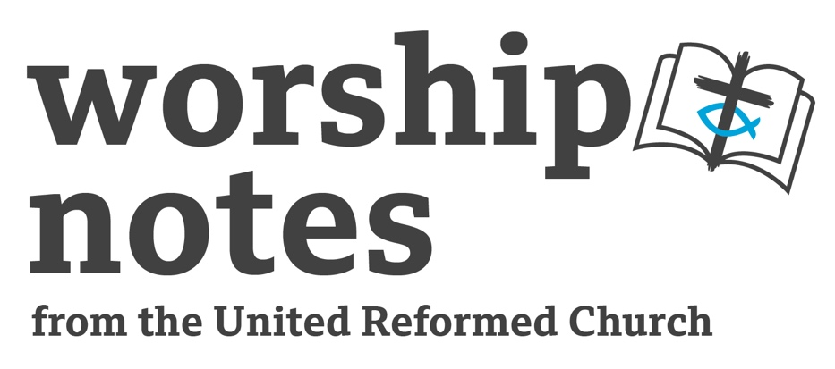
Sunday 10th
September 2023
Proper 18 | Ordinary 23
The Rev’d Martin Knight

Call to Worship

We gather
to be reminded of hope
to be built up in love
and to step out together, on the way of Jesus;
the path of the Kingdom.

(a Peace Candle may be lit)

We gather
as a community seeking peace:
peace in our homes,
our church
and our world.

Spirit of God, dwell richly with us we pray. Amen

Prayer of Praise, Confession and Assurance of Forgiveness

In gardens and bushland, mountains and oceans
We see the signs that God is with us.

In grass that grows through cities of concrete and brick,
We see the signs that God is with us.

In the faces of people whom God so loves,
We see the signs that God is with us.

Where the poor and abused are heard and raised,
We see the signs that God is with us.

In our brokenness, there is the hope of wholeness.
In our emptiness, there is the hope of fullness.

In our darkness, there is the hope of light
In our doubt, there is the gift of faith.

This is the Word of Christ for us!
The flame of the Holy Spirit lives in this place and calls us to follow Jesus.

Gracious and loving God,
we give thanks for your presence in our lives,
we praise your name and lift our voices to you!

Great God, in the silence we lament our brokenness,
not to weigh ourselves down with guilt
but to acknowledge our limits, to name them with you,
and to seek the mercy that leads to new life.

(Silence is kept)

And so, we use a confession from the Iona Abbey Worship Book,
in which I confess and then you confess:

Before God, with the people of God,
I confess to turning away from God
in the ways I wound my life, the lives of others and the life of the world.

May God forgive you, Christ renew you,
and the Spirit enable you to grow in love.

Amen

Before God, with the people of God,
I confess to turning away from God
in the ways I wound my life, the lives of others and the life of the world.

May God forgive you, Christ renew you,
and the Spirit enable you to grow in love.

Amen

(©2016, The Iona Community, Wild Goose Publications)

Jesus shows us God’s life and as we pray the prayer that he taught us,
the Spirit brings it to life in our hearts: Our Father…

Prayer of Illumination

As we prepare to hear God’s word, we sing or pray together:

Listen to the word that God has spoken;
listen to the One who is close at hand;
listen to the voice that began creation;
listen even if you don’t understand.

(Words and music: Canadian source unknown, © ‘We walk his way’, John L. Bell)

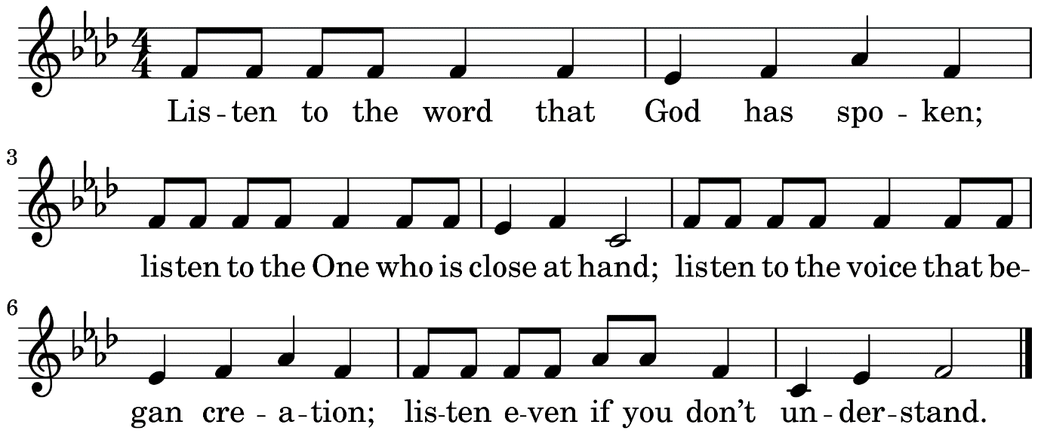

Readings

Exodus 12: 1-14 | Psalm 149 | Matthew 18: 15-20 | Romans 13: 8-14

All age Introduction

If you have an appropriate AV system and copyrighting in place, you might consider playing the theme to ‘Bob the builder’ – or sing it with the congregation. We can often fix physical things, like buildings, furniture, toys, arms or legs. (You might have an example of something physical that has been fixed – or show how it was done) Relationships are more tricky! God calls us to live together peacefully, so that we can work together to support others and to change the world, but we don’t always get along. Sometimes we need help to fix friendships, families, church relationships. Sometimes we need to let them go, because they are too painful – or they cause us to suffer. Sometimes what we are facing can impact how we treat others. Good relationships can bring us real joy. Being honest with each other can help us to understand each other. Good news! God is alongside us always, supporting and encouraging us as we live together.

This link to ‘Ministry to Children’ might also be helpful:

Sermon Notes

Exodus 12: 1-14

In the NRSV this section of ch.12 is labelled ‘The First Passover Instituted’. It is placed between the 9th and final plagues: darkness and the death of the Firstborn. In some ways this passage feels instructive. It tells the community what to do to avoid God’s plague of death. (There is plenty of scope for a reflection on if this brutality is how God shows Gods love) This passage is also instructive for following generations about how to mark the Passover; it is about memory and remembering. These are important acts for any society as they help us to connect to our past and to reshape and redefine our future. What important remembrances of our past, help us to reshape our future?

Psalm 149

There is unmitigated musical joy in this Psalm! It may also border on triumphalism – joy coupled with a call to violence against our enemies. This militaristic language is always challenging, but I sense in Psalm 149 its aim is to underline the sovereignty of God. To proclaim that God rules the world is to invite opposition from those who claim power for themselves. Who claims power for themselves in our contexts? What does it mean to assert God’s reign and the coming of God’s Kingdom? My mind is drawn to the Climate Crisis. Who is claiming power, who is abusing the earth, who is interested only in short-term profit? What does it mean to assert that God is the Lord of all creation? I was drawn to verse 1: ‘Sing a new song’ Because God rules the world, the faithful can sing a new song. What might that ‘new song’ sound like for our environment and the created world? Perhaps ask these questions for other local or global issues.

St Matthew 18: 15-20

This passage is easy to avoid or look over. None of us are keen on conflict and even less so the need to confront it in ourselves or others. There is certainly scope to judge the Matthean solution. I can see potential in the approach of going to the person who has sinned or hurt you. These encounters can give space to be heard and to listen, but…there is need to be careful: Who defines what constitutes a sin? We might go into the conversation too sure of our own righteousness! Would we really expect someone who has been abused to face their abuser? How does this fit with restorative justice? My trusty New Interpreter’s Bible suggests, I think quite rightly, that difficult conversations like those found in vs 15-16 should not be in the context of ‘self-righteous vindictiveness, but of radical caring for the marginal and straying, and of grace beyond all imagining’. In other words, these encounters should be rooted in love. If not, they will almost certainly do more harm than good. A key point for me is found in the vision of the church that is laid before us. Throughout this text, the church is the people of God – it is a community. To be Christian is to be bound in community. We might spend some time unpacking what it is like to live in community – both joy and demand.

Romans 13: 8-14

I love it when there is a clear connection between lectionary readings! Romans 13 connects us back to Matthew. The Church is the people of God and living in community is not easy – in any context. We might unpack some of the ways that this is true, in our age. What makes community a challenge? But also, what are the joys of community? The guidance given to the community in Rome (that is both the Christian Jews and Christian Gentiles), is to underpin church, community and relationships, with love. ‘Love your neighbour as yourself’ is a well-known phrase. I have been drawn to wonder how useful it is in an age when mental health issues and a society dominated by images of perfection, leave many unable to love themselves. If you can’t love yourself, then how can you love others? Equally, if we don’t care for ourselves, how can we care for others? Perhaps this passage asks us to consider both, how to love our neighbour and how to love ourselves? ‘Love does no wrong to a neighbour’ we are told. Perhaps love does no wrong to ourselves either? Love is revolutionary – particularly when it is so lacking. Love is our call.
What might revolutionary love look like in your church setting?

Affirmation of Faith

We believe, O Most High,
that you speak to us in song and silence, in word and witness, in worship and work.
Help us to discern Your voice.
We believe, O Lord Jesus,
that You call us to listen and follow, to turn around and change direction,
leaving behind all that drags us down.
Help us to discern Your voice.
We believe, O Holy Spirit,
that You speak to us as we discern and discuss together,
always calling us to love and justice.
Help us to discern Your voice.
We believe, O God, that You are always heard best in community.
Help us to discern Your voice.
Andy Braunston

Offertory
Gracious God,
may the money we offer
and the gifts you have given us to use for your service,
be a blessing to our community, in your name. Amen

Holy Communion

Introduction

Everyone who seeks to follow Jesus Christ is welcome at this table. This is a place where we gather and we model the community God would have us be.

The Peace

As we come to this meal, we seek peace for each other and for the world. The peace of the Lord be always with you. And also with you.

Invitation

Jesus was often a guest. He shared many meals with his friends, and they long remembered his words at the table. Though some disapproved of the company he kept,
Jesus ate and drank with all kinds of people and showed everyone the love of God. Wherever people met together Jesus was glad to be welcomed and to be fed. Today, we are the guests of Jesus. He welcomes us, whoever we are and whatever we bring, and he will feed us at his table. Old or young, rich or poor, joyful or in sorrow, Jesus invites us to share bread and wine with him, to remember the story of his life and death, and to celebrate his presence with us today. On the night before he died, Jesus shared a meal with his disciples in an upstairs room in Jerusalem. The Gospel writer tells us what happened that night.

The Story

While they were eating, he took a loaf of bread, and after blessing it he broke it, gave it to them, and said, ‘Take; this is my body’.

Then he took a cup, and after giving thanks he gave it to them, and all of them drank from it. He said to them, ‘This is my blood of the covenant, which is poured out for many. Truly, I tell you, I will never again drink the fruit of the vine until that day when I drink it new in the kingdom of God.’

We are the friends and disciples of Jesus today. He invites us to break bread together,
to remember him and to pray that God’s Kingdom will come – and so we pray as he did:

The Great Prayer

God is with us!
We give thanks and praise to God!

Loving God, the world you made is beautiful and full of wonder.
You made us, with all your creatures, and you love all that you have made.

You gave us the words of your prophets,
the stories of your people through the generations,
and the gathered wisdom of many years.

You gave us Jesus, your Son, to be born and to grow up
in difficult times when there was little peace.

He embraced people with your love and told stories to change us all.
He healed those in pain and brought to life those who had lost hope.
He made friends with anyone who would listen and loved even his enemies.

For these things, he suffered. For these things, he died.
And he was raised from death and lives with you forever.

You give us your Holy Spirit, to teach and to strengthen us,
to remind us of Jesus Christ, and to make us one in him.

For all these gifts we thank you, and we join with all your people
on earth and in heaven, in joyful praise:

Hosanna! Blessed is the one who comes in the name of the Lord!
Hosanna in the highest heaven!

We praise you that we are here today, around the table of Jesus. We have heard the good news of your love; the cross is the sign of your arms stretched out in love for us
and the empty tomb declares your love stronger than death.

Christ has died! Christ is risen! Christ will come again!

Send your Holy Spirit upon this bread and wine, and upon your people,
that Christ may be with us, and we may be made ready to live for you
and to do what you ask of us, today, and every day to come.

We make this prayer through Jesus Christ,
in the power of the Holy Spirit, in the love of the Creator,
One God, to whom be glory and praise forever, Amen.

The Sharing

Among friends, gathered round a table, Jesus took bread, broke it and said,
‘This is my body, broken for you.’

In the same way, he took the cup of wine and said, ‘This is the new relationship with God, Take this – all of you – to remember me.’

These are the gifts of God, For the people of God.

(Serve) Sharing the broken bread, we are renewed and made whole.

(Serve) The cup of blessing pours out to us.

based on Iona liturgies in ‘A Wee Worship Book’
Intercessions

Let us pray, giving thanks for this gift beyond words, reaching out to the world in love.

Loving God, you have fed us generously at this table as we have remembered Jesus and rejoiced that he is with us today. We are ready now to follow him, and to be your people in the world. May your Holy Spirit show us the way, make us holy and fill us with love.

Lord, in your mercy, hear our prayer.

We pray for the Church throughout the world, and for our own church community gathered today for worship and prayer. May we follow Jesus every day, grow in understanding of him, and learn to love you and our neighbours. Fill us with your Spirit, and make us a community of peace, of faithful prayer and loving action.

Lord, in your mercy, hear our prayer.

We pray for the whole world; for the people, the animals, the earth, the sea and the air.
May all that you have made be sustained in peace and harmony, and may all your creatures share in the goodness of creation. Bring healing to all who are suffering, and may all your people share in hope

Lord, in your mercy, hear our prayer.

We pray for ourselves, for our families and our friends,
for all those we love and for those we find it hard to love.
May young and old respect one another, and the generations honour one another.
May nothing divide us or come between us, but let your love bind us in affection.
Bless us with your peace, that together we may praise you forever.

Lord, in your mercy, hear our prayer.

Glory to God. Glory in the highest. Today and always Amen.

Blessing

Having gathered for worship
we go, strengthened to live our faith as Church in the world
and to dwell with each other in community,
and the blessing of God
Creator, Son and Spirit,
goes with us. Amen

Hymn Suggestions
 | RS | CH4 | StF | MP
Come, ye faithful, raise the strain | 236 | 414 |  | 103
Guide me, O thou great Jehovah | 345 | 167 | 465 | 201
Lord, enthroned in heavenly splendour |  |  | 593 | 431
All people that on earth do dwell | 712 | 63 | 1 | 20
New songs of celebration render | 709
Praise the Lord, his glories show | 102 | 152 | 84
Ye servants of God | 293 | 130 | 340 | 784
Sing of the Lord’s Goodness |  | 157 | 65
As we are gathered | 469 | 197 |  | 38
Brother, sister, let me serve you | 474 | 694 | 611 | 1261
God is here, as we his people |  |  | 25 | 1193
Jesu tawa pano |  | 773 | 27
Jesus calls us here to meet him |  | 510 | 28
Love divine, all loves excelling | 663 | 519 | 503 | 449
One human family God has made |  |  | 687
A new commandment | 745 |  | 242 | 1
Dear Lord and Father of mankind | 492 | 485 | 495 | 111
Let love be real |  |  | 615
Thanks for friends who keep on loving |  |  | 619
Let us break bread together on our knees | 452 |  | 592 | 414
The Love of God comes close | 107 |  | 654 | 940
RS – Rejoice & Sing | CH4 – Church Hymnary 4 | StF – Singing the Faith | MP – Mission Praise

