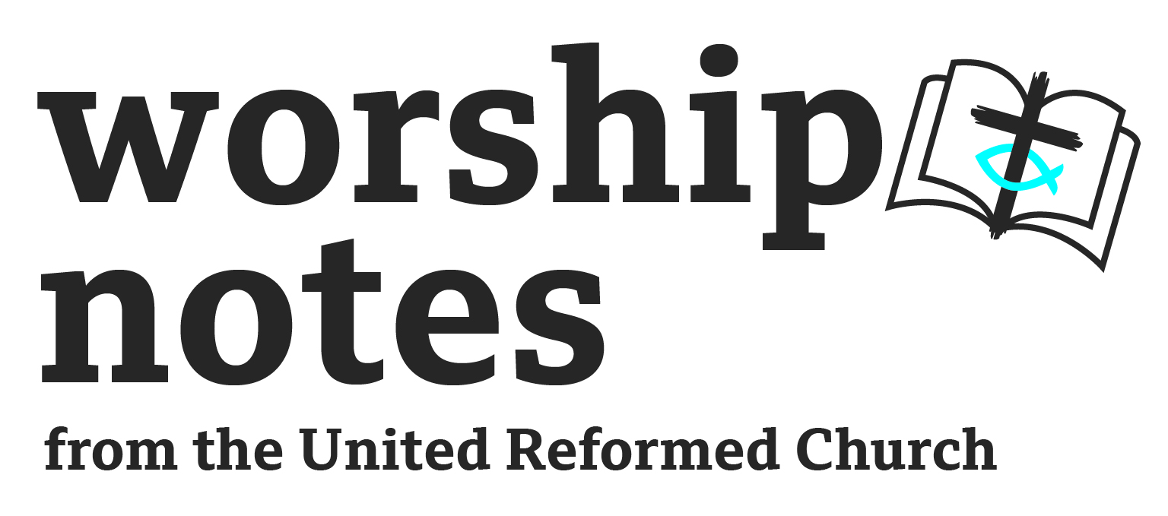
Sunday 27th August
Proper 16 / Ordinary 21
The Revd Paul Robinson

Call to Worship

Let us worship God as hear these words from Psalm 86: Teach me your way, LORD, that I may rely on your faithfulness; give me an undivided heart, that I may fear your name. I will praise you, Lord my God, with all my heart; I will glorify your name forever.

Prayers of Approach, Confession and Forgiveness

Almighty God, we come to worship in your name,
creator of the universe, source of true humanity,
and a loving parent to us all. Eternal God, be present.

We come to worship in the name of Jesus, the Word made flesh,
Saviour of sinful humanity, and Lord of all. Eternal Lord, embrace us.

We come to worship in the name of the Holy Spirit,
the Lord and giver of life, source of new humanity, and inspirer of us all.
Eternal Spirit, renew us.

Holy Lord, we confess that we have broken your commandments;
we have sinned by our selfishness,
our unbelief and our pride;
we have not acted justly, loved mercy nor walked humbly with you.
In your mercy blot out our misdeeds, and wash away our sin.
Create in us a clean heart, and help us to forgive others
as you have forgiven us; through Jesus. Christ our Lord.

May God have mercy upon us, pardon and deliver us from our sins,
confirm and strengthen us in all goodness, and keep us in life eternal;
through Jesus Christ our Lord. Amen

Prayer of Illumination

We pray using words taken from Psalm 19

The law of the LORD is perfect, refreshing the soul.
The precepts of the LORD are right, giving joy to the heart.
The decrees of the LORD are firm, and all of the righteous.
They are more precious than gold, than much pure gold;
they are sweeter than honey, than honey from the honeycomb.
May the words of my mouth and the meditation of our heart,
Be pleasing in your sight, Lord, my Rock and my Redeemer. Amen

Reading

Matthew 16:13-20

All-Age Activity

I would focus on the ‘Who do you say I am?’ In Matthew 16:15… One activity would be to show photographs of famous people - who are these people…Perhaps include some slightly obscure people, that perhaps only a few people might know, or there could be some debate about - like a ‘guess who’ round of a quiz…. You could also ask what they are famous for… Jesus asks ‘who do people say I am?’ A little confusion - looks a bit like John the Baptist, Elijah or a prophet… But Peter knows the answer… v.16… If Jesus were to ask you - who do you say I am? What might you say? Something similar?

Notes to help with sermon preparation

The first thing to note is that this week the lectionary readings include several well-known and rich readings. The first task might be to work out what you may have to leave behind. I chose to focus on the reading from Matthew’s gospel. Even that reading contains plenty of potential preaching themes - Simon’s identification of Jesus as the Messiah and the Son of the living God. There’s the opportunity to reflect deeply on the question, ‘But who do you say I am?’ - either an evangelistic call, but also a search in all our hearts - perhaps from a point of view of knowledge, of thought, or of action - Who do you say Jesus is?

I was led and chose to speak on the next few verses and the nature of church that lies behind verses in which Simon receives the name Peter. It struck me as significant that this conversation took place in Caesarea Phillippi - a good commentary will explain the context of that place at the time and how relevant the images of the ‘Gates of Hades’ and the ‘Keys to the Kingdom’ are.

Here are the notes I developed…

Introduction…

When you hear the word “Church” what comes to mind?
- a local church - people, hymns, sermons, prayers, cups of tea?
- An institution - meetings, programmes, assemblies, policies and employers
- A world-wide organisation - partners, relationships, diversity of theology and cultures
- A missionary movement - action, justice, projects

How do you feel about the ‘church’?

- excitement at what lies ahead?
- Tired and fed up?
- Hopeful and expectant?
- Let down? Angry? Hurt?
- Perhaps like many in society - ambivalent

Key question: What is God’s vision for the church?

In Matthew 16 Jesus uses the word ‘church’ - he doesn’t do that very often. In fact not mentioned much in the New Testament. Greek word (Ekklesia) is a translation of a Hebrew that is used often in OT for the gathering and assembly of the people….

Take a close look at v.17-19…

(1) The Building Blocks of Church

Jesus statement about the Church comes about following a significant moment for Simon.
Caesarea Philippi - a place full of different altars for different religions.
Who do people say I am? - Disciples respond with a Hebrew/Jewish though - Elijah, prophets, John the Baptist… but who do you say I am asks Jesus. Simon confesses that Jesus is Messiah and the Son of the living - the promised Saviour and the Son of the Living God.

Jesus recognises that this news has come to Peter by his heavenly Father, and gives him a new identity - Simon becomes Peter - he is transformed and changed v.18…
The word Peter means Rock - a phrase debated often by different Christian traditions across the ages. For me the confession and transformation seem crucial – it’s this that leads to this moment. It has more to do with what Jesus is doing in Peter than it has to do with Simon Peter himself. Jesus builds his church using people who recognise him, trust him and are changed by him.

That’s significant today - the building block of the church are individuals being changed by Christ The foundational building block: is not a single charismatic individual, not a culture, not an institution, nor is about anything any one of us may have - money, time and energy, or anything any one of us might ‘like’ : hymns, choices, and preferences…

But EVERY LIFE that Jesus transforms as people recognise Jesus as Saviour and the Son of the Living God.

(2) The Security of Church

Next we hear something about the security of the church - v.18… Caesarea Philippi based on Mount Hermon. A religiously significant sight. In the OT it was a place of Baal worship - particularly fertility god; in the Greek empire it became a place of worship of Pan; and in the Roman Empire (when it got its name Caesarea Philippi) it became a place of worship of the Roman Emperor. It’s a melting pot of religious cultures. The focus of which was a cave at the bottom of Mount Hermon - every spring water would flow out of the cave - seemed like he entrance to the underworld - when water flooded out - the gods of the underworld unleashed their demands and evil deeds upon the town - prostitution and goats (?!?!) - Caesarea Philippi known as a place where the Gates of Hades opened and invaded. That’s the context for ‘the gate of Hades will not overcome it’. Why is that? - because the church is Jesus’ - I will build MY church. On the cross Jesus defeated sin and death - so anything evil, anything sinful and bringing death need not have any hold on the church.

I used the analogy of building a sandcastle on the beach - often we can think of the church as being glorious, but being washed away… these verses tell us its a bit more like a wooden beacon at the end of a groin on the beach - standing tall whatever the weather!

(3) The purpose of Church

What is this foundation for? So we can feel smug and lord it over others? NO
But for a beautiful and wonderful task - v.19…
This is the verse from which people get all those images of Peter standing at some pearly gates in charge of who gets into heaven.
But… if the rock is not Peter, but lives transformed by Christ; and our security is in Christ (not in whether Peter ‘lets us in’)… then this verse is for the collective group of people called church - we have been given the keys of the Kingdom of heaven!
In contrast to the Gates of Hades unleashed all the pain and abuse in Caesarea Philippi;
The church is to unleash all the goodness of God in communities and towns.

Invite communities to experience the goodness of God and the justice, joy, peace and grace he can bring. Unleash the opportunities for spiritual restoration- salvation, hope, joy and peace. Transformed live and communities - that in turn become the building blocks for the church!

What would it look like if all the goodness of Jesus’ Kingdom was unleashed in your context? We have the keys of the Kingdom of Heaven - often it feels like the church uses the keys to keep all the goodness of God locked up - out of fear…. Challenge - to unleash the Kingdom of heaven…

Conclusion…
Daunting task of being church in the 21st century…
Church is Jesus through and through - Jesus changing lives, Jesus security, Jesus Kingdom

What was declared in words to Peter was so clearly shown and demonstrated upon the cross..
Jesus - the promised Messiah and Son of the living God
Jesus - with the grace and mercy to change our lives
Jesus - the victor over sin and death
Jesus - a beautiful kingdom of love and power.

Invitation…

To be the Church.
Confess Jesus as Saviour and Son of living God
Be confident in Jesus’ hope for the church
Unleash the Kingdom of heaven - uses the keys to unlock the goodness of God for the world.

Affirmation of Faith

We believe in God, the Father Almighty, Creator and ruler of all things.

We believe in Jesus Christ, His only-begotten Son, Our Lord and Saviour.
Through his life, his death on the cross and his resurrection,
He conquered sin and death, forgiving our sins and reconciling us to God.

We believe in the Holy Spirit.
Through him Christ dwells in the believers, sanctifying them in the truth.

We believe in the Church,
the body of Christ and the fellowship of the saints.

We believe, in the Holy Scriptures
and in the Ministry of the Word and Sacraments.

We believe in the coming of the kingdom of God,
and in the blessed hope of life eternal through our Lord Jesus Christ.

We believe that the chief end of humanity
is to glorify God and to enjoy Him forever. Amen.

from the Presbyterian Church of Wales

Prayers of Intercession

Let us pray.

We pray, Lord, for the peace that is from above, and for the salvation of all:
Lord, hear our prayer.

We pray for the peace of the whole world.
For the welfare of God’s holy Church, and for the unity of all: Lord, hear our prayer.

We pray for all who share in the work of the Church,
that they may fulfil their ministry with a pure heart and good conscience,
and faithfully make known the Gospel of Christ
through witness and service: Lord, hear our prayer.

We pray for our rulers in local and national governments,
that they may week and receive your guidance,
that they be true to that which is right and just,
and seek always to promote the well-being of all: Lord, hear our prayer.

We pray for the wick and suffering, and those close to death;
the bereaved, the lonely and the sorrowful.
We pray for those we know. Lord, hear our prayer.

We pray for the poor and the needy, the hungry and the homeless,
for those who suffer in situations of war and conflict,
for refugees and asylum seekers, for those who suffer persecution,
and for all prisoners of conscience: Lord hear our prayer.
In fellowship with all God’s people, in heaven and on earth,
we commend ourselves and one another
and all our life to Christ our Lord: Lord, hear our prayer. Amen.

Offertory Prayer

We thank-you and praise you Lord
for the way in which you have blessed us,
and our experience of your faithfulness towards us.
We bring you now our gifts - those including time, energy, and money -
and ask that you would use us and what we have for the building of your Kingdom. Amen.

Blessing

Now may the blessing of Almighty God,
Father, Son and Holy Spirit,
Creator, Redeemer and Sustainer,
Be with us this day and for evermore.
Amen

Hymn Suggestions
 | RS | CH4 | StF | MP
As we are gathered | 469 | 197 |  | 38
Great is thy faithfulness | 96 | 153 | 51 | 200
Jesus Christ I think upon your sacrifice |  |  | 274 | 995
Lord of the Church |  |  |  | 442
Glorious things of thee are spoken | 560 | 738 | 748 | 173
The Kingdom of God is justice and joy | 200 |  | 255 | 651
Go forth and tell | 574 |  |  | 178
The Church’s one foundation | 566 | 739 | 690 | 640
Holy Spirit, living breath of God | 485 |  |  | 1183
Almighty Father of all things that be |  | 497
We are your people |  |  |  | 741

RS – Rejoice and Sing | CH4 – Church Hymnary 4 | StF – Singing the Faith | MP – Mission Praise

