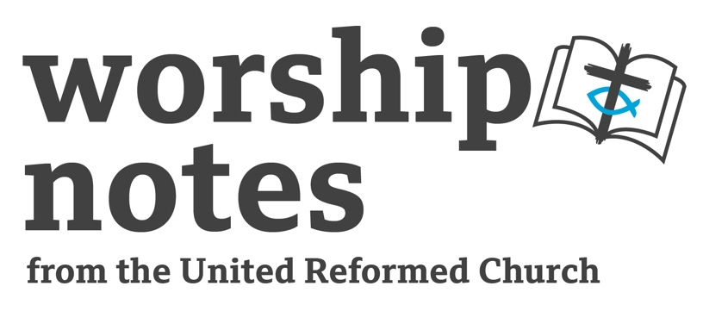

Sunday 23rd July 2023
Ordinary 16 | Proper 11
The Rev’d Lance Stone

Call to Worship

Where can I go from your spirit?
Or where can I flee from your presence?

If I ascend to heaven, you are there;
if I make my bed in Sheol, you are there.
If I take the wings of the morning
and settle at the farthest limits of the sea,
even there your hand shall lead me,
and your right hand shall hold me fast.

Psalm 139: 7-10
Opening Prayer

Blessed and loving God,
God of Abraham, God of Isaac, God of Jacob,
God of Rebecca and Rachel and Mary – and Jesus,
we worship and praise you – faithful, trustworthy God.
We praise you for your commitment to the world you love;
we praise you for your promises
to bring salvation and healing to your world;
We praise you that in Jesus Christ heaven and earth
are connected and bound together,
open to each other and united in your love.

Confession and Pardon

O God, we need you to open up a way between
heaven and earth, for our world lies separated from you,
turned in upon itself, resistant to you.
And we confess that we are turned in ourselves,
and we turn away from you and from our neighbour
and from your call.
O God come to us in your forgiving love;
open our lives to you and your Holy Spirit
and make us your dwelling place.
We pray in Jesus’ name and we pray in the words
Jesus taught us, saying together… Amen.

All Age Activity

Tell the congregation that this morning we are thinking about a dream that someone in the Bible had. Ask the congregation if they remember their dreams or not. Anyone recall a particularly memorable dream? What do people think are the 10 most common dreams that people have? According to Google, here are the 10 most common dreams that people have:
- Teeth falling out.
        - Being chased.
        - Unable to find a toilet.
        - Being naked.
        - Failing exams.
        - Flying.
        - Falling.
        - Crashing a car.
Point out that most of those things would be bad dreams. Being chased… being unable to find a toilet… falling… these are scary experiences!Perhaps the reason we have such dreams is because we are feeling worried or afraid, and so we dream of scary things.

The dream we are considering today was one that dreamt by someone who was worried and afraid. He was a man called Jacob and earlier in the story he had cheated his brother Esau, and Esau had vowed to kill him and so Jacob had run away. He was scared that Jacob would catch up with him and harm him for what he had done. So you might think that he would have had a bad dream. But he has a very beautiful dream of a ladder going up to heaven with angels going up and downand that God was right beside him. And God makes a promise to him that he will be greatly blessed in years to come. And when he awoke he had a geat sense of being at the very gate if heaven – of God being very close to him,right there in that place.

What Jacob was learning was that sometimes it’s when we are most worried and afraid that we find God is closest, and that the scariest places can be the very gate of heaven.

Prayer for Illumination

Living God,
open up earth to heaven and heaven to earth,
and speak your Word to our hearts and lives.
We pray in the name of Jesus, the Living Word. Amen.

Reading Genesis 28: 10-19a

Sermon Notes

Theme: Surely God was in this place and I knew it not.

Sermon structure:

- Brief recap of Jacob’s situation: he is a cheat who has has deceived his father and his brother and who is now a fugitive, fleeing his brother who has vowed vengeance. So the phrase ‘He came to a certain place and stayed there for the night, because the sun had set’ (v.10) expresses not not just this man’s surroundings but also the state of his soul: he is in a dark place. But then comes the dream… dreams are outwith our control, they arise from the depths, and since Jacob is a calculator, a controller and manipulator of events maybe this is the only way God can reach him: when he is passive and God is able to penetrate his defences.

- The content of the dream: the ladder, angels ascendingand descending, the realisation, ‘surely God was in this place and I knew it not’.

- Three ways this story might address us:
- It points to Jesus. Jesus is ‘the ladder’between earth and heaven and he referred to this story to speak of himself – see John 1:51. Note v.13, which says the ‘the Lord stood beside him’ – seems to suggest the Lord stood beside him at the foot o f th leader.Howver Hebrew is fluid and this can also mean ‘the Lord stood above him.’ Which is it? In Christ God is both – alongside and above, one with us and yet sovereign over us and our world, in the heights and the depths. And who would have thought that God would be present in a Galillean peasant crucified as an agitator and blasphemer? Yet, with Jacob, we conclude: ‘Surely God was in this place and I knew it not’.

- It points to the Church, as Bethel here becomes a holy place. Our call to worship from Psalm 139 reminds us that God is present everywhere and yet, as Jacob discovered, there are ‘thin places’ set apart where heaven is open to earth and earth to heaven and where the Holy Spirit descends and ascends. There is an old English word, ‘trysting’ which means ‘meeting’, and ‘trysting places’ are special places where lovers meet. The Church is such a trysting place, a meeting place of earth and heaven: ‘where two or three are gathered in my name…’. A sinful world is one turned in upon itself, closed down, and we need these trysting places where earth is torn open,letting in the fresh air of heaven.

- It speaks to us individually. Jacob is in a dark place, haunted by guilt, ensnared by his own devious nature. We could think of the many dark, twilight places where we find ourselves. Yet here Jacob finds God and the promise, ‘Know that I am with you and will keep you wherever you go… I will not leave you until I have done what I promised you.’ And to his surprise Jacob finds himself uttering words of astonishment: ‘Surely, the Lord is in this place – and I did not know it.’ This is the testimony of many Christians, as dark places become Bethels.

Prayers of Intercession

Holy God,
to whom earth is open,
and who has come amongst us in Jesus Christ:
come, we pray, and transform every dark place,
bathing it in your presence
so that it may become Bethel, the house of God,
the gate of heaven.

Lord, in your mercy,
Hear our prayer.

O living God of Bethel,
we pray for prisons,
that they may be places where people
find strength to change and to lead new lives.
and we pray for prison staff and for those imprisoned,
whether justly or unjustly.
We pray especially for those condemned to death:
that even in this dark place heaven and earth may mingle
and you rpresence might be known above and beside them.

Lord, in your mercy,
Hear our prayer.

O living God of Bethel,
we pray for hospitals,
thanking you for the advances
in medicine and technology,
and praying that resources might be found
to share the fruits of research,
such that there is an end to preventable diseases in places
where life continues to be unnecessarily lost.
And we pray for nurses and doctors and all auxiliary staff,
that they may work together to make hospitals places
of healing and of hope.

Lord, in your mercy,
Hear our prayer.

And living God of Bethel,
we pray for those today who are in dark places
of fear and anxiety;
for those who are struggling with relationships,
for those who are suffering with sickness and disease,
mental or physical,
and those who are feeling the effects of age.
May they know that you are indeed with us
and so may they find strength and peace.

Lord, in your mercy,
Hear our prayer.

And we pray all these things in Jesus’ name. Amen.

Offertory Prayer

All praise to you, loving God,
for all good gifts that enrich our lives
Take us and all that you have given us
and use us in the service of your Kingdom.
Amen

Blessing

May God be above you,
and God beside you,
and heaven all around you
as you journey on;
and may the gace of our Lord Jesus Christ,
and the love of God,
and the fellowship of the Hoily spirit,
be with you all, today and always. Amen

Suggested Hymns
 | RS | CH4 | StF | MP
The God of Abraham praise | 121 | 162 | 91 | 645
O God of Bethel! By whose hand | 71 | 268 | 475 | 907
Blessed assurance, Jesus is mine |  | 561 | 548 | 59
I want Jesus to walk with me |  | 539
You are before me, God, you are behind (Psalm 139) | 731 | 96
I heard the voice of Jesus say | 349 | 540 | 248 | 275

RS – Rejoice & Sing | CH4 – Church Hymnary 4 | StF – Singing the Faith | MP – Mission Praise

