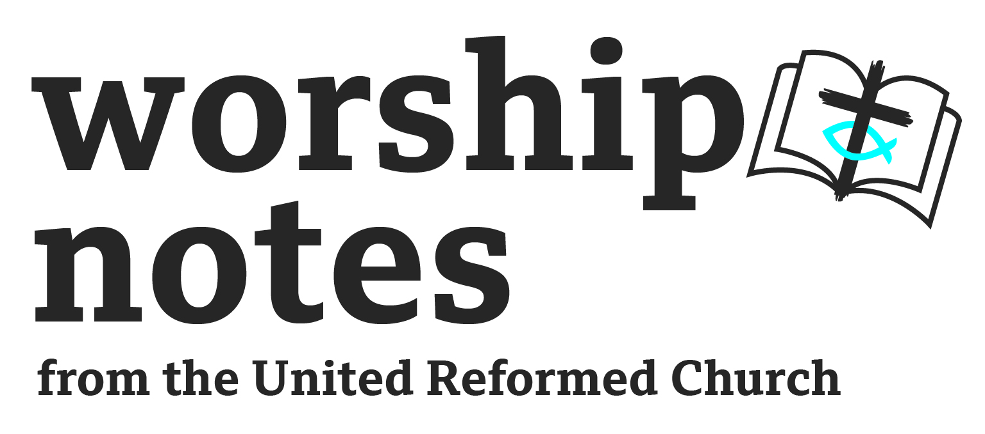

Christmas Eve
Midnight Communion Service
The Rev’d Andy Braunston

Call To Worship

One: Come and hear the news the angels bring!

Many: News of great joy and mirth!

One: Come, leave your sadness and listen to the angels’ news

Many: News of great joy and mirth!

One: Come, out of darkness & into light & listen to the angels’ news:

Many: News of great joy and mirth!

One: Come and worship!

Prayers of Approach, Confession and Forgiveness

In the darkness of this night, Eternal One, You bathe us in light.
In the shadows of these long days, O Most High, Your light shines on us.
In the midst of gloom and despair, O Emmanuel, You increase our joy.

O God, You free us from all that oppresses and drags us down,
but we prefer the darkness of sin, to the light of love.

You send us the Prince of Peace,
but we prefer wars and rumours of war.

You send us a Wonderful Counsellor,
but we prefer listening to whispering shadows.

Forgive us, good God, and give us time to change, time to turn towards You,
time to work for justice, and time to heal. Amen.

Hear the words of the angels:

Do not be afraid; for see - I am bringing you good news of great joy for all the people:
to you is born this day in the city of David a Saviour, who is the Messiah, the Lord.

Accept the salvation offered to you, live in freedom and work for change. Amen.

Prayer for Illumination

Lighten our darkness, we beseech You, O God;
and by Your great mercy,
break open Your word to us as it is read, proclaimed, and understood,
for the love of Your only Son, our Saviour, Jesus Christ, Amen.

Readings

Isaiah 9:2-7 | St Luke 2:1-14

Sermon Notes

To worship during the night at Christmas is special and wonderful; it’s more special and wonderful if the worship, whilst still dignified and joyful, doesn’t go on too long! I remember attending a Midnight Mass at an Anglican Church in London many years ago which didn’t start until midnight and the, no doubt glorious, liturgy dragged on. I slipped away at 1.30 but they were still going strong. Christmas services may get visitors – resist the temptation to preach everything you think they need to hear! Instead, focus on leaving them wanting a little more but feeling content with the menu you offer. Above all, if this is a midnight service don’t preach for very long!

These are difficult times really. We live in an age of economic and political instability where wars and rumours of wars abound. Inflation attacks our savings; wages, pensions and benefits aren’t increasing enough to keep up and, whilst the fuel crisis has been delayed, it is still a real threat. Mr Putin has broken about every law going and Ukraine aches under the burden of invasion, war and terror. The poor and downtrodden flee war, persecution and violence yet rich countries close their borders. Our readings also reflect dark times – appropriate for worship in the dark closest to the longest night.

Isaiah

Isaiah’s prophecy comes at a time when the northern kingdom of Israel was being ground down by Assyria, where invasion, battle, and terror were every day events where, like Ukraine now, the nation was threatened with extinction. In the midst of the gloom of the age the prophet points to hope - a great light will dawn on a nation that’s lived in darkness, joy will be increased – joy great than when soldiers divide plunder. Oppression will be lifted, uniforms will be burned and the nation was to find peace in a new born baby – a baby who would be wise, have the authority of the Most High and who would be a prince of peace. Isaiah’s words were grounded in the political and economic realities of his time.

St Luke

The famous passage from St Luke telling of the angels appearing to poor shepherds out on the hills is also grounded in the realities of the time. The Roman overlords wanted everyone counted – why? Almost certainly to know who to tax. Not only did the Romans rule Israel but they wanted the Jews to pay for the invasion and occupation through harsh taxes. Luke grounds his story in the reign of the Emperor Augustus and during the governorship of Quirinius. We read this story every year and give these details little thought – but Luke makes it clear that Jesus was born in a nation under occupation and brutal military rule. No thought given to how poor people could comply with the census; Mary struggled to find somewhere to give birth with dignity and safety. The first people told of this great event weren’t the rich and powerful but poor, outcast shepherds. Jesus was born in the night during the darkness of an occupied, downtrodden, poor country where world politics and imperial intrigue were played out.

Drawing the threads together

In the darkness of invasion, war, and a precarious national existence, Isaiah offered hope in the birth of a child who would bathe the people in light, deliver them from oppression, and bring peace.

In the darkness of occupation, poverty, and national obliteration Luke has angels come to sing of Christ’s birth – good news to the poor and the outsiders, good news for those on the edge. Good news for us too.

In our dark times God gives us hope.

- Hope that evil and warfare won’t have the last word.
- Hope that the prince of peace will inspire us to change our ways.
- Hope that perpetrators of war crimes will face justice.
- Hope that the poor won’t always be with us.
- Hope that fairer policies and politics, economics and ethics will come.

The baby whose birth we mark on this night both fulfilled and disappointed the dreams of his people. In Him, God came to share our humanity, our pain, our suffering and, through his death and resurrection, transformed our lives forever. Yet, the people longed for political liberation, for the overthrow of the Roman empire and restoration – just as God had restored Israel of old. Jesus was, of course, a revolutionary and, in the long run, the radical love that he taught and which Christians espoused fatally undermined slavery - the economic basis of the Empire. He wasn’t, however, the political freedom fighter that people thought they needed.

We long for change now, not through revolution but through Jesus’ same radical love being used to change our world. Jesus’ wisdom helps undermine the empires of our day: the economic Leviathans which privilege the rich and powerful; the ethical systems which say truth is relative, and the social powers which divide us in order to rule.

Instead:

- that wonderful counsellor calls us to see the world as it really is.
- that Prince of Peace calls us to love our enemies with a radical, truth telling, assertive love which calls out crime and oppression.
- that child whom Isaiah named as everlasting Father, calls us to recognise our interconnectedness and mutual responsibilities as people related to each other in the human family.

In these dark times we are given light; light to see the way, light to challenge what goes on in the dark, and light to bring life to others.

Intercessions

In the darkness of this night, O God, we come to your light, bringing the gloom of our world before you.

We remember before you

those who worship in secret this night, for fear of the authorities…
those who sleep on the streets this night….
those who work this night…
those who are in pain this night…

that the hope you bring will permeate their lives.

We remember before you

those who lead, or aspire to lead, our nations…
those who worry about paying their bills this winter…
those living in war torn lands…
those looking for light in the dark…

that the hope you bring will permeate their lives.

We remember before you, in silence, those we know in any kind of need…

that the hope you bring will permeate their lives.

We join our prayers together as we pray, with Jesus… Our Father

Holy Communion

Jesus, we praise You and give You thanks,
because you emptied Yourself of power,
and became foolishness for our sake;
for we celebrate the night when
You were delivered as one of us, a baby needy and naked,
wrapped in a woman's blood, born into poverty and exile,
to proclaim good news to the poor, and to let the broken victims go free.

We remember the night when, gathered with your friends
You took bread and having blessed it, broke it and said:

"Take this all of you and eat it, for this is my body which will be broken for you, do this in memory of me"

In the same way when the Supper was finished,
you took the cup filled with wine, blessed it and said:

"Take this all of you and drink from it, for this is the cup of my blood,
the blood of the new and everlasting covenant, which will be shed for you. Do this in memory of me."

Let us proclaim the mystery of our faith......

Christ has died! Christ is Risen! Christ will come again!

Come now dearest Spirit of our God,
embrace us with Your comfortable power,
brood over these bodily things and make us one body in Christ,
as we eat this bread and wine, His body and blood.
As Mary's body was broken for him, and her blood shed,
so may we show forth His brokenness for the life of the world
and may creation be made whole through the new birth in His blood.

Therefore, with the woman who gave You birth,
with the women who befriended You and fed you,
the woman who anointed You for death,
the women who met You risen from the tomb,
and with all Your lovers, women and men,
throughout the ages, we praise You as we realise that:

Through You, with You, in You, in the unity of the Holy Spirit all glory and honour is Yours, almighty Creator, for ever and ever, Amen.

Eucharistic Prayer adapted from Janet Morely’s All Desires Known © 1988

Blessing

May the joy of the angels,
the eagerness of the shepherds,
the perseverance of the wise men,
the obedience of Joseph and Mary
and the peace of the Christ-child
be yours this Christmas;
and the blessing of God Almighty,

the Father, or the Eternal Majesty
the Son, the Incarnate Word
and the Holy Spirit, and the Abiding Word
be among you be among you
and remain with you always. and remain with you always.
Amen. Amen

Blessing adapted from one in Common Worship
© Central Board of Finance, of The Church of England

Hymn Suggestions
 | RS | CH4 | StF | MP
On Christmas Night All Christians Sing | 153 | 294 |  | 537
It came upon the midnight clear | 144 | 303 | 205 | 345
While Shepherds Watched (always fun to sing this to Cranbrook (On Ilkley Moor Bah Tat) | 155 | 296 | 221 | 764
What child is this? | 170 |  |  | 749
Hark the Herald Angels Sing | 159 | 301 | 202 | 211

RS – Rejoice & Sing | CH4 – Church Hymnary 4 | StF – Singing the Faith | MP – Mission Praise

