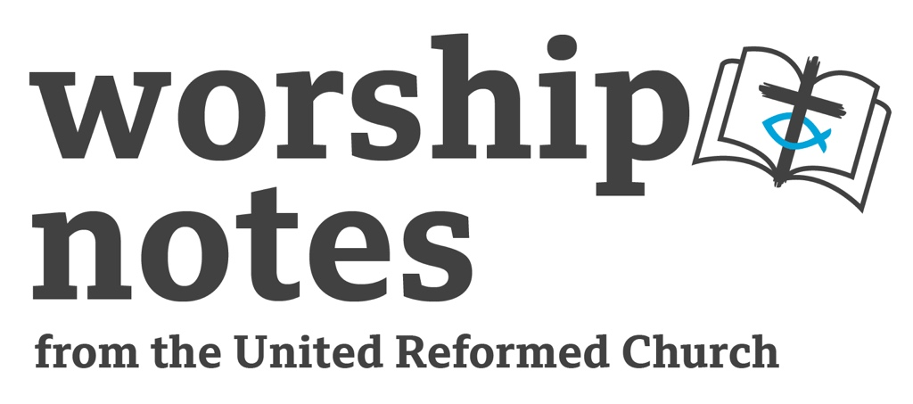
Sunday 12th February 2023
Epiphany / Ordinary 6
The Rev’d Phil Nevard

Call to Worship

Our Lord, you bless everyone who lives right and obeys your Law.
I don't ever want to stray from your way.
You bless all those who follow your commands from deep in their hearts
I don't ever want to stray from your way.
Thinking about your commands will keep me from foolishness.
I will do right and praise you; don't turn your back on me.

(based on Psalm 119, CEV)
Prayers of Approach & Confession

Creator God,
we take this day, as a special day,
to celebrate the goodness of the world you have made, the world you sustain.
The world teems with life and is filled with beauty, celebrating its creator.
You have breathed your life into each one of us,
made us in your image, called us to be your children.
We rejoice, and we are glad.

Saviour God,
we take this day, as a special day, to celebrate Jesus' rising from the dead.
With joy in our hearts we can proclaim that he is risen!
He shared our life and suffered our death
so that we might share his life and his rising - conquering death.
Because he lives, we too shall live!
We rejoice, and we are glad.

God-with-us,
we take this day, as a special day,
to celebrate the coming of your Spirit,
for you are not a God above and beyond us, but with us and in us.
Your Spirit within us, we have a measure of your love,
of your joy, of your peace, of your power to live as your children in the world.
We rejoice, and we are glad.

God of every day,
We take this day as a special day,
forgive us when we take it as the only day to rejoice and be glad in all you have given, for Monday and Thursday, Tuesday and Friday,
Wednesday and Saturday are your days too.
Help us to live as your children all the days of our lives. Amen.

Prayer of Confession

When we offer God our confession,
we join the beautiful work of reconciliation,
which begins with our reconciling with God.
Trusting in our Partner in grace, let us make our confession, first in silent prayer.

(Silent confession)

Gracious and loving God,
open our hearts so that we can admit to you the fullness of our lives –
that which is beautiful and good,
and that which is hurtful and hateful.

We confess that we do not follow Jesus in all that we do.
We love with condition.
We judge and condemn.
We cast the first stone;
We keep the logs in our own eyes;
We do not turn to You as the source of our healing.

Forgive us, we pray.
Forgive our sin and empower us to be imitators of Christ in love and service. Amen.

Beth Merrill Neel on her blog,
‘Hold Fast to What Is Good’. Used with permission.

A Declaration of Forgiveness

Friends in Christ, know this:
the mercy of God is from everlasting to everlasting,
and I remind you of this surpassing grace, in Jesus Christ, we are forgiven.
Alleluia! Amen.

Beth Merrill Neel on her blog,
‘Hold Fast to What Is Good’. Used with permission.

An all age introduction/activity

The overall theme of the service will be about how to live your BEST life and that in order to live your best life it’s not enough just to stop doing bad stuff. It’s not enough just to empty out the bad things from your life.

As a visual illustration, take a plastic drinks bottle and ask how you might get all the air out of it. Try several suggestions. It is fun to take a vacuum cleaner and attach the hose to the bottle and suck all the air out. But as soon as you have sucked it all out, the air rushes back in.

Produce a jug of water and slowly fill the bottle with water. Declare that all the air is removed. (bat off any clever clogs who says that water is H2O and so still contains oxygen by declaring that oxygen is not the same as “air” )

The point is obvious, I hope. Explain that living your best life is more about filling it with so many good things – love, joy, peace, patience, kindness etc… so that there is no room for envy, jealousy, bitterness, spite etc. Fill it so much that it overflows.

A Prayer of Inspiration

Loving God, Spirit of Wisdom and Truth,
break through our drowsiness,
break through our stubborn-ness,
break through our prejudice,
break through our comfort-level,
break open your Word
that our lives might be turned towards your Glory. Amen.

Readings

Deuteronomy 30:15-20 | St Matthew 5:21-37

Sermon Notes

The Deuteronomist presents a choice to the people. It’s a choice between life & prosperity or death and adversity. To choose the former, press the button marked “live a life of obedience to God’s commands”. The preacher might want to spend some time thinking through the idea introduced in the introduction to our theme. Is a life empty of obvious bad stuff a good life? Is it good enough to live a fairly empty life which has avoided all the bad stuff listed in the commandments? Jesus told a story once about a man who swept his life clean of demons and left it sparkling but empty. The demons came back, delighted to find an empty, clean place to live!

The Deuteronomist produces a sound-bite slogan worthy of any modern day politician, “Choose life!” in the 1990s a ground-breaking and iconic film, “Trainspotting” opened with a monologue entitled “choose life”. The preacher may want to look it up, it is easily found on the web – be prepared for the f-word! The character rejects the package of “life” that 1990s Britain is offering him. The preacher might want to reflect on what we think the normal and noble aspirations of life might be in 2022. Alongside that, the preacher might want to imagine what the “life” is that the Deuteronomist is inviting us to choose.

In our Gospel reading Jesus takes his characteristic “exaggeration for effect” approach with the same idea. Is it enough just to not DO the bad stuff. Is our best life also affected by the attitudes we hold (even if they don’t result in immediate action?) For your own dramatic effect you might want to offer a bread knife to anyone who has had impure thoughts during the last week, inviting them to hack off their arms.

Jesus used hyperbole and dark humour to make his point. It would serve the preacher well to identify and be able to articulate what that point is. My guess is that Jesus wants to delve deeper than the plastic purity of a life lived blamelessly but only on the surface. My guess is that Jesus invites us into a much scarier and more profound journey to discover who we REALLY are – our attitudes, our prejudices, our fears, our guilty passions. My guess is that Jesus is saying that we can only really live our best lives when we bring all that to God in prayer, when we understand who we truly are, when we do the work needed to understand where this stuff in our heads comes from. Only then can we really answer the call of the Deuteronomist to “Choose Life!”

An Affirmation of Faith

We believe in God.
The God of all creeds, with all their truths.
But, above all, in the God that rises from the dead to become part of life.

We believe in the God that accompanies us along
every step of our path on this earth,
many times walking behind us, watching me and suffering with our mistakes,
other times walking beside us, talking to us and teaching us,
and other times walking ahead of us, guiding and marking our pace.

We believe in the God of flesh and blood, Jesus Christ,
the God who lived in our skin and tried on our shoes,
the God who walked in our ways, and knows of lights and shadows.
The God who ate and starved, who had a home and suffered loneliness,
who was praised and condemned, kissed and spat on, loved and hated.
The God who went to parties and funerals, the God who laughed and cried.

We believe in the God who is attentive today, who looks at the world
and sees the hatred that segregates, divides, sets people aside, hurts and kills,
who sees the bullets piercing the flesh,
and the blood of innocent people flowing on the earth,
who sees the hand that dips into another's pocket,
stealing what somebody needs to eat,
who sees the judge that favours the highest bidder,
the truth and justice of hypocrites,
who sees the dirty rivers and the dead fish,
the toxic substances destroying the earth
and piercing the sky
who sees the future mortgaged and humanity's debt growing.

We believe in God who sees all this … and keeps on crying.

But we also believe in God
who sees a mother giving birth – a life born from pain,
who sees two children playing - a seed growing,
who sees a flower blooming out of the debris - a new beginning,
who sees three crazy women clamouring for justice – an illusion that doesn't die
who sees the sun rising every morning - a time of opportunities.

We believe in God who sees all this …
and laughs, because, in spite of it all, there is hope.

written by Gerardo Oberman, Argentina. From Prayers for the Week of Prayer for Christian Unity 2004, posted on the World Council of Churches website

Outline prayers of intercession which could be expanded locally

(invite the congregation to imagine the scene where a pebble is thrown into the middle of a pond.)

A pebble falls into the middle of a pond. It makes a splash or a plop, it breaks the surface, you can’t help but notice.

This coming week lies before us, each of us sits at the centre of our own little world – the place where the pebble lands and makes most impact on our feelings and emotions, stirs our anxieties and our fears, inspires our hopes and our dreams…

Think for a moment of your immediate world – the things that you are worried about this coming week in your own life – the things that directly affect you. Never mind anyone else for now – God is interested in you – God wants to come close to you in your hopes, your dreams, your fears, your anxieties…. Say something to God about how you feel about this coming week, and listen for God’s words of comfort and reassurance, hear God’s promise to walk alongside you and continue holding you in the palm of his hand…

The ripples begin to spread, creating circles, maybe the ducks are startled! The splash has disappeared – set your own life aside for a moment - your mind can now focus wider – the people and situations around you – your family, your friends, your work colleagues, your village, your club, your church…. God is interested in all of them – God is present in all of them – God wants to come close to their lives… say something to God about how you feel about this coming week and all those people and situations that surround you, and listen for God’s words of comfort and reassurance… listen also for God’s words of prompting challenge that we might find new ways of being fruitful disciples in the heart of those people and situations…

The ripples are getting harder to see – but you can see their impact on the shores of the pond – the water rises and falls. We know we are part of an unimaginably huge world – some of it we choose to get involved in – we have our passionate campaigns, some of it we choose to ignore – it seems to big, too complicated – too distant for us to effectively care for it all. God is intimately interested in all of it – God wants to come close to every living breathing tiniest part of it… say something to God about what you feel about the wider world that you are aware of through the news and through an ever more complex web of media that seems to bring it closer and closer to our doors… listen for God’s words of comfort and reassurance, hear God’s promise that she will redeem every part of creation… listen also for God’s gentle, persistent, prompting challenge to stretch ourselves and find ways to join in God’s care for the whole of creation.

Now the pond is still. Take a moment to drink in the peace of God that is beyond all human understanding… now mentally gird up your loins, put on your sandals, roll up your sleeves, pick up your stick – ready yourself to go out and face this week – for having talked it through with God, it is already changed. Amen.

An Offertory Prayer

Our offering is collected in many and various ways these days, but our gifts are no less precious to God. Let us pray.

Loving God, you give to us beyond human measure;
You give to us without pausing to count the cost.
Accept these our gifts of money and with them the gift of our lives
to be lived in your service today and every day. Amen

A Blessing

Loving God, send us out into your world, to love and to serve.

And the blessing of God, Father, Son and Holy Spirit
rest and remain with each one of you
this day, this week, and even for evermore. Amen

Hymn Suggestions
 | RS | CH4 | StF | MP
Before I take the body of my Lord |  | 658 | 575
Brother, Sister, let me serve you | 474 | 694 | 611 | 1261
Christ is made the sure foundation | 559 | 200 | 677 | 73
For the beauty of the earth | 41 | 181 | 102 | 152
For the healing of the nations | 620 | 706 | 696
Holy Spirit, truth divine | 301 | 626
I bind my heart this tide |  | 508
Longing for light |  | 543 |  | 1201
Teach me, O Lord, the perfect way |  | 79
We lay our broken world |  | 721 | 718

RS – Rejoice & Sing | CH4 – Church Hymnary 4 | StF – Singing the Faith | MP – Mission Praise

Another suggestion….

Build Up from CD “Build Up” by Fischy Music

