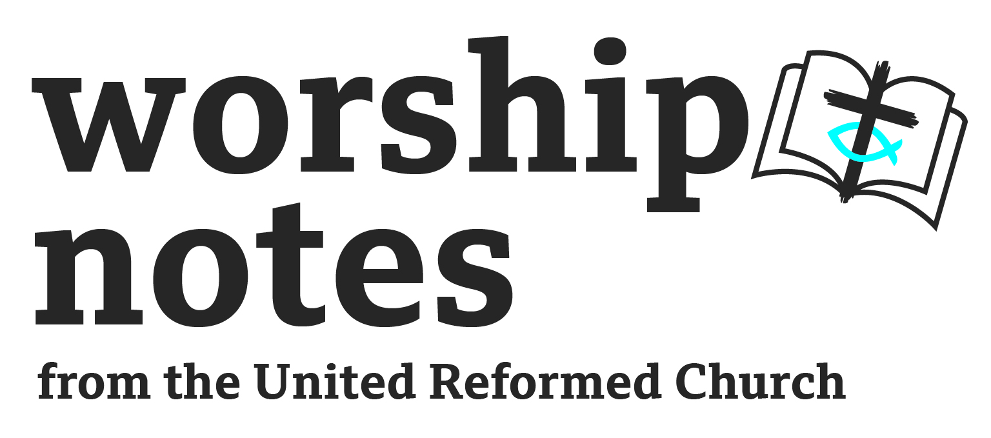
Sunday 22nd January
Epiphany 3 / Ordinary 3
The Rev’d Dr
Matthew Prevett

A Call to Worship

People who walk in darkness,
come now to follow the great light of Christ.
People oppressed by the yoke of the world,
come now to follow the liberation of Christ.
People walking the journey of faith,
come now to follow in the life of Christ.

Prayers of Approach

God who calls,
we open our hearts to hear your Word today.
We have left many jobs behind,
unfinished reading or writing,
incomplete tasks in the kitchen or garden,
and have followed into your presence.
In this time with you,
we gather to hear your Word,
to be inspired by your gospel
and to be challenged by your Call
as we come in adoration and praise. Amen

A Prayer of Inspiration

In our darkness, you show us light.
In our daily lives, you call our names.
In our community, you show us love.
May we know your light and love
as you speak to us now through your Word. Amen.

Readings

Isaiah 9.1-4 | St Matthew 4.12-23 | 1 Corinthians 1.10-18

Sermon Notes

An emphasis drawn from these readings is one of illumination or awareness, with a focus on both what it means to be called, and what the costs may be.

The readings from Isaiah and from Matthew’s Gospel both outline what it is to be the people who are called. Isaiah talks of the light that shines – which clearly resonates with the Christmas season – and the breaking down of the barriers that restrict and oppress. There is a liberation that comes from being called, although in a modern society perhaps it isn’t very clear what that means. What might it mean to be called into a community that increases joy in the nation, or be breaking the rod that oppresses the people? What strength and light might the Christian message have in our modern age?

John the Baptist fulfilled a calling to preach and baptise in God’s name, even baptising Jesus in the Jordan. His arrest, though, highlights the cost of discipleship. We live in a society in which proclaiming faith, while not always welcomed, is not illegal. Although around the world people from different faiths experience religious persecution. What might be the costs of being a follower in our society, or even in your local context? What might be the barriers that prevent others from becoming aware of the Christian message, and what costs might the gospel have on you and your Christian community to be an illuminating presence?

Being called together in Christ’s name – like the fishermen were in the Gospel reading – is emphasised in the First Letter to the Corinthians where divisions between followers are showing. This is a community seemingly divided about their focus and direction, unsure about being of the same mind and purpose. During the Week of Prayer for Christian Unity it may be worth considering what Unity looks like. Is it something that requires uniformity? Or is it something where diversity can be celebrated? In an individual sense, Christ calls fishermen into a community of his followers; Christ decides who can become part of the community, and calls each by name through a personal word to follow him. We must certainly wish for a diverse community – but can we be sure that we are always following the footsteps of Christ?

The light that shines in the darkness of the world is the acts of the people of God. As followers it is the way in which we are called and follow, how we face the challenges and the difficulties, and how we live out our diversity in ever-complex communities with ever-changing priorities. The Church’s presence in the world is as a community of followers – individuals who have been called and who face the challenges of faithful discipleship – called to live out freedom and liberation to the oppressed, the weakest and most disadvantaged in our communities, and those who are weighed down by the oppression of the world. Following means understanding a purpose and bringing joy to a world that desperately needs it. What might that mean in your context – with the people in and around your community – today?

Prayer of Confession

God of opportunity,
in the darkness of the world, we do not always shine your light.
We fail to live your gospel boldly, with the full commitment you ask of us.
We do not always speak out for the oppressed and weak,
and we do not live your joy and liberation in the world.
In response to your Word, and in silence,
help us recognise the opportunities we have to better respond to you,
as the followers you call us to be.

A Declaration of Forgiveness

For the message about the cross is foolishness to those who are perishing, but to us who are being saved it is the power of God.
1 Cor 1.18
Thanks be to God. Amen.

Prayers of Concern

As we bring our prayers of concern for all peoples, nations and languages, let us pray:
In a land of deep darkness: may your light shine

We pray for all peoples of the world:
for those like us and known to us
and those who are unknown to us or from different backgrounds.
Your world is a diverse and exciting place,
full of cultures and peoples with some many backgrounds and traditions,
a kaleidoscope of people with whom we share much or little.
Yet we are called to love and share together in your kingdom.

We pray for those peoples who are treated as outsiders,
refugees and asylum seekers, who come looking for love.
We continue to pray not for uniformity but unity in our communities,
where people can know love irrespective of race, gender, sexuality and sexual identity, age, disability, religion or belief.
We pray that those who fail to show love by attacking and abusing others
because of their difference, may transform into people of love,
and know the kingdom God is calling us into.

In a land of deep darkness: may your light shine

We pray for all nations of the world:
for those in our closest relationships and those furthest away.
In a global society, we are interlinked across the world
with governments making decisions that affect all nations.

We pray for those in leadership of all types.
We pray for those who lead Churches and faith groups,
those who work together for unity in a world of disunity,
and all those who reach across denominational divides
to speak, share and shape the gospel in the world.

In a land of deep darkness: may your light shine

We pray for those who feel lonely in a world of communication.
We keep in mind those who have been cut out of communities or families,
those who will spend tonight on the streets, and those who are unable to talk about their mental, physical or spiritual concerns.
We pray for all who reach out in love, as families and friends,
and all those who work in wellbeing and support services,
for the love, dedication and words they use to break down barriers.

In a moment of quiet, we remember all those known to us whose concerns rest heavy on our hearts today
Silence

In a land of deep darkness: may your light shine

Ancient One,
as we pray for the coming of an everlasting kingdom of love,
we ask for your strength and support in our own lives.
Help us know of your true love for ourselves,
and the truth to which we are called.
May we be inspired by the love of your Call
and be your hands and your feet in the world.
For the Kingdom, the Power and the Glory are yours,
for ever and ever. Amen.

Offertory Prayer

As we seek to bring about the kingdom through love that makes all things new, we dedicate ourselves and our resources to the one who Calls:

As we gather together the opportunities you give us,
bless them and us,
that we may respond to your call
and may bring joy and liberation to your world.

We join together now in the prayer Jesus taught us, using the words or language that is most familiar to us: Our Father…

Blessing

In a world of noise, may we hear our name called.
In a world of light, may we see the way we are called to follow.
In a world of opportunity to respond, may we be compelled to share the good news of the Cross.
And the blessing of God, Father, Son and Holy Spirit,
be with you, and all those for whom we have prayed,
this day, and forevermore. Amen.

Hymn Suggestions
 | RS | CH4 | StF | MP
The Kingdom of God is justice and joy | 200 |  | 255 | 651
Will you come and follow me? | 558 | 533 | 673
Called By Christ to be disciples |  |  | 660
When Jesus saw the fishermen |  | 340
I the Lord of sea and sky |  |  | 663
Jesus calls us! | 355 | 509 | 250 | 359
Community of Christ |  |  | 681
I want to walk with Jesus Christ | 367 |  |  | 302
Almighty Father of all things that be | 485 | 497
O Jesus I have promised | 509 | 644 | 563 | 501

RS – Rejoice & Sing | CH4 – Church Hymnary 4 | StF – Singing the Faith | MP – Mission Praise

