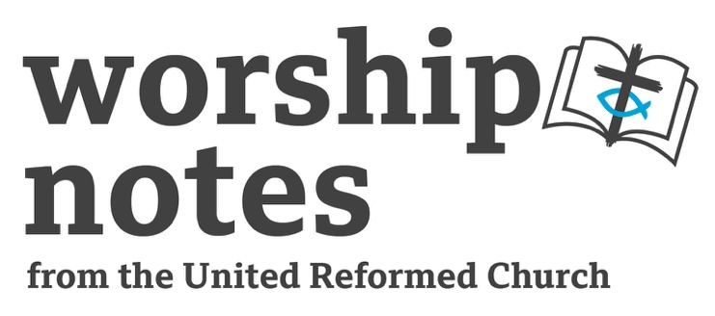
Sunday 16th April 2023
The Second Sunday of Easter
The Rev’d Jayne Taylor

Call To Worship

Alleluia! Christ is Risen! He is Risen indeed! Alleluia!

Rejoice, heavenly powers! Sing, choirs of angels!
Exult, all creation around God’s throne! Jesus, our King, is risen!
Sound the trumpet of salvation!

Rejoice, heavenly powers! Sing, choirs of angels!

Rejoice, O Earth, in shining splendour, radiant in the brightness of our King!
Jesus has conquered! Glory fills you! Darkness vanishes for ever!

Rejoice, heavenly powers! Sing, choirs of angels!

Rejoice, O holy Church! Exult in glory! The risen Saviour shines upon you!
Let this place resound with joy, as we sing, echoing the mighty song of all God’s people!

adapted from the Exultset
Prayers of Adoration and Confession

Risen Lord,
the glory of your resurrection reaches out to the world and to every human being.
In your life you shared with us all that it means to be human.
You died our death, but you rose from death and changed the world,
enabling us to see that your love encompasses the whole of humanity.

Risen Lord, we come to worship you
and stand in awe of the power that made this happen.
You have conquered sin and death for us
and now we are released to achieve our full potential,
to be children of our Heavenly God.
Now we know that nothing can ever daunt us because you are with us forever.

Forgiving Lord, despite everything that Easter means to us
we still sometimes doubt You.
We are frail creatures, easily distracted.
You know our shortcomings and our failures, our doubts and our fears.
Forgive us the many ways we have taken you for granted,
or failed to follow in your footsteps.
Forgive us and enable us, like Thomas, to say ‘My Lord and my God’. Amen.

Readings

St John 20:19-31

Sermon Notes

Thomas has had a bad press through the ages being given the nickname of ‘doubting Thomas.’ And yet, he is the disciple who is not locked away in a house on the first Easter Day ‘in fear of the authorities.’ Jesus appears to the ‘fearful’ disciples and they believe.

Thomas joins them a week later and they tell him they have seen the risen Jesus, but Thomas does not believe them. This is a natural reaction, especially as they are still locked away in fear!

What would you do in Thomas’ situation?

There had been others who had claimed to be the promised Messiah. Acts mentions two of them: Theudas, who had over 400 followers, we’re told, and also Judas the Galilean. Both had met with untimely deaths and their followers had been persecuted and had scattered (Acts 5:36-37).

In the thinking of the disciples, the Messiah would free his people, a new king David, to defeat the Romans.

We know about Thomas, from the story of the raising of Lazarus in John chapter 11.

When Jesus decides to visit his dead friend two days after being called by Lazarus’ sisters, the disciples are opposed to him going. They remind Jesus that during his last trip to Judea people had tried to stone him. They wanted to keep Jesus safe...and alive.

But Thomas is the one who supports Jesus. He even encourages the others to join him at the risk of their own lives: ‘Let us also go, that we may die with him. he says’ (John 11:16).

Thomas, apparently, was not afraid of the authorities, or of dying with Jesus.

Back to Easter day and Thomas is not convinced by the disciples’ story but Jesus appears again and gives Thomas the proof that he has asked for, at which point Thomas declares; ‘My Lord and my God!’ Thomas is the first disciple to declare that the Risen Jesus is God!
And Jesus says: ‘Because you have seen me, you have believed; blessed are those who have not seen and yet have believed.’

This is not a rebuke to Thomas; after all the rest of them didn’t believe without first seeing Jesus either!

Affirmation of Faith

As followers of Jesus Christ, living in this world—which some seek to control, but which others view with despair—we declare with joy and trust: our world belongs to God!

From the beginning, through all the crises of our times, until His Kingdom fully comes, God keeps covenant forever. Our world belongs to God!

We rejoice in the goodness of God, renounce the works of darkness, and dedicate ourselves to holy living, for our world belongs to God!

As committed disciples, called to faithful obedience, and set free for joyful praise, we offer our hearts and lives to do God's work in his world, for our world belongs to God!

With tempered impatience, eager to see injustice ended, we expect the Day of the Lord. And we are confident that the light which shines in the present darkness will fill the earth when Christ appears for our world belongs to God!

from the Christian Reformed Church
Intercessory Prayers

Loving God, for the precious gift of life that you have given to us, we give you thanks.

For the enduring presence of your love in this world, we give you thanks.

For the knowledge that you are with us, and the realisation that the Church is yours, not ours, we give you thanks.

On this day, we hear the message that we must strive to be the people that you intended us to be.

On this day, we journey in hope as we trust in your promise.

We are conscious that we share in the life of the world.

We are conscious of the presence of those who are near to us, and of those from whom we are apart.

Whether near, or far, embrace us all in your love.

Lord, we are conscious of others, whose life and work is woven into the fabric of our society, and upon whom we depend. Those who serve us, especially at this time. And we pray for them:
for delivery drivers and postal workers,
for refuse collectors and cleaners,
for shop workers and care workers,

protect them and keep them safe.

for nurses and doctors,
for scientists and surgeons,
for midwives and ambulance drivers,

protect them and watch over them.

For those who govern on our behalf.
For those who make decisions that impact upon us all.
For all who shape our common life,

protect them and increase their wisdom and understanding.

Lord, in your mercy, hear our prayer.

And grant us faith to journey into the days and indeed weeks to come,
through the wilderness of despair and anguish and hurt
into the dawning realisation of new life, new hope and a new dawn.

As we are assured of the presence of the crucified and risen Christ,
may we be more like him in all we are and all we do. Amen.

Blessing

May God, the creator of all life,
Jesus Christ, the giver of eternal life,
and the Holy Spirit, the power in each and every life,
bless each one of us, this day and every day. Amen.

Suggested Hymns
 | RS | CH4 | StF | MP
Now the green blade rises | 243 | 417 | 306
Thine be the glory | 247 | 419 | 313 | 689
When Easter to the dark world came | 251 |  | 316
Christ is alive! Let Christians sing | 260 | 416 | 297
Christ has risen while earth slumbers | 296 | 430 | 296
The Day of Resurrection | 246 | 413 | 311
You Shall Go Out With Joy | 415 | 804 | 487 | 796
This Joyful Eastertide | 248 | 415 | 314
When We Are Tempted to Deny Your Son |  | 400
How Often We like Thomas |  | 432
Shout for Joy the Lord Has Let Us Feast |  | 676 | 598
As We Are Gathered Jesus Is Here | 469 | 197 |  | 38

RS – Rejoice & Sing CH4 – Church Hymnary 4 StF – Singing the Faith MP – Mission Praise

All-age activity
Saddleback kids have a range of good cartoons for all age worship. Individual videos can be purchased through https://store.saddlebackkids.com/
They also have a free bible story pack https://store.saddlebackkids.com/free-bible-story-pack
This includes:
Old Testament:
Joseph and His Coat
Noah and the Flood
Sarah Laughs
Samson and Delilah
Josiah
Joshua Leads
New Testament:
Jesus Calls Peter
Jesus Calms the Storm
Paul
Jesus Sacrifice
Zacchaeus
Jesus Feeds the 5000
The Jesus sacrifice video is particularly good for the Easter story. They can all be viewed via YouTube but registering through the store entitles free use in church.

