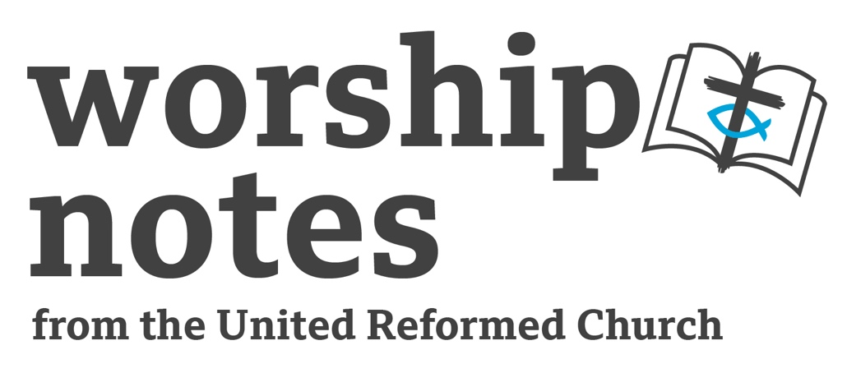
1st January 2023

The First Sunday
after Christmas

The Rev’d
Nicola Furley Smith
Call To Worship

The Psalmist says:

Praise God from the heavens!
Praise Him from the skies above!
Praise God, angels and all the hosts of heaven!
Praise Him, sun and moon, and shining stars!
Praise God, all creatures great and small,
Praise God, kings of the earth and people everywhere,
Praise Him, men and women, young and old!
Let all the earth bring praise to the Lord,
at whose word creation came into being.
We gather to praise and worship our God!

Prayers of Approach and Confession

Lord of the passing years, in you all time and space are perfectly at one:
we lift up our hearts to you, with gratitude for your faithfulness to us.

We look back over a year that is gone
and celebrate that you have been with us each step of the way:
the times you were closer than breath, nearer than hands or feet;
the times when your love carried us through the darkest of deep valleys
and your light shone brightly;
the times when we were not so conscious,
but deep in our hearts knew you were there.

We confess we have not always walked with you:
we have turned aside and found other paths.
We confess we have not always listened to you:
we have tuned our hearing to other sounds.
We confess we have not always been faithful:
we have not shown your love for your world.
With heart and voice we ask forgiveness.

So hear our prayers, asked and offered in the name of him who stands at the door of the New Year: even Jesus Christ our Lord. Amen.

Declaration of Forgiveness

In Jesus Christ, God makes all things new.
The former things have disappeared.
God will wipe away every tear from our eyes.
Sisters and Brothers,
your sins are forgiven;
be at peace. Amen.

A Prayer of Inspiration

At the start of this New Year, Almighty God, the giver of light and the source of all peace, illumine our hearts that we receive every word you speak to us today. Amen

Readings

Hebrews 2:10-18 | St Matthew 2:13-23

Sermon Notes

It’s not a nice world out there. Once the hype of Christmas fades, and the wonder of the new-born babe in the manger starts to become a memory, we come back down to reality. The Gospel reading strikes a new tone for the season by dramatically leading us away from anticipation of Advent and the revelry of the holidays to the fragile and dark days between what God has promised in Jesus and its fruition. Threats abound but God carefully orchestrates Jesus’ earliest days according to Matthew. As the Christ-child lies defenceless in his mother’s arms, God’s steady protection and Joseph’s faithful obedience combine to ensure his safety in a world of danger.

The stark focus of today’s Gospel reading on political tyranny, senseless mass killing, and the continual threat of violence, both resonates with our world and makes it hard to wonder where we might find good news.

Herod feared that this baby would be the long-awaited Messiah. Herod is under no illusions that the Messiah is some purely spiritual title – something you might want to explore as we’re much more comfortable with spiritual rather than political titles and themes! Herod knew that if the people start following a Messiah, they will stop bowing down to the ruling authorities. Herod clings to his throne like an alcoholic to a bottle. His need to rule is simple, brutal, and chilling.

The popular version of Christmas has no story of Herod killing babies. People want Christmas to be full of the feel-good factor, not a time to be reminded of tyrants and injustice. But such stories don’t resonate with our world. 2022 saw:

- war in the Ukraine,
- political tensions amid drought and conflict in the Sudan
- economic crisis compounded pounded by a decade of war in the Syria
- humaritarian crises in Somalia, Myanmar, the Democratic Republic of Congo, South Sudan, Nigeria, Yemen, Ethiopia and Afghanistan.
- Not to mention the crash of our own economy with many thinking about making the choice between food and heat.

Egypt becomes the unlikely refuge and safe haven for the Holy family. Egypt is Israel’s enemy and oppressor. Egypt is the home of the Pharaoh who did not know Joseph, who initiated the hundreds of years of Hebrew enslavement. And Egypt evokes the story of Moses and the liberation of Israel from the tyranny of slavery. In order to make his point Matthew cites Hosea’s prophecy: “Out of Egypt I called my son”. recalling the journey of earlier Joseph in Egypt and the strange providence that made Egypt a place of refuge and protection for that Joseph’s family. But Egypt was also the place of slavery, the place where God’s children lived under the Pharaoh’s yoke, the place from which God liberated Israel. And now, from Egypt, Jesus, God’s son is called. and the promises made to Israel by God are fulfilled.

This is a good time to remind people that the Holy Family fled danger and persecution not on a small boat across the channel but on the trade routes to Egypt. Might the Home Office have turned away the Holy Family?

For Matthew, this escape is not simply an expedient move or an accident of history. It has been foretold. God chose this path in the distant past. Ancient prophecies come to life and guarantee Jesus’ inescapable mission.

But what of this mission? The value of the Christmas we have just celebrated lies not in the fact that it celebrates the birth of a child wondrous as it is because child-birth happens all around us. Rather, the value of Christmas and all Christmasses we celebrate lies in the nature of this new child and what this new child will accomplish as Redeemer and Saviour of the world.

This is the story of the birth of one king and the violent opposition of another. The royal power represented by Herod from the very beginning cannot tolerate the presence of Jesus. The first word of his birth leaves Herod troubled. In one sense he rightly perceives the threat Jesus represents Jesus is Israel’s true king.
The writer of Hebrews reminds us that our human sinfulness is inextricably linked with the suffering of Christ, that the baby whom we happily adore at Christmas is the one whose relationship with us leads to the cross. Because Jesus identifies with us his suffering provides not only new life for us but a model of hope and endurance for those of his followers who likewise may experience suffering and temptation just as he did.

As we move forward from the manger out into the larger world of human pain and destructiveness, a world over which the new-born king rules which will ultimately mean his suffering and death, we must move also.

At the start of this New Year we are called to model our hope and endurance on Christ and create something new.

An Affirmation of Faith

God is the God of all beginnings and all ends who remains faithful.
In each moment God is present.
God’s steadfast mercy and grace remains
our constant yesterday, today, and forever.
God is the God of all beginnings and all ends who remains faithful. Amen

Prayers of intercession

God of all beginnings and all endings at this dawn of this New Year,
call us to something new.

God of all beginnings and all endings
we pray for people who cannot see the way ahead:
for people who because of prejudice cannot see truth,
that you will be the dawn for all who cannot see move forward.
God of all beginnings and all endings
we pray for people carrying heavy responsibilities:
people who in Christ work to create peace,
strive to create a better health service,
a better police force and better schools;
people who seek to bring the truth of Christ
to caring for those unable to care for themselves,
and to children and young people vulnerable to bad influences,
that you will be the dawn for all who carry heavy responsibilities.
God of all beginnings and all endings
we pray for your church throughout the world:
for the church where few people are interested in a truth outside themselves;
for the church where the words of others drown out the Word;
for the church where your people feel uncertain of the truth;
that you will be dawn of light and truth renewing your church,
through Jesus Christ, our Lord, Amen.

Offertory Prayer

Loving God, you sent your only Son to live among us, bringing us your grace and truth. All we have to offer is what you have given us in manger and cross. Receive all that we have and all that we are to your glory and for your service, in the name of Jesus Christ, our Saviour and Lord. Amen.

Blessing

As Mary and Joseph were called to Egypt
Go your way;
go forward in faith;
go forward in hopefulness;
walk in the light of God.

And the blessing of God Almighty
Father, Son and Holy Spirit
be amongst us and remain with us
this day and for evermore. Amen.

Hymn Suggestions
 | RS | CH4 | StF | MP
Born in the Night | 188 |  | 193 | 62
Eternal God, You’re love’s tremendous glory | 33 |  | 3
The Coventry Carol
See Him Lying On A Bed Of Straw | 151 | 310 | 216 | 589
The Tyrant Issues His Decree |  | 330
Unto Us A Boy Is Born | 169 | 331 | 218 | 714

RS – Rejoice & Sing | CH4 – Church Hymnary 4 | StF – Singing the Faith | MP – Mission Praise

The Coventry Carol isn’t in many hymnbooks but has become popular again in recent years due to Annie Lennox’s version – you may wish to play that in church. The carol is of medieval origin and is in the Public Domain.

Lully lullay thou little tiny child
Bye bye lully lullay
Thou little tiny child
Bye bye lully lullay

O sisters too,
how may we do
for to preserve this day?
This poor youngling
for whom we sing
Bye bye lully lullay.

2 Herod the king in his raging
charged he hath this day
His men of might, in his own sight,
all children young to slay.

3 That woe is me poor child for thee
and ever mourn and may,
for thy parting, neither say nor sing
Bye bye lully lullay

