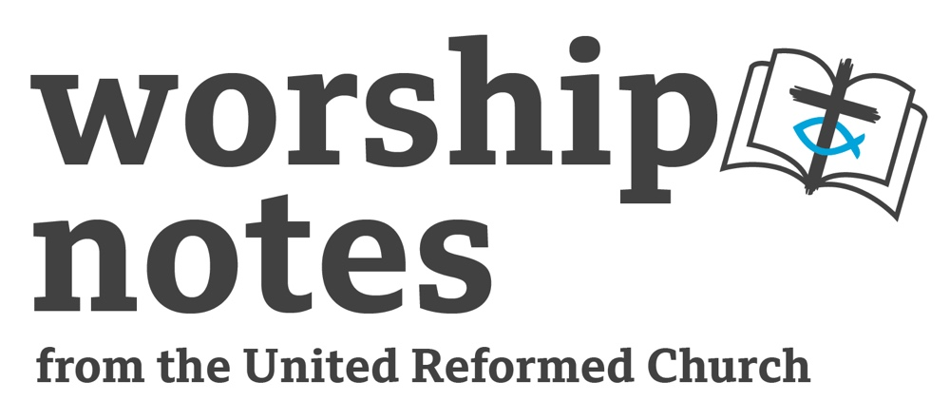
Sunday 26th
November 2023
Christ the King
The Rev’d Jenny Mills

Introduction

In our readings we hear about shepherds. They are a familiar image in the Bible as they would have been someone that most people could identify with. Features of a shepherd include: good with a sling, brave, like their own company, like sheep, know the importance of a community with different characters and temperaments, usually not very wealthy, caring and kind but also fiercely protective. This Sunday is Christ the King. A day when we imagine Jesus as King of the world. We probably could not imagine two roles so opposed as the shepherd and a King. What features do we think of when we think of a King Rich, powerful, makes laws, lives apart from ordinary people and gets served, makes decisions that affect others. And yet, we refer to Jesus as both. Jesus the Shepherd and Jesus the King of Kings. On Palm Sunday when we recall how he rides into Jerusalem just before he is arrested, we sing ‘Hosanna to the Son of David, Hosanna to the King of Kings’. What image sits best with you? How does it feel to think of Jesus as King?

Call to Worship

Make a joyful noise to the Lord, all the earth.
Serve the Lord with gladness;
come into his presence with singing.
Know that the Lord is God.
It is he who made us, and we are his;
we are his people and the sheep of his pasture.
Enter his gates with thanksgiving
and his courts with praise.
Give thanks to him; bless his name.
For the Lord is good;
his steadfast love endures forever
and his faithfulness to all generations.
Psalm 100:1-5
Prayers of Approach

Gracious and loving God,
we are your people,
we find ourselves loved and free.
We see the wonder of your love all around us, each and every day.
We see your love in relationships, in creation, in kind acts and in each other.
We are blessed by you in so many ways.
We experience your love in our lives,
your hope in our hearts and your inspiration in people, situations and places around us.
We come before you and we worship you as parent, sibling, confidante,
protector, sustainer, enabler and holy, divine love.
We are humbled by all you have been, are and will be in this world and in our lives.
Pause

Yet we still mess up, we still get it wrong, and we still fail,
often despite our best attempts and efforts. Amen

Prayers of Confession

We come with our prayers to give ourselves time to consider where we have got things wrong, where we have abused our positions of power, where we have failed to speak out for those on the margins, where we have fallen short on the way.

In a moment of quiet, let us all to hold before God the things for which we are sorry. The personal, relational, community and worldwide situations that we have not challenged or questioned or not responded to in a more loving and compassionate way. The things we have done or left undone that would have helped others or made a difference for good. The stuff we have avoided or ignored because it felt too much.
pause

Gracious God, these words we offer,
seeking to make amends and to change.
But knowing that, even if we continue to fall short, we are loved. Amen

Declaration of Forgiveness

Jesus reassures us that we are forgiven.
Let us hear his words: Come to me all you who are heavy laden, and I will give you rest.
We claim that rest and seek to forgive ourselves and forgive others.
In Jesus’ name we pray.

We wrap up all these prayers in the words that Jesus gave us, saying: Our Father…

Prayer for Inspiration

Bless these words from Scripture
that they may give us glimpses of your kin-dom,
words to live with and live by and bring us closer to you. Amen.

An All-Age Introduction
Have words to describe a king and a shepherd on separate cards scattered around the church (King: rich, powerful, makes laws, lives apart from the people, gets served, makes decisions that affect others, lives in nice surroundings. Shepherd: brave, often quite poor, lives apart from others, likes own company, likes sheep, good with a sling, fiercely protective.)

The readings that we will be hearing today speak of shepherds. This is a familiar biblical image. Today is the last Sunday of the Church Year and so is called Christ the King. Another common image in the Bible. Scattered about, written on cards, are words that describe both Kings and Shepherds. In the next few minutes I would like us to find the words and separate them out- do they speak of a King or a Shepherd?

Encourage all ages to find them and chat about which category they think they belong to- then go and put them with the corresponding word, so all can see.

When all the cards have been divided up, go through the list of attributes and see if everyone agrees. Maybe some can apply to both? Allow for conversation.

Remind everyone at the end that, in the Bible, a ruler or king was sometimes referred to as a shepherd. Leave this part of the service with two ‘wondering questions’:

- I wonder why the Old Testament writers thought there was a similarity between the role of a king and the job of a shepherd?
- I wonder if we would think there was any similarities today?

Readings

Ezekiel 34:11-16, 20-24 | St Matthew 25: 31-46

Sermon Notes
Ezekiel 34:11-16, 20-24

The book of Ezekiel is set in Babylon. Ezekiel was likely to have been brought to Babylon with the first group of exiles following the capture of Jerusalem in 597BCE. He is identified as a priest, most likely (as he was in the first group who arrived) someone of importance or family prominence. He became known as a prophet to the Judean community, but he seems to have been concerned that his words were not being taken seriously enough by the people.
The book of Ezekiel is a strange piece of writing as it has both precise dating and a clear, logical structure with odd, often seemingly bizarre imagery, complexity in both grammar and the texts and a literary style that can be confusing.

Ezekiel was concerned about the destruction of the temple in Jerusalem and the presence of the Temple (or lack of it) is key in his writings as it reflects the people’s relationship with God. The people’s relationship with God is complex and God is portrayed as desiring to both punish and rescue the people.

In Ezekiel, as was common in the Near East and is seen in other parts of the Old Testament, the image of a ruler as a shepherd is a common one. In this text that addresses the Shepherds of Israel, the leaders have not protected the people and cared for them as they should have. God speaks into this, through Ezekiel, promising that the leaders will be removed, and God will restore a descendant of David as shepherd for the people. This alternating language of shepherd and king feeds into the reflections offered in the rest of this service.

St Matthew 25: 31-46

This text from the Gospel according to Matthew comes after a couple of other parables around readiness, faithfulness and using talents well. This text speaks to ‘the nations’- regarded to be a metaphor for the whole of humanity. This text is clear in what is expected for those who are faithful to God, it is loving neighbour, especially those who are marginalized. The text makes it clear that judgment of actions and of hearts is an expected feature of the end time, which may have been regarded as an imminent event. This text contains images of punishment as warning and elements of fear. What is disturbing about this is how the text has been used to create and perpetuate division and elevate one group of people above others. And yet, this does not seem to be the purpose from the writer’s perspective, it feels more about having the right heart when living alongside others in community and showing compassion by looking out for each other. It is interesting to note that both the sheep and the goats express surprise, so this is not about piety and good works, this is about good hearts, good attitudes, about mercy as well as grace.

Affirmation of Faith

We believe in God, divine Creator, overseer of all, enabler of life and love.

We believe in Jesus, Son and Saviour, role model, trouble-maker, and shaker-upper.

We believe in the Holy Spirit, source of grace and peace,
inspirer and enthuser, accessible and welcoming.

We believe in the Godhead, three in one, confuser, bewilderer and assurer
who invites us into the eternal dance of creation,
alongside the whole of humanity,
free from division and discrimination.

We believe in God - here, now, forever and for all. Amen.

Prayers of Intercession

This prayer by Pope Francis appeared at the end of his 2015 encyclical Laudato Si.

All powerful God,
you are present in the universe and in the smallest of your creatures.
You embrace with your tenderness all that exists.
Pour out upon us the power of your love, that we may protect life and beauty.
Fill us with your peace, that we may live as brothers and sisters, harming no one.
O God of the poor, help us to rescue the abandoned and forgotten of this earth,
so precious in your eyes.
Bring healing to our lives,
that we may protect the world and not prey on it,
that we may sow beauty, not pollution and destruction.
Touch the hearts of those who look only for gain
at the expense of the poor and the earth.
Teach us to discover the worth of each thing,
to be filled with awe and contemplation,
to recognize that we are profoundly united with every creature
as we journey towards your infinite light.
We thank you for being with us each day.
Encourage us, we pray, in our struggle, for justice, love and peace. Amen.

Loving God, we know our responsibility to your world
and those alongside whom we live.
We pray for those we do not and may never know.
Now in a time of quiet,
we offer our prayers for those people, places and situations known to us.
We pray that you will hear and hold these words
and may we never forget that our prayers change us as well as changing your world.

Silence

All these we pray in the name of Jesus: King of Kings, Lord of Lords,
Shepherd, Compassionate healer and divine Son. Amen.

Offertory

Gracious God,
thank you for your love in our lives,
for who we are, who we can be and all we have.
Because we are so blessed we come with our freewill offerings
of money, time and talents.
Take these and use them for your glory,
to bless and encourage and love.
In Jesus’ name. Amen.

Blessing

Let us go out as Christ’s hands and feet,
sowing seeds of harmony and community,
challenging injustice and promoting peace,
dancing together in the eternal dance of humanity,
united by the love of God and empowered by the Holy Spirit.

And may the love of God
Creator, Sustainer and Son
uphold, enable and bless us,
along with those we love
and those we struggle to love.
Now and forever, Amen.

Hymn Suggestions
 | RS | CH4 | StF | MP
Come all you people, come and praise your Maker |  | 757 | 22
At the name of Jesus | 261 | 458 | 317 | 41
The King of love my shepherd is | 552 | 462 | 479 | 649
When I needed a neighbour |  | 544 | 256
Let there be love shared among us | 477 |  |  | 411
Ye servants of God | 293 | 130 | 340 | 784
Crown Him with Many Crowns | 262 | 459 | 347 | 109
All Hail the Power of Jesus’ Name |  | 457 | 342 | 131
Jesus is Lord! Creation’s Voice Proclaims It | 268 |  | 353 | 367
Rejoice the Lord is King | 657 | 449 | 335 | 575
You Lord Are Both Lamb and Shepherd |  | 355
Christ Our King Before Creation |  |  | 318
Christ Triumphant Ever Reigning |  | 436 | 319 | 77
How Sweet the name of Jesus Sounds in a Believer’s Ear | 277 | 461 | 322 | 251
Jesus is King and I will extol Him |  |  | 327 | 366
RS – Rejoice & Sing | CH4 – Church Hymnary 4 | StF – Singing the Faith | MP – Mission Praise

