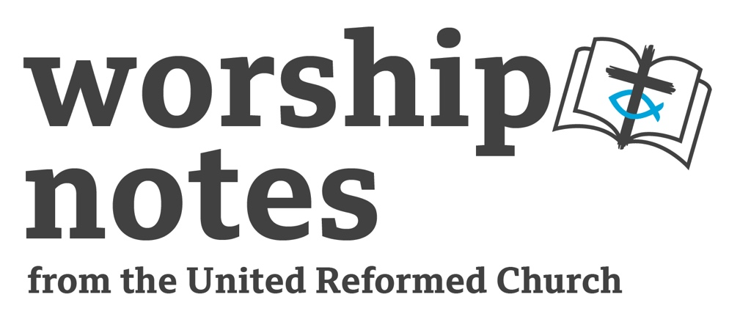

8th January 2023
The Baptism of the Lord
The Rev’d Susan McCoan

Call to Worship
Ascribe to the Lord, O heavenly beings, ascribe to the Lord glory and strength.
Ascribe to the Lord the glory of his name; worship the Lord in holy splendour.
The voice of the Lord is over the waters; the God of glory thunders, the Lord, over mighty waters.
(Psalm 29:1-3)
Prayers of Approach

God of earth and heaven, you reign in glory and holy splendour,
yet you come amongst us in humility and share our humanity.

We praise you for all that you are, all the wonders of your creation,
and all that you continue to create in our lives.

We praise you for Jesus, stooping to be baptised, identifying with sinners
and calling all people to saving grace.

We praise you for the Holy Spirit, alighting on Jesus, present with us today,
guiding, affirming and giving us strength.

God of earth and heaven, accept our prayer and praise today.Amen.

Prayer of Confession

Loving God, You come all the way to meet us in Jesus,
and sometimes we pretend not to be in,
hiding behind closed doors, hoping you won’t notice the mess.
Forgive us for not trusting in your mercy;
forgive us for trying to look respectable in your eyes, fooling nobody.
Give us the courage to open our lives to you,
to let in your compassion, to allow you to heal and renew.

(silent reflection)

Assurance of Pardon

Hear the words of assurance,
for all who come in hope and faith.
I have formed you and call you
I will take you by the hand.
Behold, I am making all things new.
Thanks be to God.

from ‘Prayers for Life’s Particular Moments’ by Dorothy McRae McMahon

Suggestion For All-Age Activity

Ask people: how many got baptised in this particular building?
If quite a few, try and work out whose baptism was longest ago, whose most recent.
If many were baptised somewhere else, find out whose was farthest away.
Invite people to share a story about their baptism (perhaps one they have been told, if they were baptised as a baby).

If you know the congregation, it might help to prime people in advance.

Prayer of Illumination

God, whose word spoke creation into being,
open our ears to hear your word in scripture,
open our minds to new understanding,
and open our hearts to the new life it brings. Amen.

Readings

Isaiah 42:1-9 | Psalm 29 | Acts 10:34-43 | St Matthew 3:13-17

Sermon Notes

Theme: Rivers as boundaries and barriers – which God can break.

River as barrier:
Think of a scene from a movie, where the hero escapes from dire peril, makes it through dangerous terrain, only to come to a river too fast-flowing to swim across. Crossing a river – or not being able to cross – is a theme that recurs throughout history and literature.

Examples:
    - History – Caesar crossing the Rubicon
    - Legend - St Christopher, who carried Christ himself without knowing it
    - Humour - Stanley Holloway monologue ‘The Runcorn Ferry’ with its fare of ‘tuppence per person per trip’ (written by Marriot Edgar but performed and made famous by Stanley Holloway).
    - Song – Running Bear and Little White Dove, two native Americans in love but separated by a wide river. One day, unable to live without each other, Little White Dove leaps into the water and is drowned.

River as boundary:
Perhaps because they are natural barriers, rivers are often used as boundaries between territories.

Rivers and other waters in the bible
Moses crossing the Red Sea. Red Sea starts as a barrier, through divine intervention becomes a means of escape, then an instrument of defeat in drowning the Egyptian army, then a barrier again.

After 40 years in the wilderness, Joshua leads the people across the Jordan and into the Promised Land. God instructs the priests carrying the Ark of the Covenant to step into the Jordan – and as they do, the water upstream stops flowing, the water downstream moves on, and all the people cross over on dry ground.

Note that they crossed the Jordan near Jericho, from east to west. The land to the west of the Jordan is the Promised Land; to the east it is Gentile territory. The river itself is not just a physical barrier that has to be overcome, but is also the boundary between God’s land, and the rest of the world.

Baptism of Jesus.
Picks up on the general motif of water as physical barrier and boundary, and on the Biblical motif of barriers and boundaries that can be overcome by God.
The baptism of Jesus takes place in the river Jordan – the same river that was crossed by Joshua and the people of Israel to get into the Promised Land. This may be partly for practical reasons – the available water, and space for people to gather. But here, as in many episodes in the Bible, the practical reason goes hand-in-hand with a symbolic significance. John happens to be using, for baptism, the boundary river, the divider between the Holy Land and the Gentile territory. For everyone else who comes to John, it’s just a river, and the symbolism is in the act of baptism.

But when Jesus stands in this water, he is about to begin a ministry that will bring all people to God as equals so that there is no longer Jew or Gentile, man or woman, slave or free. As the heaven breaks open, so Jesus breaks the boundary between people.
There are other boundaries too. Jesus stands in the Jordan valley, in one of the lowest places on earth – the Jordan runs into the Dead Sea –and God opens up to him a direct link to heaven. Jesus has stood amongst ordinary people, accepting a baptism of repentance like everyone else, and he has been singled out by God as God’s beloved Son.
The baptism of Jesus is a breaking of boundaries: the physical bounds of the landscape; the human boundaries of race and religion; and the invisible boundary between the earthly and the heavenly realms. In this one event, we see all the possibilities of the incarnation opening up. We have seen God’s love, made real, standing in a muddy river with a crowd in the middle of nowhere.

Our response
There are still people divided. There are still people who feel like outsiders. There are still people who feel God would not want to know them, who feel the church has no place for them. There are almost certainly barriers within ourselves that stop us seeing some people as our equals.

It is our call now to break down barriers. It is our call to face in honesty our own prejudices and fears, so that we can avoid the damage they might cause. It might sometimes feel like standing in the mud, and it might sometimes feel like having cold water poured over us. But we do this because Jesus did this for us, and it is our privilege to share his work.

Affirmation of Faith
We believe in God, the God of new beginnings:
of Creation and re-creation
of birth and baptism
of forgiveness and new life.

We believe in God, the God of wholeness,
holding together heaven and earth,
glory and humility,
and people of all nations and identities.

We believe in God, the God of hope:
feeding the soul,
lifting the spirit,
and bringing us to eternal life.

Intercessions

Holy God,
thank you for the gift of your Son Jesus,
for his humanity and his humility,
His willingness to accept a baptism he hardly needed
to stand alongside people like us,
His courage in accepting a ministry
that would lead one day to the cross.

As we bring our prayers for others,
we remember that we pray in his name;
that we too are children of God,
empowered and guided by the same Spirit.
So we pray with confidence.
Help us to see how we can play our part
in answering the prayers we make.

We have thought of water that divides;
we think too of the water that destroys,
Through storm and flood and rising sea levels.
We think of places where the rains don’t come,
where crops and livestock die,
where rights to water are the subject of increasing conflict.
We hold before you everyone suffering from the effects of climate change.

We have thought of divisions and barriers,
and we think of divided communities and places of conflict.
We pray for wisdom among leaders and a desire for peace.
Especially today we pray for…

We pray for people who feel excluded or unwanted,
especially for those who they are not welcome in the Church.
…

We have thought of the peace and healing Jesus brings,
and we think of people we know who are in need of peace and healing.
We remember those who are ill, in hospital or awaiting treatment;
we give thanks for those who are recovering.
We pray for the medical teams and all those caring for them.
Especially today we pray for…

We lift these prayers to you, in love and trust, in the name of our Lord Jesus Christ. Amen.

Offertory Prayer

Generous God, giver of all things,
we bring our gifts to you
as a token of our thanks
and a sign of our love.
Accept and bless all that we bring,
and all that we are,
and use us and our gifts to serve and honour you.
In the name of Jesus, Amen.

Blessing

May you live in the love of God,
in the friendship of Jesus,
and in the inspiration of the Spirit,
May you hear the voice from heaven that says,
‘You are my beloved child’,
And may that blessing dwell in you, now and always. Amen.

Hymn Suggestions
 | RS | CH4 | StF | MP
Light of the world (Here I am to worship) |  |  | 175
I Am Not Ashamed to Own My Lord | 428
In Christ there is no East or West | 647 | 624 | 685 | 329
At the name of Jesus | 261 | 458 | 317 | 41
When Jesus Came to Jordan |  |  | 233
Crashing Waters At Creation |  |  | 376
Lord of the Love that in Christ has reclaimed us | 431
Christ is our light! |  | 336

RS – Rejoice & Sing | CH4 – Church Hymnary 4 | StF – Singing the Faith | MP – Mission Praise

