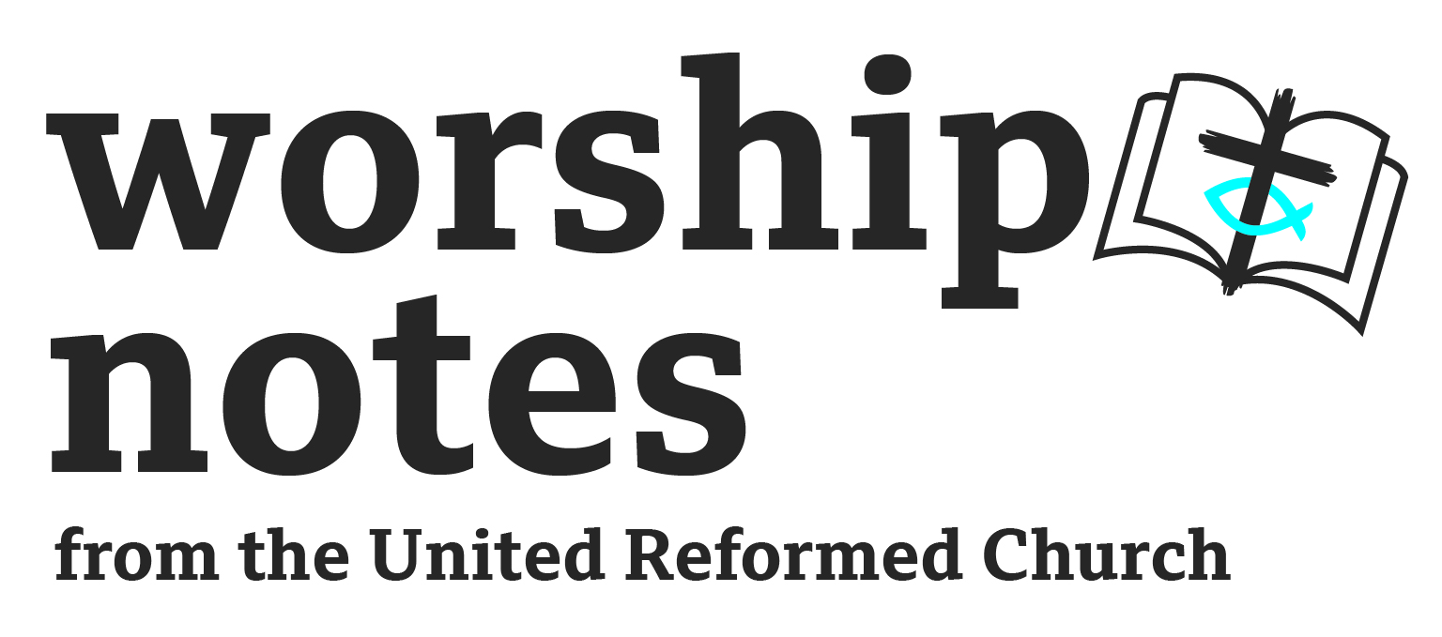
Sunday 11th December 2022

Advent 3

The Rev’d Andy Braunston

Call to Worship

One: In the darkness of these days,
in the gloom and despondency of our time,
when wars, instability, and chaos are all around us: we dare to hope

One: As of old when God’s people were promised
better times, healing, and restoration: we dare to hope

One: When we dwell in our self-imposed dungeons
and have given into doubt and despair,
we know that our healing is found when: we dare to hope

One: So we come to worship, we come to life, we come to God
and: We dare to hope

Prayers of Approach, Confession and Forgiveness

Eternal God, we come to meet you in worship,
knowing you give us strength in our weakness,
water in the dryness of our lives,
fruitfulness in our sterility, and strength in our fear.

O Most High,
you give us hope as you gave assurance to John the Baptist of old.
In our dungeons of despair,
you assure us of your love and truth;
in our confusion, you show us the way – a holy way where even fools can’t get lost.

O God-with-us, we confess that we have fallen into despair,
given into the gloom that pervades our age,
thought there was no hope, and tried to save ourselves.
Forgive us, O God of our salvation,
give us time to remember to trust in you, to turn back to you,
as we prepare for you to come again to renew and restore us. Amen.
Rejoice, O People of God,
as the desert shall rejoice and blossom,
as the people will see God’s glory,
as the dry places shall break forth with water,
so you are forgiven:
find the strength to forgive yourselves! Amen.

Advent Candle Lighting

In the darkness of these days, O Most High,
we dare to light candles in the gloom.
Candles to represent hope,
candles to represent your light in our dark world,
candles to represent the light you call us to be,
that we may be signs of the hope you give,
that we might be lights in the darkness of our world.
As we prepare for your coming again,
give us hope, bathe us in your light, and allow us to point to you,
our Rock and our Redeemer. Amen.

Prayer of Illumination

Give us patience, Eternal God, as we wait for your coming.
Give us patience, O Most High, as we discern your word read and proclaimed.
Give us patience, O Ancient of Days,
as we embody your uncontainable Word into our lives.
Give us patience, O God, as we wait for our world to be changed. Amen.

Readings

Isaiah 35:1-10 | St Matthew 11:2-11
Sermon Notes

We live in turbulent times. This year we’ve seen:

- war in Europe,
- threats to use nuclear weapons,
- international law broken and war crimes discovered.
- economic and political turmoil,
- something of a churn in Prime Ministers, Chancellors and Cabinet ministers.
- energy prices go through the roof with a price guarantee set up for two years now reduced to just six months.
- Scandals in policing make us wonder about the bodies that are supposed to keep us safe.
Of course the turmoil and worries we have are nothing compared to those who have had to flee their homes and countries due to war, terror, and poverty. Imagine the plight of Ukrainians seeing their country torn apart, or the plight of women, Christians and lgbt people in Afghanistan – increasingly looking like something out of a Margaret Atwood novel. Imagine being a mother trying to find food to sustain your children in war ridden countries in Africa.

These are difficult times and these times help us to understand the contexts of our readings.

Isaiah

The passage was written to give hope to a people in exile in Babylon. Carted off hundreds of miles from their home the exiles had to settle in a strange land. Their own land lay in ruins, the Temple destroyed, the political and religious elite either dead or now in captivity. With hindsight we know that freedom was coming but for those shipped off to Babylon it must have been an utter catastrophe. The exile lasted 70 years only the very old would go back and they’d have left as children. Those who left would have never seen their homes again. The first deportees would have been mentally and physically traumatised - like those now who seek to cross the Channel each day. Living with mental and physical wounds they knew that hope was gone.

These are the people Isaiah spoke to where, audaciously, he told them that the weak would be given strength, the fearful given courage, the feeble saved and the coming of the Lord would bring redemption.

Salvation for Isaiah’s listeners would have meant a return to Israel – and the way of return instead of being a place of fear would become a highway of joy. Travelling back to Israel would have been a massive risk – the wilderness was dangerous, no soldiers to protect you, unsure of the way, wild animals to prey on you – no wonder that some Jews stayed and formed a Jewish community in Iraq and Iran which is still there today. Yet the promise in his passage was that the wilderness would be safe, the journey holy, fear would be turned into joy. It’s quite a promise of restoration; it gave hope to the people then and can speak to us now as we are fearful in our own day.

What might salvation mean now for those on the edge? Don’t dwell, at this point, on spiritual salvation – Isaiah, after all, saw salvation in the return to Israel after Exile where God’s sovereign power would guide and help the people flourish.

St Matthew

John is in prison; Herod had heard one too many sermons about his lifestyle, his incestuous marriage and his domestic policies. John was no fool and he would have realised that in the ancient world prison was a staging place on a journey to exoneration, exile or execution. Given John’s preaching topics, exoneration and exile were unlikely outcomes. Through his followers he sent word to Jesus and his message is one of doubt and fear; it’s understandable.

In our darkest moments we can ask what the point of our life is, what good we’ve achieved, whether anyone has ever listened to us. So John sends word showing he’s doubted.

Jesus’ reply echoes our Isaiah reading – the blind see, the lame walk, the lepers are cleansed, the deaf hear, the dead are raised and the poor have good news for a change. And Jesus praises John to the crowd “a prophet, yes, and more than a prophet.” Jesus tells John not to doubt but look and see what he was doing, to reassure John that he was right to prepare the way for Jesus.

You might want to explore when you doubt now (without getting too personal) or you might want to help your congregation understand when they doubt – do they wonder about the church’s future, the future of faith in these islands for example?

Joining the threads

Isaiah assures broken exiles that the Temple will be rebuilt, the ruined nation of Israel restored, and shows that all will be made new again. Jesus tells John, in the depths of despair and awaiting a grisly death, that his ministry was not in vain and that no one in the Kingdom of God is greater than him.

These are good themes for an Advent where we live with political and economic uncertainty. These are good themes as we look at the destruction in Ukraine and millions of uprooted people in our world. These are good themes as we worry about climate change and all that will bring – they are good as they offer hope. Not a pie in the sky “it will be alright” but a hope that, even in the midst of despondency and despair, God can be at work. Hope that even in an executioner’s dungeon, words of hope can come. Hope that even in the midst of destruction and gloom, God’s hope will break through.

- As markets rise and fall we know that God remains constant.
- As wars and rumours of wars enfeeble us we know that God is our refuge and strength.
- As politicians come and go, often with alarming speed, we know that God remains.
- As bills rise yet wages and pensions remain constant, as we battle with despair, we know that God gives hope.

Hope, not in a change of political approach, but hope in something more lasting, a coming Kingdom where there will be equity and fairness. Hope not in a new Prime Minister and Chancellor, but in a baby who will show a different form of leadership, a radical form of renewal where the lowly are lifted up and the rich sent away empty handed. Hope not in a brokered peace which won’t last but an everlasting peace, heralded by a wounded suffering servant.
Affirmation of Faith

In a society which sees the earth as expendable,
we turn to the God who makes heaven and earth.
In a world that faces the horror of war;
we turn to the God, who calls us to peace making and justice seeking.
In a world where financial empires seek to enslave and impoverish us,
we turn to the God who enables us to spoke the wheels of injustice.
In a world bound to the tyranny of its ruler,
we turn to the God who sets us free.
In a world longing to be free,
we turn to the God who liberates us from the powers of evil, injustice and darkness. Amidst the powers of darkness and gloom,
we turn to God, light of light, who cheers and changes us. Amen

Offering

Our world worries about money and goods. We always want to have more than enough, to have some set aside for a rainy day and we put our security in what we have rather than in the gracious goodness of God. We cling to money forgetting that it’s toxic and needs to be diluted through giving. As we journey through Advent we’re reminded, again and again, of the power of giving – the gift of presence as we well as the gifts of time, talent and treasure. So rejoice as you give! Rejoice as you give in the collection using envelopes or simply popping your cash in. Rejoice as you give directly to the bank. Rejoice as you give of your time and your talents; remember God loves a cheerful giver as giving is good for us.

Let us pray

All good gifts come from you, Eternal One,
help us to let go and give away
some of our time, some of our talents, and some of our treasure -
that in our giving, we may become rich,
and your world may become whole. Amen.

Intercessions

Eternal One,
we praise You for Your faithfulness to your people of old,
calling them home after bitter years of exile,
making straight dangerous highways,
causing the desert to bloom,
restoring their life and hope.

Eternal One,
give us hope in our own age,
hope that the powers of evil
which rule our world won’t have the last word,
hope that the poor won’t always be with us,
hope that the deserts caused by our rape and pillage of Mother Earth,
will once again flourish with life.

O Enfleshed God,
You offered hope to John the Baptist
when in the darkness of his dungeon of despair he doubted.
Give hope to Your people now,
hope that times will improve,
hope that we can make a difference with our love and our ministries,
hope that You’ve not finished with us.

O Spirited God,
you inspired Your people of old,
giving hope in bad times,
enabling them to trust in You,
bless with Your love those we now hold before you…

bless Your Church as it seeks to show Your love and grace,
that we may be agents of hope and peace.

O God, hear our prayers as we now pray as Jesus taught….

Our Father…

Blessing

May the long promised Saviour
who releases captives,
binds broken hearts
and enriches the poor
bless you that you proclaim welcome to the coming kingdom
where all things will be put right.

And the blessing of Almighty God, or And the blessing of Almighty God
Father, Son, and Holy Spirit, Eternal Majesty, Incarnate Word,
be with you all, and Abiding Spirit
now and always, Amen. be with you all, now and always, Amen

Hymn Suggestions
 | RS | CH4 | StF | MP
Alleluia! Hurry, the Lord is near |  | 280
Comfort, Comfort Now My People |  | 274
Arise Shine |  |  | 170 | 110
Come Now O Prince of Peace |  | 275
Hark the Glad Sound | 137 | 277 | 171 | 210

RS – Rejoice & Sing | CH4 – Church Hymnary 4 | StF – Singing the Faith | MP – Mission Praise

