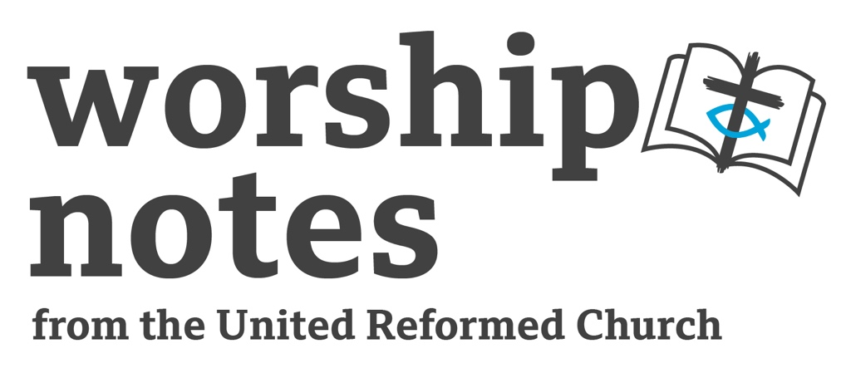
Sunday 4th
December 2022
The Second Sunday
of Advent
The Rev’d Dr
Elaine Colechin

Call To Worship

A voice calls in the wilderness:
“Prepare the way, make the path of the Lord straight.”

Straight for whom?
Those who seek to the Lord?
Or for the Lord to enter in?

As we come to worship God this Advent, we prepare for both—
Christ’s return
and our return to Christ.

So let us rejoice.

Prayer of Approach

With words of gratitude and songs of praise, we approach you, O God,
because of your wonderous works and mighty acts.
We seek your presence and guiding wisdom
so that as your people we live our lives in a way that always
pursues justice, loves kindness and walks your way
filling the world with your glory
shown us by Jesus Christ,
the promise of Advent
and whom we wait to return. Amen

Prayer of Confession

A voice calls in the wilderness: “Repent, for the kingdom of heaven has come near.”

Matthew 3.2
Gracious God, daily your kingdom comes near
through the generous hands of others,
the call for justice,
the desire to see the end of poverty and neglect and a rebalancing of society.
Yet, the world as you would will it to be is not the world we always strive to make it.
We get distracted by a need for wealth;
power and authority go to our heads misguiding our actions and words;
our own vulnerabilities take priority.
As we look for your return and long for your coming forgive us.
Restore us to your path, guiding us in your ways of righteousness and truth.
Through Jesus Christ for whom we wait. Amen

Assurance of Forgiveness

Hear the good news.
The Lord is faithful in all words, and gracious in all deeds.
The Lord upholds all who are falling, and raises up all who are bowed down.

Psalm 145.13-14
Therefore, let us be assured that God has not just come near,
God is here:
encouraging us while challenging us,
accepting us while confronting us,
and always forgiving us in these things.

Thanks be to God.

All Age Activity & Introduction

Making ready… Introduce the idea that certain things in life do not just happen, they have to be prepared for. Ask if anyone can think of some examples and what they did to prepare.
Slightly more tricky question (more directed at older young people/adults):
Did your preparations really prepare you?

We cannot anticipate the unexpected and so we always hope that how we prepare will allow us to overcome any obstacles along the way. But there are always things we are never quite prepared for. Today in our gospel reading, we hear that Advent call to get ready, yet our other scripture readings challenge us in what we are readying ourselves for and whether we will ever be truly ready for what Advent is about: the coming of Jesus Christ.

Prayer of Illumination

A voice calls in the wilderness: “prepare the way.”
For us to prepare your path, we need to know your way, Lord God.
Teach us your truth, anointing us with Spirit,
and make us ready as Christ’s body today. Amen
Readings

Isaiah 11: 1 – 10 | Psalm 72: 1 – 7, 18- 19 | Romans 15: 4 – 11 | St Matthew 3: 1 - 12

Sermon Notes

There are a number of different themes one could pick up on from the lectionary for this second Sunday in Advent. Both the Isaiah and Matthew readings identify the characteristic of the coming Messiah. Yet all the reading talk about God’s hope, what it might look like and our part to play in bringing it about.

Isaiah 11.1-10

Although prophecy can and does point towards future events, in can also be related to the situation at the time. King Ahaz, who was the king of Judah at the time of the first part of the book of Isaiah, was seen as having failed God and the people. He had caused the mighty tree of the Davidic line to fall. However, all was not lost, there was hope in the rule of his son, Hezekiah, that was to come. And that hope was harmony and peace.

Could a king who would sit as judge deliver of such hope? Can new life come grow from a tree that has fallen?

Hezekiah could be seen as another branch of the same tree, but the shoot does not come from the stock of David, we are taken a generation further back. This changes the emphasis on who will rightly and justly rule—it is no mere inherited title or privilege—it is bestowed and empowered by God. Therefore, it would be in God’s enabling that righteous rule of God’s people would come forth and God’s order for creation restored.

Psalm 72.1-7, 18-19

These verses from Psalm 72 echo the words of the prophet turning them into a prayer for God’s blessing. To rule with justice, the king needs the support of God and God’s anointing. As words accredited to King David, they hand that inherited sovereign rule of a nation to the next generation with that hope that it will be continue until the end of time.

Romans 15.4-11

When it comes to the letters of the apostle Paul, it is always worth exploring what was going on in the church or society around the church that might have caused Paul to write in the way he did. One of the issues in the church of Rome was its cultural diversity and this was causing problems. As we approach the end of the letter, Paul really focuses in on the division between the Jews and Gentiles in the church. This was not God’s intention for the church—it was not to be a place where anyone should feel excluded! Sure, Jesus was a Jew and as Messiah, he fulfilled the promises made to the Jewish ancestors. Yet, this was not his only purpose. He came to make God’s boundless mercy known to all. Therefore, whether Jew or Gentile, this was their hope: all should come to know God as glimpsed through Jesus Christ. That shared hope would be what would bring harmony among them, not a set of laws for a different time and place.

As the Church today prepares for Christ’s return, is it that hope that unite us?

St Matthew 3.1-12

In contrast to harmony hoped for in prophecy of Isaiah and Paul’s words to the church in Rome, there is some uncomfortable division going on in John the Baptist’s words to the Pharisees and Sadducees. The old wood being cut away, the chaff being sorted from the wheat, judgement in the strongest sense of the term. Yet this the curveball that we need to take us from the prophecy of old to being the church of today.

Reading Isaiah’s prophecy in the context of times of Isaiah, the restoration of God’s people was controlled by the centre which was seen as the nation’s sovereign. Yet it required a very different understanding of power and rule, which may have been in a dynasty’s roots but was not strong enough to keep the dynasty from failing in its task. God response was to try a different approach. Rather than from the centre bring change from the margins. John the Baptist pathed that way and the church should continue that mantle.

Prayers of Intercession

God of hope,
in this season where we watch and wait for your return
and we celebrate that you took on our mortal form
to live among us to show us your way,
we acknowledge how little has changed.
The poor remain marginalised, the needy are ignored,
and we think about peace and harmony being about an easy life
rather than bringing about radical change in the world.

Therefore, as we prepare for the change that you will bring,
we pray for ourselves and the world.

In this world where there is a great chasm
between those that have and those who have nothing,
we pray for real change in political policy, economic goals and societal understanding.

We give thanks for the agencies that challenge social norms and seek level-up society.
And we pray for the charities that try to make a little go a long way
so those with nothing have something, even if it is only the basics to survive.
We pray for those nations which are ruled by corruption rather than justice;
where belief and free speech is controlled and persecuted against;
where being different is outlawed.

We pray for the Church in all these situations and its grappling with its own divisions.
We pray for the wisdom and counsel of the Holy Spirit
so that we can be true messengers of hope
in those places that are without hope, that have no future vision.

And we pray for ourselves, for current challenges on our lives,
for circumstances where courage and insight are needed.

All these prayer we gather in the one prayer
that Jesus gave us to pray when all other words and knowledge fail us:
Our Father …

Affirmation of Faith

‘Without any doubt, the mystery of our religion is great …’
1 Tim. 3:16a
yet this Advent, let us proclaim the faith of the Church universal
which the coming of Christ made possible.

We believe in God as parent, creator and protector, root of all being.

We believe in Jesus Christ — God in our midst —
coming as that fragile promise of a baby yet to be born
and whose birth was heralded with hope.
Who John the Baptist announced would turn the world upside down
seeing deep into the human heart
separating the wheat from the chaff
and the sheep from the goats.
Yet who passed through the grip of death so all might know justice and peace—
God’s gifts of mercy and compassion far beyond our human understanding.

We believe in the Holy Spirit, implanter of truth,
who brings us to birth as the body of Christ,
holds us together, and empowers us to confront and transform
all that is wrong in our lives and the world
for the glory of God who draws near, who is always near
and who promises to come near again. Amen

Offertory

In preparing for what God’s hope will and does bring into the world
we make our own offering to God.

God of hope,
through Jesus Christ you have set change into motion,
through the Holy Spirit you enable and encourage that change to continue.
Through what we can offer— time, talents, tithes—
use us to prepare for your change to come. Amen

Blessing

Go then to prepare the ground
for what God’s hope brings.
And may the Spirit of the Lord rest upon,
giving wisdom, counsel and understanding,
as you follow Jesus Christ and journey in God’s love. Amen

HYMN SUGGESTIONS
 | RS | CH4 | StF | MP
Come, Holy Spirit, come! |  | 594
Hail to the Lord’s anointed | 127 | 474 | 228 | 204
Hills of the north, rejoice |  |  | 172
Long ago, prophets knew |  |  | 178
On Jordan’s bank the Baptist’s cry | 134 | 334 | 182 | 538
The voice of God goes out to all the world | 131 | 283

RS – Rejoice & Sing | CH4 – Church Hymnary 4 | StF – Singing the Faith | MP – Mission Praise

Another Suggestion…

The Time Has Come When, From the Past
John L Bell (b.1949) From: Known Unknowns by John L Bell and Graham Maule,
Wild Goose Publications, 2018
Sung to the tune: Sussex Carol (CH4 294, MP 537, R&S 327)

The time has come when, from the past,
prophetic words ring true at last;
though earth’s hostilities increase,
God’s promise is of lasting peace.
Hallelujah! Prepare the way.
Hear what God’s chosen prophets say.

2: The time has come to make it known
that every tear and pain and groan
are registered in heaven above
to be redeemed by holy love.
Hallelujah! Prepare the way.
Only Love lifts us from dismay.

3: The time has come to make amends:
earth and its people should be friends.
Erase the policies of death,
spread hope with every vital breath.
Hallelujah! Prepare the way.
God gladly comes to earth to stay.

4: The time has come to share good news,
to sweep the floor and mend the shoe,
prepare to protest, praise and dance
for God is eager to advance.
Hallelujah! Expect a birth:
God’s gracious feet will touch the earth.

