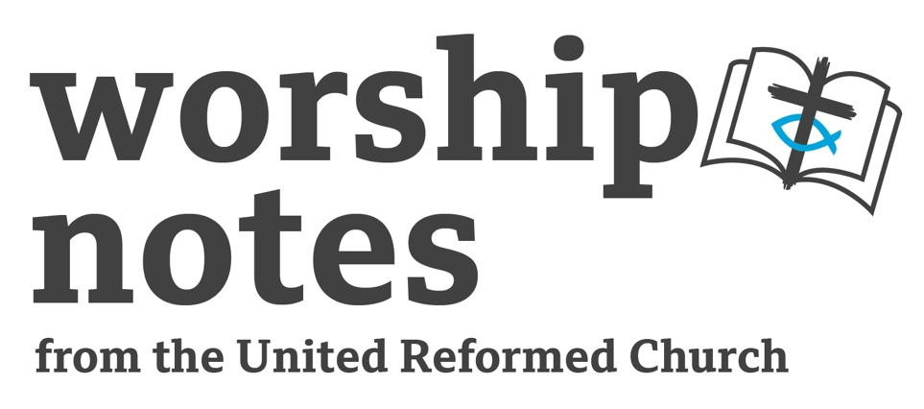

Sunday 27th November 2022

The First Sunday of Advent

The Rev’d Jan Adamson

Call To Worship

A new year dawns, a saviour comes.
A time to prepare, a time to get ready.
A time to reflect, a time to repent.
A time to begin again, a time to start afresh.
A time to worship and adore.

Prayers of Adoration, Confession and Assurance of Forgiveness
Lord God, you tell us that you are coming among us, and we are excited.
You come to be our King. You come to be our Saviour.
You come to be our Shepherd. You come to be our friend.
And we know, Lord Jesus, that you come for everyone in our family,
our church, our community, our land and our world.
Help us to make you known by word and deed
so that people will be ready for your coming.
And when you come, Dear Jesus,
come and make your home in our hearts, that we shall be healed.

We live in a chaotic world, Lord,
for though you have shown us the way of life, we have not walked in it.
We have gone our own separate ways, done our own things.
We thought we could live without you.
We have pretended not to need you.
We have tried our independence.
Now loving God, forgive what is past; renew what is,
and lead us into the future of your Son, for he only is Lord, and there is no other.
He is the truth that sets us free.
God of our lives help us to walk in his ways.

Pause

To all who turn to him he says: “Your sins are forgiven!”
He also says: “Follow Me!” Thanks be to God. Amen

Readings

Isaiah 2: 1 – 5 St | Matthew 24: 36 – 44

Sermon Notes
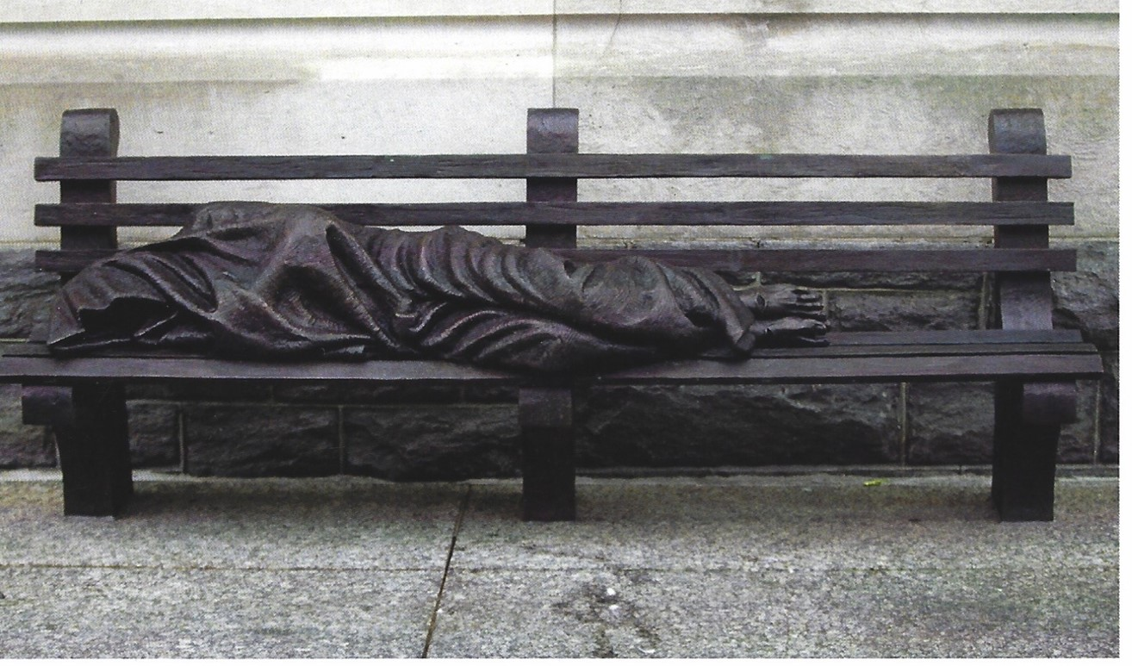

“The Homeless Jesus” by Timothy Scmalz photo credit: Jan Adamson

This picture is a life-sized figure cast in bronze of a person sleeping on a park bench. The figure has a blanket covering the head, but the feet are uncovered. The feet however, are pierced suggesting that the figure is Christ, hence it being known as the “Homeless Jesus!” The artist intends to illustrate the saying from Matthew’s gospel: ‘In so far as you did this to one of my brothers and sisters, you did it to me.’ The church for which this sculpture was made, refused to accept it. It was later blessed by Pope Francis and since then copies have been cast for countries all over the world. For Scotland, Glasgow Churches Together received planning permission from Glasgow City Council to place this one behind St Georges Tron – right in the heart of the busiest pedestrian areas of central Glasgow. Private subscriptions raised the £30K for its installation.

The cost of living crisis will plunge more people into homelessness. This Advent dare we hope for an end to homelessness?

Isaiah speaks of insecurity. The people of Judah had been living under the very real threat of invasion. They feared they were losing control over more and more of their land and so it is into this midst of fear and anxiety that Isaiah offers a vision of hope. In our own age Ukraine lives with invasion and threat of more war and war crimes. For them, where is hope? Where will they go? Where can they go? Might we have hope for and end of war? Hope for Peace?

Christians have looked forward to the return of Jesus who emphasised in his teaching, “You must be ready, because the Son of Man WILL come at an hour when you do not expect him!” Might we hope for the Lord to come again?

How might we use these passages of hope to suggest how we might have hope now – hope for our world, hope for justice, hope for the Lord to return and sort it out and, in the meantime hope that God’s people will change God’s world.

Offertory

The work of our churches continues to inspire through the Gospel, continues to care, and continues to walk alongside many in differing, challenging circumstances. Your giving enables this work help reach those who need it most. Thank you, whether it be via direct debit, card readers or envelopes into the offertory plate, your contribution is so very valued and appreciated.

We pray:

Bountiful God, we give thanks for all that we have been blessed with.
Our skills and talents, our friendships, families, communities to name a few.
May these monetary gifts given in response go some way towards your work
and presence being made known to others. Amen

Prayers of Intercession

Creator God, we give you our thanks for your creativity, your generosity in sending us your Son and for continued support through your gift of the Holy Spirit.

We come before you to seek your healing. We think today of those living with HIV and AIDS and thank you for the treatment successes, and that people with HIV can live long and fulfilled lives.

We pray for all the sick, the lost, the lonely, the grieving. We pray for the homeless, and for those who bring hope through shelters and hostels. May they find Hope and be filled with your peace.

Holy God, you call all nations to you and we pray for all nations, that we may live together in peace together. We pray for diplomats and those who seek to resolve conflict without war.

Loving God, heal our brokenness, so that we may put aside our anger and genuinely seek peace. Where we are at odds with those around us, give us grace to seek reconciliation.

Help us we pray to open ourselves to your presence, encouraging us to work for peace and justice for which we HOPE for each day.

Fill us with your Spirit so that we can be among those who create a community of wholeness and Shalom.

In the name of Jesus for whom we wait in patience. Amen

Blessing

© Jan Richardson from Circle of Grace: A Book of Blessings for the Seasons Prayers extracted and amended from Rootsontheweb and URC Prayer Handbook 2022

In the waiting, may we hold onto
the enduring of love,
the persisting of hope,
the remembering of joy,
the offering of gratitude,
the receiving of grace,
and the blessing of peace. Amen

Hymn Suggestions
 | RS | CH4 | StF | MP
O come, O come, Emmanuel |  | 273 | 180 | 493
All My Hope On God is Founded |  | 192 | 455 | 16
I Rejoiced When I Heard Them Say |  | 83 | 26
In Christ Alone |  |  | 351

RS – Rejoice and Sing, CH4 – Church Hymnary 4, StF – Singing the Faith, MP – Mission Praise

