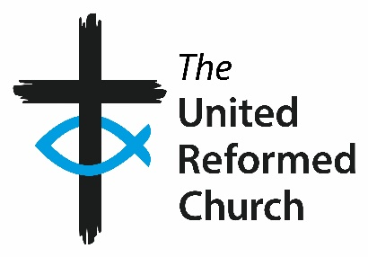
Role title | Member of Pensions Committee
Governance area | The Pensions Committee’s role is to ensure the smooth running of the Pensions Office, in terms of compliance and communications as well as seeking to ensure the work of the Pension Providers is meeting our needs (as outlined in the Terms of Reference)
Main points of contact | Committee Convener and other members of the Committee  Pensions Officer  Chief Finance Officer  Representatives of the current Pension Providers
Connected roles | None
Sources of support | Meeting Minutes taken by the PA to the Chief Operating Officer and the Chief Finance Officer  Secretary to the Committee is the Pensions Officer
Location | Most meetings will be online. Where meetings are in person, these are likely to take place at URC Church House, London.
Time commitment | 3 online meetings and 1 in person meetings per annum (dates and times suitable for the membership of committee) plus additional follow up work between meetings. Meetings are usually held Monday-Friday during normal working hours.
Remuneration | Volunteers are not remunerated. The URC will ensure financial expenses incurred by volunteers whilst supporting the work of the Pensions Committee will be reimbursed, in accordance with the URC expenses policy.

Role description
Background: We have one paid member of staff, our Pensions Officer, who undertakes the day-to-day work in handling the lay staff and ministers’ pensions scheme. The former Final Salary Schemes are closed to accrual and all lay staff and ministers are now in a Defined Contribution Scheme with AON.
Committee Summary: The Pensions Committee is currently a sub committee of the Finance Committee, but will become a sub committee of the new Resources Committee which will form after General Assembly 2024.

Principal responsibilities and duties

Attending & Participation in Meetings:
- Attend as many of the Committee’s meetings as practicably possible.
- Read all papers carefully in advance of each meeting in order to participate in discussions and ask appropriate questions.
- Familiarise yourself with the Committee’s Terms of Reference.
- Be willing to support particular pieces of committee work outside of the meetings from time to time.
Training:
- Undertake training in key areas as highlighted within the induction and through ongoing conversation with the Convenor and Secretary

Working with other committees and volunteers
This section lists the type and level of interaction that this role has with committees and other groups. It may vary from time to time and as directed by the Business Committee/General Secretariat.
Members of Pension Committee will:
- From time to time engage with members of the pension schemes and members of Synods.
Expected standards
This section refers to the way in which the role should be done rather than the duties / responsibilities.
- Promote a culture of open and effective communication.
- Actively foster an environment which nurtures equality and cherishes diversity.
- Take responsibility for own personal development and develop skills and knowledge applicable to this role.
- Ensure compliance with Safeguarding practice.
This role description reflects the overall scope and responsibilities of the role. However, it may change and evolve over time in order to meet organisational needs and this job description will therefore be subject to periodic review and change if required.
Person specification

Role: Member of Pensions Committee

Requirements | Essential | Desirable
Experience and knowledge | - Experience of working in the finance sector.  - Some expertise in the field of workplace pension. | - Knowledge of URC governance structures or a willingness to learn.  - Actuarial experience
Skills and  abilities | - Work collaboratively with a diverse range of people.  - Good IT skills including Microsoft Office, Zoom and email. | - Good communication skills  - Ability to communicate technical issues effectively to non-specialists
Other | - Member of the United Reformed Church.

