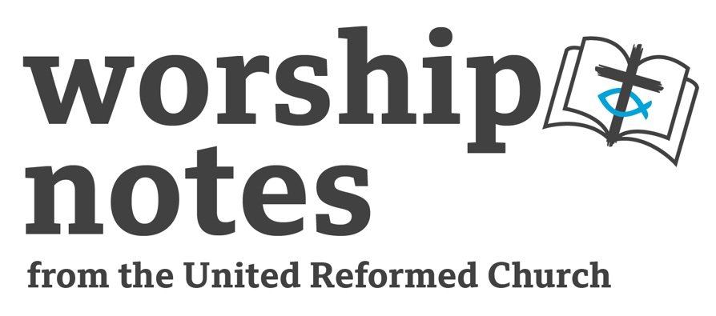
Sunday 23rd June 2024
Proper 7 | Ordinary 12
The Revd Dr Nick Jones

Call to Worship

O give thanks to the LORD, who is good;
God’s steadfast love endures forever.
Some went down to the sea in ships,
doing business on the mighty waters;
they saw the deeds of the LORD,
the Lord’s wondrous works in the deep.
For God commanded and raised the stormy wind,
which lifted up the waves of the sea.
from Psalm 107

Prayers of Thanksgiving and Approach

God of constant love and grace, ground of our being,
we gather today to draw near to you and to worship you.
We come not because we must but because we want to,
to share our thanks and praise,
to be drawn deeper into relationship with you
and into community with others.
We come together to think of the mysteries of your love,
and commit ourselves to your values,
to helping build your kingdom,
to establishing peace and fairness.
Lord, when we feel like David, struggling against the odds,
help us to be ready to act bravely in the name of justice.
When we feel like Goliath, and we have power over others,
help us to act with kindness and compassion.

Eternal God, this and every day, we bring our praise to you,
and we thank you for all you have done for us.
You open your heart to us, and we respond.
We give thanks for the world around us,
the streets of our towns and cities,
fields, hills, beaches,
the beauty of nature which surrounds us
and the people we share our life with.

God of compassion, you bring meaning and purpose to our living,
and allow us to ground our lives in your love.
You are our God, we are your people,
We give thanks too for the sense of belonging and safety
you can bring to us,
as we know that in the storms of life you are with us.

Confession and Assurance of Pardon

We turn to you, God of love,
knowing that in your mercy and goodness
you are always ready to forgive us our mistakes,
and guide us as we try to do better in the future.
Through you Lord, our sins are forgiven.

Therefore, with confidence in your forgiveness
we confess to you
the things we have done wrong and we regret;
times when we have not loved our neighbour,
times when we have been selfish,
and put our choices ahead of others’ needs,
times when we have done what is easy
rather than what is right,
times when we have not challenged injustice
but been a part of systems which oppress and discriminate,
times we have been thoughtlessly cruel or unkind.

God of second chances, help us to grow closer to you
and to your ways. Amen.

Prayer for Illumination

Gracious God, help us to read scripture
hearing its message,
embracing its difficulties and paradoxes,
exploring its history,
seeing where it leads us as people,
trying to apply it to our lives today.
And we pray in this we will be guided
by your Holy Spirit moving among us.
Amen.

Children’s / All-age activity

For David v Goliath perhaps you could find the tallest and shortest members of the congregation and act out the story (though not with a real stone and slingshot!) Perhaps give them different tasks to do, which show that sometimes being tall is advantage, but so sometimes is being smaller (like retrieving something from high up, or from the floor.) Alternatively offer the choice of two gifts, one in a small box and one much bigger. Which do we instinctively want, and is that is always the right choice?

For the reading from Mark give out coloured paper and ask the congregation to make paper boats – you can easily find origami online instructions to share. Float them in a container of water, and then switch on a fan to create the storm. See which boats survive and which ones sink! Note that you can turn the fan on and off at will, but when faced with a real storm we simply have to endure it – but we can turn to Jesus.

Sermon Notes

1 Samuel 17:(1a, 4-11, 19-23), 32-49 This is one of those occasions the lectionary suggests a non-continuous series of verses from a longer passage, missing some parts out. You can always think about what want to focus on and adjust the exact reading. The combat between David and Goliath is a well-known story, although there is always a danger in assuming everyone in church is familiar with any particular piece of scripture.) A little bit of historical context might be helpful. You can riff on the idea of a David vs Goliath struggle, one where an underdog takes on a more powerful opponent, and why this is still such a resonant idea for us today. There’s a question for us to consider – as the Church are we David or Goliath? Is God on our side and what does that mean? Maybe we, together and individually, play both roles in different part of our lives. When we have power we should be careful in how we use it, and when we are set against power we should try to be brave. You could also – with due care and sensitivity – use this tale of war and empire as a way into thinking about contemporary events in the middle east, and reflect on how the depiction of war might trouble us as contemporary Christians. Does David at times represent the values of empire which are opposed to God’s kingdom?

Mark 4:35-41 Mark’s telling of this story is typically short and to the point, but it’s evocative and powerful nonetheless. Maybe you have a story to share of being on a ship during a storm, or in an aeroplane during very heavy turbulence. There are various paintings and images of shipwrecks you could show to emphasise the power of the sea – e.g. Turner’s ‘Storm at Sea’ https://www.tate.org.uk/art/artworks/turner-storm-at-sea-d25373). On a personal level we can take the reading to be about God being with us to help and protect us when we feel afraid. Do we turn to God when we need help? Does having faith make us feel more secure? There’s a link into talking about climate change if you like. We can’t individually affect the weather or stop a storm, but collectively humanity has caused our climate to change. Unlike Jesus we can’t stop the storm instantly, but we can act together to navigate rough waters, with the support of God. Drawing both readings together you could reflect how both show seemingly impossible struggles that are made possible by God.

Prayers of Intercession

God of love,
we have today given thanks for all you have done for us,
and we have heard from scripture of your grace and compassion.
We give thanks for the gift of our world,
our planet and its people,
but we acknowledge that planet is damaged and polluted,
and that across the world many people are suffering.

We pray for the Davids of our world,
people willing to take on the powerful in the name of justice,
and we pray they may have courage and strength.
We pray for the Goliaths,
those people with power and authority;
presidents and Prime Ministers,
those whose decisions can affect many lives.
We pray those with power will act
with compassion, honesty and integrity,
rather than through narrow partisan interest.

Creator God, we think again of the universe you made,
and of the effects of climate change on our planet.
We pray for people who have lost homes and livelihoods
due to drought or flood or famine,
and we pray the nations of the world
can join together in helping those in need.
We pray for people living in poverty,
those in our own communities struggling
with the high cost of living,
and people across the world
without access to clean water and sanitation.
God of plenty and generosity,
we pray for a world in which your resources are shared fairly
and nobody goes hungry.

We pray for people struggling with illness,
either mental or physical;
for those waiting for treatment
or recovering from operations,
at home or in hospital.
We give thanks for the dedication
of NHS staff and careworkers,
and pray that everyone will receive
the care that they need to flourish.

God of peace and unity,
we pray for peace wherever there is conflict,
wherever there is war,
and we hold before those regions and nations
where wars are being fought today,
or the effects of conflict are still felt.
We think of Ukraine, Gaza, Yemen, Syria,
and many other places.
We pray for people living in fear
of bombing from the air or attack from land,
and all of those forced our of their homes.
We pray for refugees and asylum seekers
trying to make new lives in new places,
and we pray they will be met with compassion
rather than suspicion and hatred.

We pray for people across the world
who are victims of discrimination.
We pray for people held back by racist attitudes and structures,
by homophobia and transphobia,
and we remember that your love reaches out to each and every person.
Help us, in the church, to become a model of radical inclusion.

Praise the Lord, all the earth.
A time is surely coming when the poor will be fed,
the powerful will bow down,
and all creation will know that God is Lord of all.
Praise the Lord, all the earth,
as we bring our prayers humbly before God today,
trusting as always in God’s everlasting love and mercy. Amen.

Blessing

Loving God, help us to see you at work this week
in the people we meet and the places we go,
help us to be builders of your kingdom.
And may the grace of God almighty,
Creator, redeemer and sustainer,
be with and remain with us all, and the people we love,
now and always. Amen.

Hymn Suggestions
 | RS | CH4 | StF | MP
Who would true valour see± | 557 | 535 | 486 | 224
Guide me O thou great Jehovah | 345 | 167 | 465 | 201
The love of God is broad like beach and meadow | 108
Will your anchor hold in the storms of life | 598 | 737 | 645 | 770
Our God, our help in ages past | 705 | 161 | 132 | 498
The love of God comes close | 107 |  | 654 | 940
People draw near to God in their distress | 342 | 393* | 640 *
My hope is built on nothing less |  |  |  | 473
Outrageous grace |  |  |  | 1114
Hail to the Lord’s anointed | 127 § | 474 § | 228 § | 204

RS – Rejoice & Sing | CH4 – Church Hymnary 4 | StF – Singing the Faith | MP – Mission Praise

§ You may find Ellacomb a better, and more joyful, tune.
* the version in CH4 & StF is a different translation of the same words.
± if using a printed order or service sheet you may prefer to use this version of To Be A Pilgrim

We who would valour see
let us come thither;
one here will constant be,
come wind, come weather;
there’s no discouragement,
shall us them once relent
our first avowed intent
to be good pilgrims.

2 Whoso beset us round
with dismal stories,
do but themselves confound
our strength the more is.
No lion can us fright,
we’ll with fierce giants fight;
but we will have a right
to be good pilgrims.

3 Hobgoblin nor foul fiend can daunt our spirits;
we know we at the end shall life inherit.
Then fancies fly away, we’ll fear not what they say;
we’ll labour night and day to be good pilgrims.

