United Reformed Church Commitment for Life May 2024

Moving
S
Storie

Committed to supporting our global partners ZIMBABWE

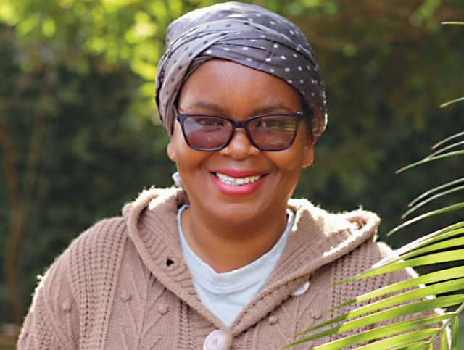
eet the Team: Grace Mugebe
Gaza: What can I do?
Events in Gaza are deeply distressing. It is difficult know how to respond. The URC has a small team that works to highlight issues in Palestine. The URC Sabeel-Kairos Action Group can suggest useful resources for helpful actions.
You can link up with them at
sabeelkairos.urc@gmail.com.

You can also support the Commitment for Life Gaza appeal here. The funds will go to helping people in Gaza obtain food and water.
Image: ©Kevin Snyman
M

On the recent Commitment for Life trip to Zimbabwe, we met up with the wonderful Grace, the Programme Manager for the Zimbabwe team. Grace was very welcoming and eager to let us
know how much she appreciated the support of Commitment for Life.

Grace has over 20 years’ experience in governance programmes, gender equality, public health, organisation development, operations management, and communications. Grace manages the Zimbabwe country programme portfolio covering social, economic, humanitarian and climate justice projects.

Grace holds several degrees, including a Master of Science in Development Studies. Without the gifts of skilled people like Grace, our work in Zimbabwe would be severely curtailed. Grace speaks about her appreciation for all that Commitment for Life does for Zimbabwe. Thank you for all you do too, Grace!

commitmentforlife@urc.org.uk www.bit.ly/URCFL

