United Reformed Church Commitment for Life May 2024

Moving
S
Storie

Committed to supporting our global partners IOPT

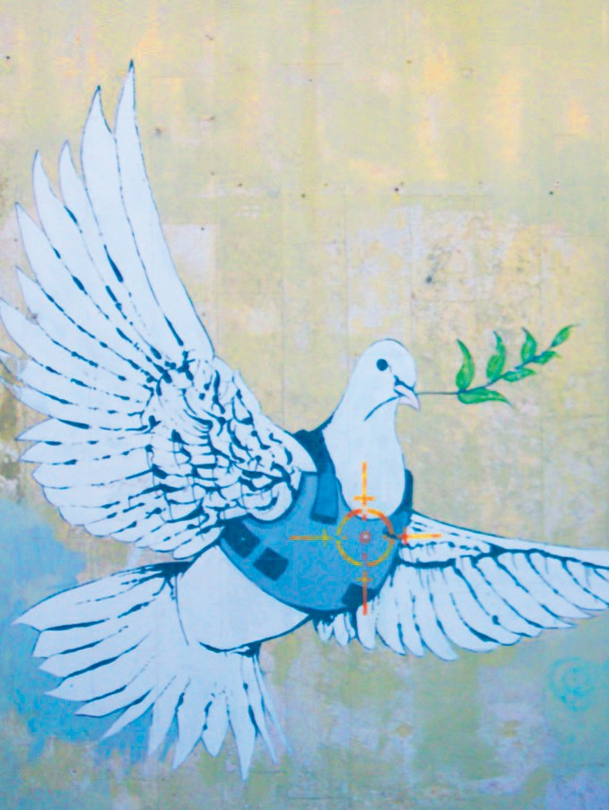
fter Hamas attacked, killed and captured Israelis on October the
Gaza: What can I do?
Events in Gaza are deeply distressing. It is difficult know how to respond. The URC has a small team that works to highlight issues in Palestine. The URC Sabeel-Kairos Action Group can suggest useful resources for helpful actions.
You can link up with them at
sabeelkairos.urc@gmail.com.

You can also support the Commitment for Life Gaza appeal here. The funds will go to helping people in Gaza obtain food and water.
A
7th 2023, the ongoing Israeli government’s military response has shocked the world. Using US, German and UK weapons, the Israeli Defence Force
(IDF) has indiscriminately bombed entire neighbourhoods, destroying churches, mosques, universities and homes. They have targeted men, women, and entire families desperately fleeing with nowhere to go.
Image: ©Kevin Snyman

Some IDF soldiers have even targeted people desperately seeking food from aid trucks. The Israeli government has authorised the use of both AI and starvation tools of war.
Time will tell whether the actions of the Israel amount to ethnic cleansing and genocide, though this seems practically indisputable.

The United Reformed Church has joined with ecumenical partners in consistently calling for an immediate and unconditional ceasefire. We have urged our government to cease providing arms to a potentially genocidal regime. Indeed, failure to do so places both ministers and staff at risk of prosecution for aiding and
abetting a genocide. The URC is also adamant that the terrible violence witnessed in Gaza and the west Bank should not be imported into the UK. The spike
in antisemitism and Islamophobia is simply unacceptable. We
urge every member to each out in peace to local Jewish and Muslim neighbours. They are not responsible for the violence
perpetrated by Hamas or the IDF.

Commitment for Life has worked closely with Julie Mehigan and William Bell from Christian Aid to support our local partners in
Gaza, sending through monetary aid to help stave off starvation.
But most importantly, we urge people to pray and to speak up against violence in all its forms.

commitmentforlife@urc.org.uk www.bit.ly/URCFL

