United Reformed Church Commitment for Life May 2024

Moving
S
Storie

Committed to supporting our global partners BANGLADESH

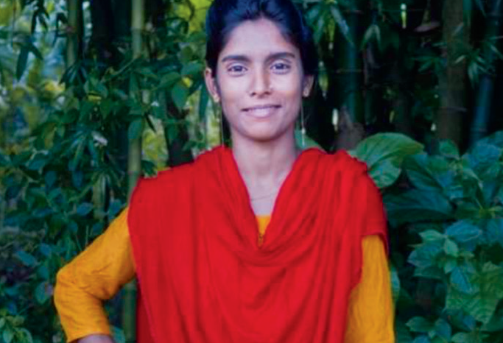

angladesh has one of the highest rates of child marriage in the world. Over half of all girls are married before turning 18. 22% are married before the age of 15. Child marriage normally spells
Gaza: What can I do?
Events in Gaza are deeply distressing. It is difficult know how to respond. The URC has a small team that works to highlight issues in Palestine. The URC Sabeel-Kairos Action Group can suggest useful resources for helpful actions.
You can link up with them at
sabeelkairos.urc@gmail.com.

You can also support the Commitment for Life Gaza appeal here. The funds will go to helping people in Gaza obtain food and water.
Image: Christian Aid, used with permission
B
the end of a girl’s education as she takes on the domestic duties of a wife and mother.

But we are making a difference. Morsheda Khatun was married as a child. She had to drop out of school because her widowed mother was unable to support her education. “Girls getting married at an early age is common here. Some are 13, 14 or 15 years old and it harms girls a lot. They can’t continue to study. It’s a huge loss,” she said. However, with support from our local Christian Aid partner, Morsheda has embraced new opportunities.

Morsheda now runs an online clothing business from home. She has also resumed her education and has already completed her Intermediate exam, equivalent to GCSE in the UK or Junior Cert in Ireland. We are confident she will go far!

You are making a difference through your support for Commitment for Life. Thank you.
commitmentforlife@urc.org.uk www.bit.ly/URCFL

