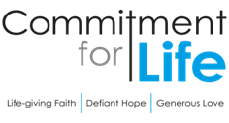
Moving
Stories
Committed to supporting our global partners ZIMBABWE
Begin with silence; or use music as a bed for this prayer.

Living God, who clothes us in garments of gratitude, adorn this prayer with the light of your grace. We bring to mind the many blessings that you so generously give…

Moment of silence…

We prayer for those gathered in this place…
those in our churches…
those in our communities…
for those who selflessly serve in making the world a better place.

Forgiving God, we too easily diminish the dignity of others, sowing division when you call for openness and trust.
Lord, have mercy;
Lord, have mercy.

We stand ashamed at the depth to which humanity can sink, how easily we march to the drums of war, how quickly we are swayed and seduced by the savagery of self-justifying narratives.
Christ, have mercy;
Christ, have mercy.

May the Trinity of Love bind our wounds, challenge our complacency, bring freedom from oppression, and lead all to abundance of freedom.

Amen.

Gender Justice in Zimbabwe
Photo: by Kevin Snyman, Regina Bhobo
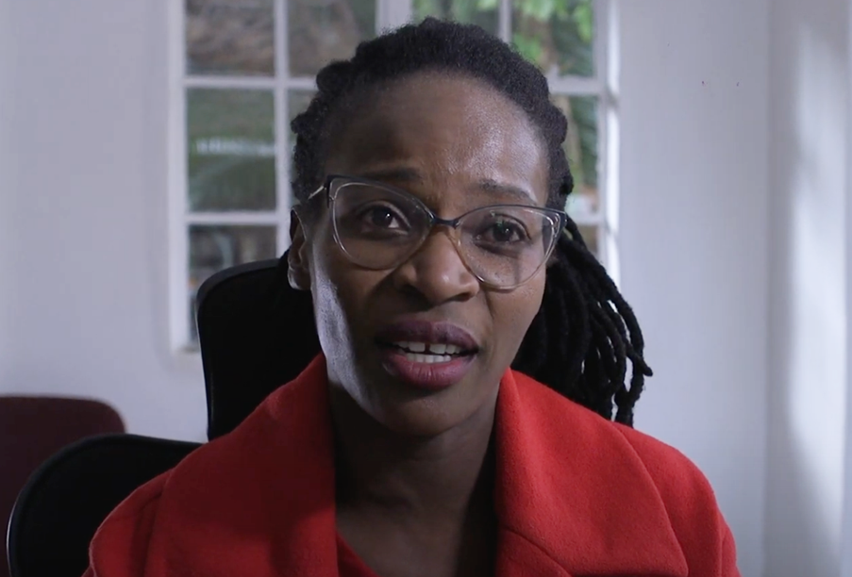

Regina Bhobo is a Gender Officer with the Evangelical Fellowship in Zimbabwe and coordinates the Zimbabwe Gender and Faith Network, also known as ‘Side by Side, Zimbabwe’.

Side by Side encompasses around eighteen different organisations. Its flagship project is called ‘Against Gender-Based Violence’. It operates in six districts of Manicaland.

Raising awareness about the issues surrounding gender-based violence is a key part of the strategy, giving women and men the awareness, language and tools to confront this awful scourge in communities.

The project has also harnessed the support of over five hundred pastors and ministers. Each was trained to be a gender champion in the local community. One large church created a well-respected refuge for survivors of gender-based violence.

Your support through Commitment for Life enables Regina’s work to thrive in Zimbabwe. You can hear Regina say more about the project in this filmed interview: https://bit.ly/4bFE0Ue

