Moving
Stories
Committed to supporting our global partners BANGLADESH
Shumana Akhter Aisha's home in Sylhet was surrounded by a sea of water on a newly formed makeshift island. "The water was sweeping away everything. It was raining heavily along with thunder," said Shumana.
Begin with silence; or use music as a bed for this prayer.

Living God, who clothes us in garments of gratitude, adorn this prayer with the light of your grace. We bring to mind the many blessings that you so generously give…

Moment of silence…

We prayer for those gathered in this place…
those in our churches…
those in our communities…
for those who selflessly serve in making the world a better place.

Forgiving God, we too easily diminish the dignity of others, sowing division when you call for openness and trust.
Lord, have mercy;
Lord, have mercy.

We stand ashamed at the depth to which humanity can sink, how easily we march to the drums of war, how quickly we are swayed and seduced by the savagery of self-justifying narratives.
Christ, have mercy;
Christ, have mercy.

May the Trinity of Love bind our wounds, challenge our complacency, bring freedom from oppression, and lead all to abundance of freedom.

Amen.

Photo: by Khairul Islam, Pixabay
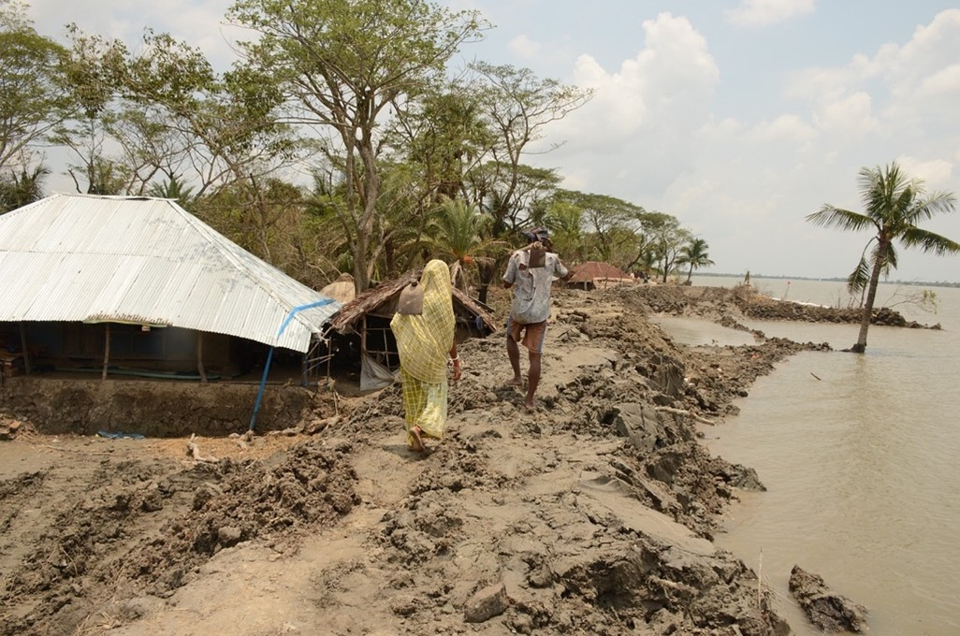
Sylhet normally has 840mm of rain in June. But in June 2022 it was soaked by more than 1,500mm. Erratic weather patterns will get worse in Bangladesh, one of the world's most climate vulnerable nations. The UN estimates that by 2050, 17% of the country will be submerged by rising sea levels. 20 million people will have lost their home.
Our partner Christian Aid is calling on world leaders to commit more to climate finance.
“Governments urgently need to take further action at home and internationally, to cut emissions, and adapt to the effects of climate change. And where the impacts go beyond what people can adapt to, the loss and damage fund must be resourced to compensate the poorest countries for the effects of a crisis that isn’t of their making,” said Patrick Watt, Chief Executive of Christian Aid.
Commitment for Life supports the call for governments to radically increase their climate budgets and commit to relentless climate action, particularly in support of climate vulnerable nations like Bangladesh.

