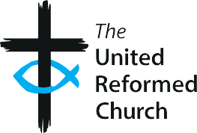
The United Reformed Church

SR3

Example safeguarding

questions for discussion/interviews
Here are some suggested questions about safeguarding for use during discussions with potential volunteers or in an interview with job applicants.

Volunteers
- What experience do you have of working with children/adults at risk?

- Why do you want to volunteer with children/adults at risk?

- What sorts of things would make you concerned about the safety of a child or adult at risk?

- What would you do if you saw or heard something about a child/adult at risk that made you concerned for their safety or welfare?

- Do you know of any reason why you should not be volunteering with children or adults experiencing, or at risk of, abuse or neglect?

Applicants for paid roles
- What experience do you have of working with children/adults at risk?

- What do you think are the key elements in effective safeguarding practice?

- Can you give an example of how you have responded to a safeguarding issue in a previous role (either employment or voluntary work)?

- What did you learn from this/how would you deal with a similar situation in future?

- Can you describe how you would respect the background and culture of children/adults at risk with whom you would be working?

- Do you know of any reason why you should not be working with children or adults experiencing, or at risk of, abuse or neglect?

- What is your understanding of confidentiality when dealing with a safeguarding concern?

Good Practice 6 – Resource SR3
1

