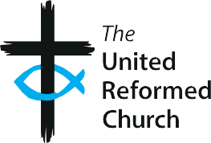
The United Reformed Church

S2

URC Training Matrix
Safeguarding Training Framework

Levels of mandatory training

Note: An Introduction to Safeguarding in the URC is recommended to members of the Church congregation. This is available as e-Learning.

Roles requiring mandatory training: | Foundation Training | Intermediate Training | Advanced Training
Synod Safeguarding Officers/Advisors
Managers of Synod Safeguarding
Officers/Advisors
Church Safeguarding Coordinators
Deputy Church Safeguarding Coordinator
Members of the Safeguarding Advisory Group (or its successor), Synod Safeguarding Committees and Reference Groups
Active Ministers and CRCWs (including retired ministers who meet the requirements of active ministry)
Synod Moderators
Youth and Children workers including volunteer leaders
Youth and Children’s workers (volunteer helpers) **
Adult workers including volunteer leaders
Adult workers (volunteer helpers) **
Managers of Children, Youth and Adults workers
Pastoral workers/visitors
Synod Clerks
Section O Investigation, Commission and Appeal Panel Members

Worship Leaders and Assembly Accredited Lay Preachers
URC Trustees and Synod Trustees
Elders as local church trustees

** those helping at a holiday club, assisting occasionally with Sunday school, running a craft activity at Messy Church, running the tuck shop at a youth group, helpers at a craft club/lunch/trip, etc, where it is clear these people are in ‘helper’ roles, are always working in the presence of, and under the supervision of, a ‘leader’.

