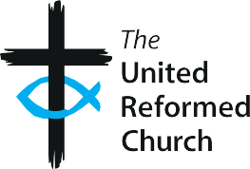
The United Reformed Church Suggested safeguarding wording for local

D2

church websites
The United Reformed Church (URC) is committed to safeguarding in every area of its life and ministry. Safeguarding is the action taken to promote and protect the well-being and human rights of individuals.

This means we will:

- Do all we can to create and maintain a safe and caring environment for all people
- Respond promptly and effectively to any form of abuse and neglect, including reporting abuse to statutory agencies when necessary
- Seek to prevent abuse in any form from occurring. We will seek to identify individuals who may pose a risk to others and take necessary actions to minimise risk whilst supporting these individuals in our communities when safe to do so.

If you wish to discuss a safeguarding concern, please contact:

Church Safeguarding Coordinator/Pastorate Safeguarding Coordinator or

Synod Safeguarding Officer. Contact details:

For information on safeguarding in the URC Synod of please click here.

For a full statement on the URC’s approach to Safeguarding, click here.

To view Good Practice 6, the URC’s Safeguarding Guidance document please click here .

Good Practice 6 – Resource D2
1

