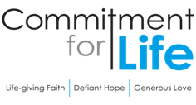
Moving
Stories
Committed to supporting our global partners ZIMBABWE

Debt Justice
Debt Justice is a campaigning organisation dedicated to ending unjust debt and building a fair economy for all, here in the UK and across the world. During November, Debt Justice held an art exhibition titled ‘It’s the debt that you owe: colonialism, debt and resistance’ in Peckham Levels. The artwork explored the impact of debt on countries in the global South, including through the artists’ own lived experience of colonial and neo-colonial oppression and debt. For further information about the work of Debt Justice click here:
https://debtjustice.org.uk/

Prayer in a Time of Conflict
Peaceful God,
We are inundated with distressing news of conflict and war.
We are told to choose sides;
that the good side’s violence is justifiable, because the bad side
is wrong or evil.

Help us only ever to choose the side of peace. When faced with his own arrest and violent crucifixion, Jesus refused to yield to fear or hatred or violence. Jesus chose the side of peace.

We know from scripture that true peace grows in the fertile soil of justice, mercy, humility, and the equal sharing of your free gifts. Help us set aside the misguided attempt to choose whose violence is better.
God of love, may your true peace be planted anew in us. May your love fall gently upon our communities like morning dew on thirsting crops as we remember that nothing in creation, neither heights nor depths, nor powers, nor principalities, can separate us from the indescribable love of the God.
Amen.

Photo: by Kevin Snyman, Manele Mpofu
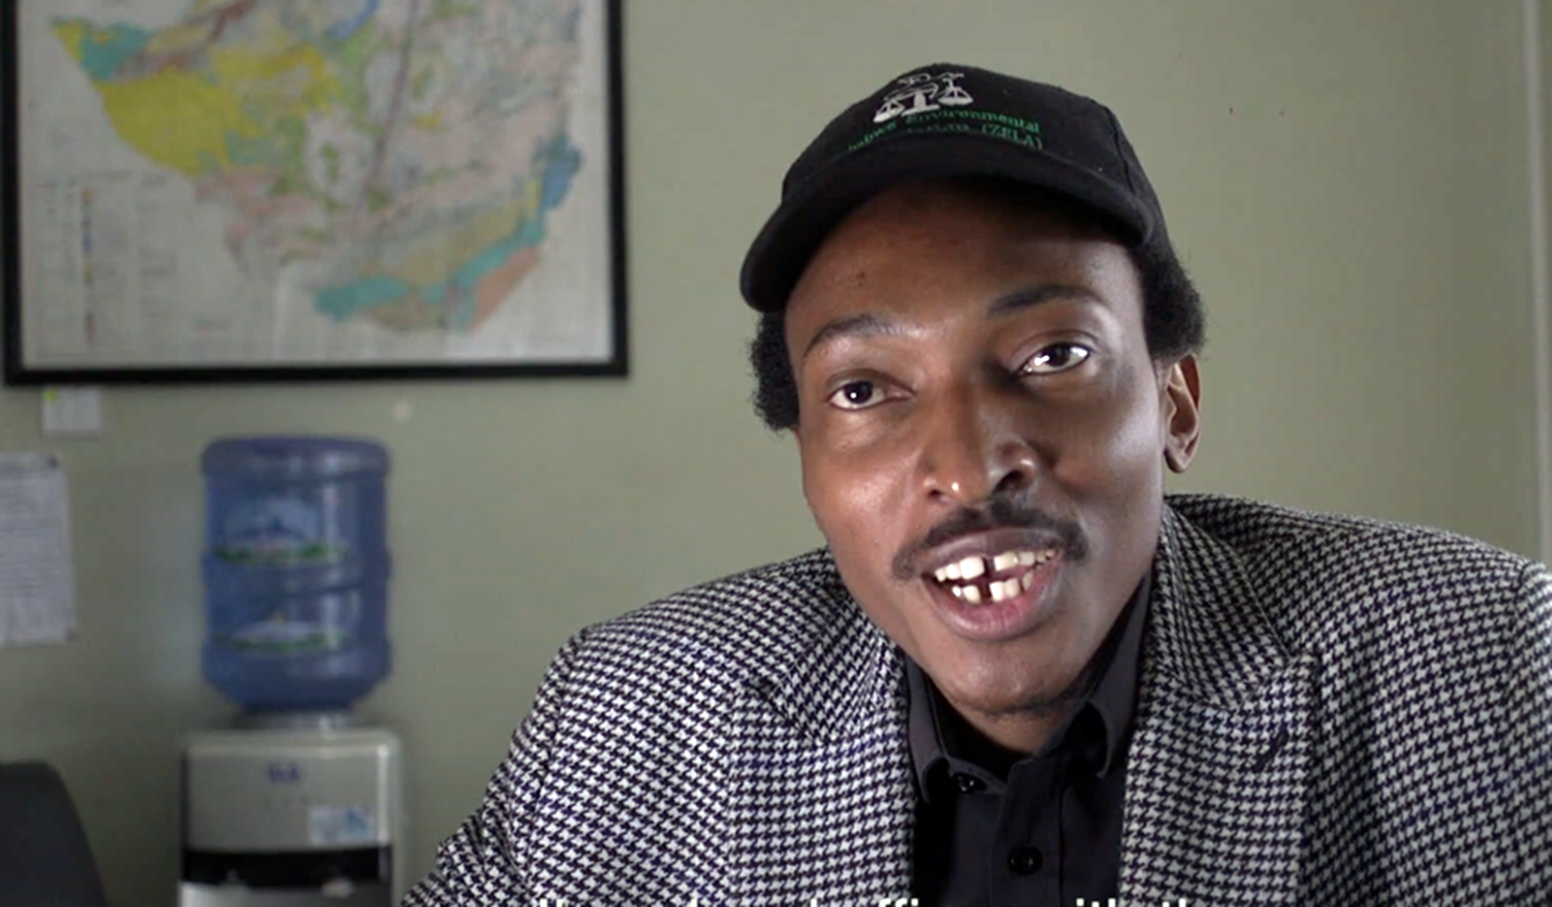
Manele Mpofu works for the Zimbabwe Environmental Law Association (ZELA) based in Harare. “These mining corporations are interested in profits,” he told us. “Many are looking to develop their mining interests in some of the most sensitive cultural and environmental areas of the country, including the famous Mana Pools, often against the law. We are here to represent the interests of local communities and the environment, both of which are negatively impacted by destructive mining practices.”

ZELA works closely with local communities to find out how they wish to engage with a proposed mining or industrial developement in their area. ZELA will then take these concerns and suggestions to the companies that may be in breach of human rights. In some cases, ZELA might be compelled to litigate through the country’s courts, but quite often the companies can be persuaded to take the law and the interests of the affected communities seriously.

The support you provide though Commitment for Life is critical to the effectiveness of our local partners in Zimbabwe like ZELA. Thank you for your efforts! If you’d like to listen to Manele yourself, please watch the video produced by Commitment for Life
(link below or scan QR code).
https://bit.ly/41exajJ

