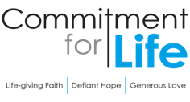
Moving
Stories
ISRAEL & THE OCCUPIED PALESTINIAN TERRITORY

Debt Justice
Debt Justice is a campaigning organisation dedicated to ending unjust debt and building a fair economy for all, here in the UK and across the world. During November, Debt Justice held an art exhibition titled ‘It’s the debt that you owe: colonialism, debt and resistance’ in Peckham Levels. The artwork explored the impact of debt on countries in the global South, including through the artists’ own lived experience of colonial and neo-colonial oppression and debt. For further information about the work of Debt Justice click here:
https://debtjustice.org.uk/

Prayer in a Time of Conflict
Peaceful God,
We are inundated with distressing news of conflict and war.
We are told to choose sides;
that the good side’s violence is justifiable, because the bad side
is wrong or evil.

Help us only ever to choose the side of peace. When faced with his own arrest and violent crucifixion, Jesus refused to yield to fear or hatred or violence. Jesus chose the side of peace.

We know from scripture that true peace grows in the fertile soil of justice, mercy, humility, and the equal sharing of your free gifts. Help us set aside the misguided attempt to choose whose violence is better.
God of love, may your true peace be planted anew in us. May your love fall gently upon our communities like morning dew on thirsting crops as we remember that nothing in creation, neither heights nor depths, nor powers, nor principalities, can separate us from the indescribable love of the God.
Amen.

The United Reformed Church Moderator, the Revd Dr Tessa Henry-Robinson, is one of 69 international church leaders who have signed a powerful and moving letter to Prime Minister Rishi Sunak.
Photo: by Hosny Salah (Gazan Photographer), Pixabay
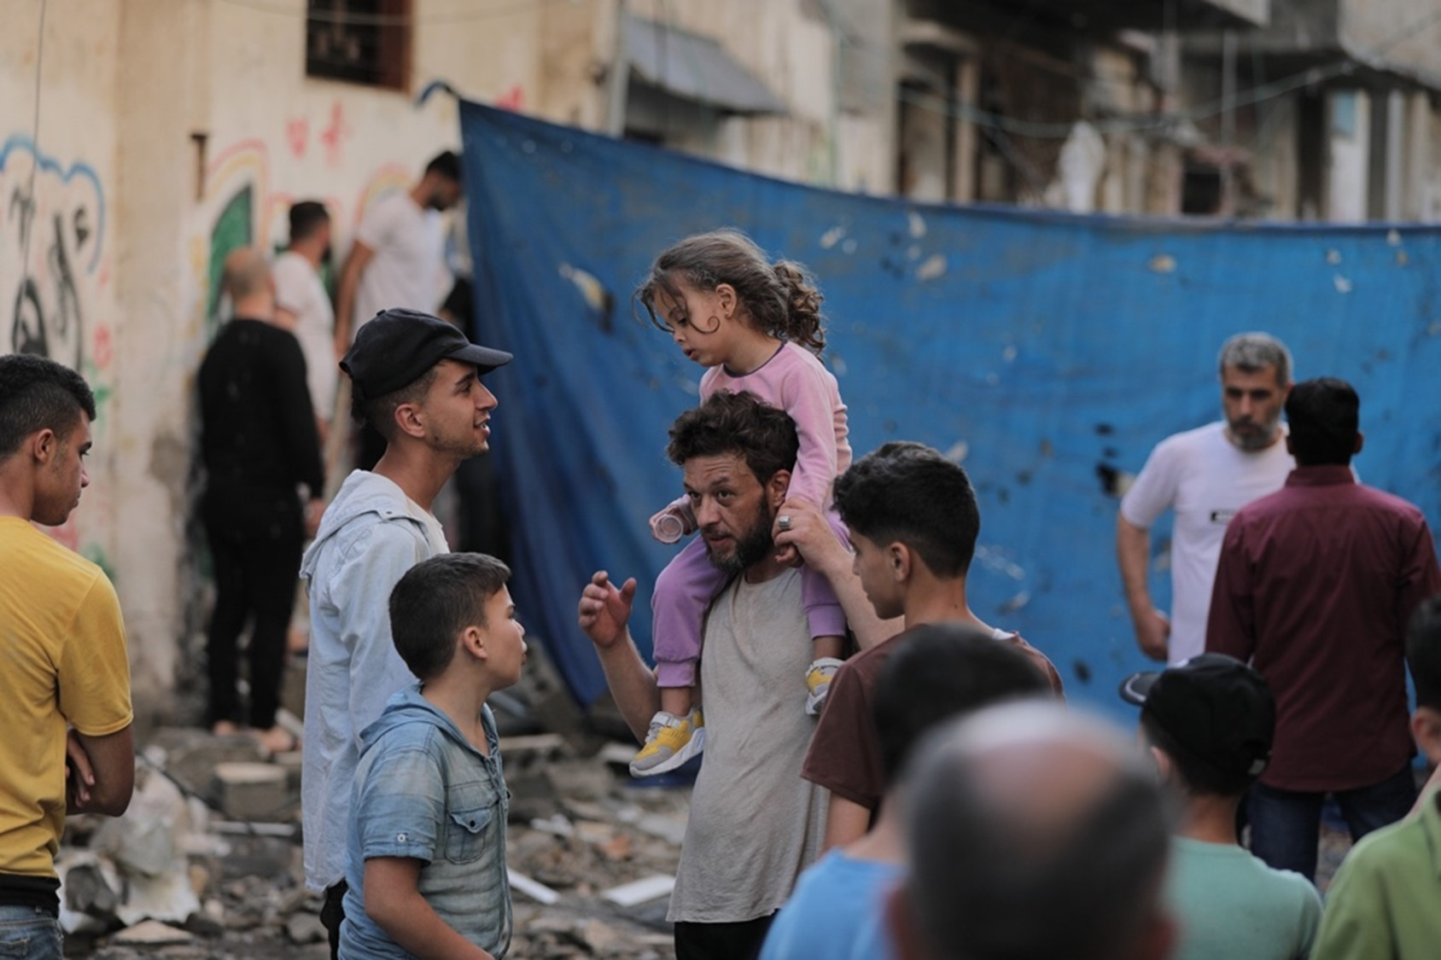

It is unacceptable that millions of people are in desperate need of clean water, adequate food, fuel for electricity, and urgently needed medical supplies… We weep with broken hearts as we hear of hospitals, mosques, churches, and schools damaged and destroyed by this war. In Gaza, there is no safe place. There is no refuge. There is no escape.

Commitment for Life supporters agree that the current violence cannot be decontextualised. Gazans have little hope in the face of seven decades of relentless disenfranchisement. Three-quarters of Gazans are refugees dating back to 1948. Gaza has become an open-air prison, according to Human Rights Watch. Illegal settlements expand every day in the West Bank. Illegal Israeli settlers act with impunity, attack Palestinians, and force the indigenous people from their ancestral lands. Nevertheless, none of this should be used to justify the violence used by either Hamas or Israel in pursuit of political objectives.

Commitment for Life has been supporting Christian Aid partners in Israel and the occupied Palestinian territory for well over 30 years. It is precisely these kinds of long-term, sustained partnerships that provide concrete examples of how to break out of vicious cycles of violence and retribution. Please continue to pray. Let’s not give up hope but continue in faithfulness to trust in God for justice for all.

