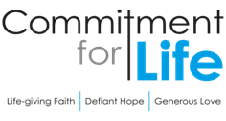
Moving
Stories
Committed to supporting our global partners BANGLADESH

Debt Justice
Debt Justice is a campaigning organisation dedicated to ending unjust debt and building a fair economy for all, here in the UK and across the world. During November, Debt Justice held an art exhibition titled ‘It’s the debt that you owe: colonialism, debt and resistance’ in Peckham Levels. The artwork explored the impact of debt on countries in the global South, including through the artists’ own lived experience of colonial and neo-colonial oppression and debt. For further information about the work of Debt Justice click here:
https://debtjustice.org.uk/

Prayer in a Time of Conflict
Peaceful God,
We are inundated with distressing news of conflict and war.
We are told to choose sides;
that the good side’s violence is justifiable, because the bad side
is wrong or evil.

Help us only ever to choose the side of peace. When faced with his own arrest and violent crucifixion, Jesus refused to yield to fear or hatred or violence. Jesus chose the side of peace.

We know from scripture that true peace grows in the fertile soil of justice, mercy, humility, and the equal sharing of your free gifts. Help us set aside the misguided attempt to choose whose violence is better.
God of love, may your true peace be planted anew in us. May your love fall gently upon our communities like morning dew on thirsting crops as we remember that nothing in creation, neither heights nor depths, nor powers, nor principalities, can separate us from the indescribable love of the God.
Amen.

We recently heard about an amazing young woman
in Kurigram, one of Northern Bangladesh’s poorest regions.
Photo: by Christian Aid
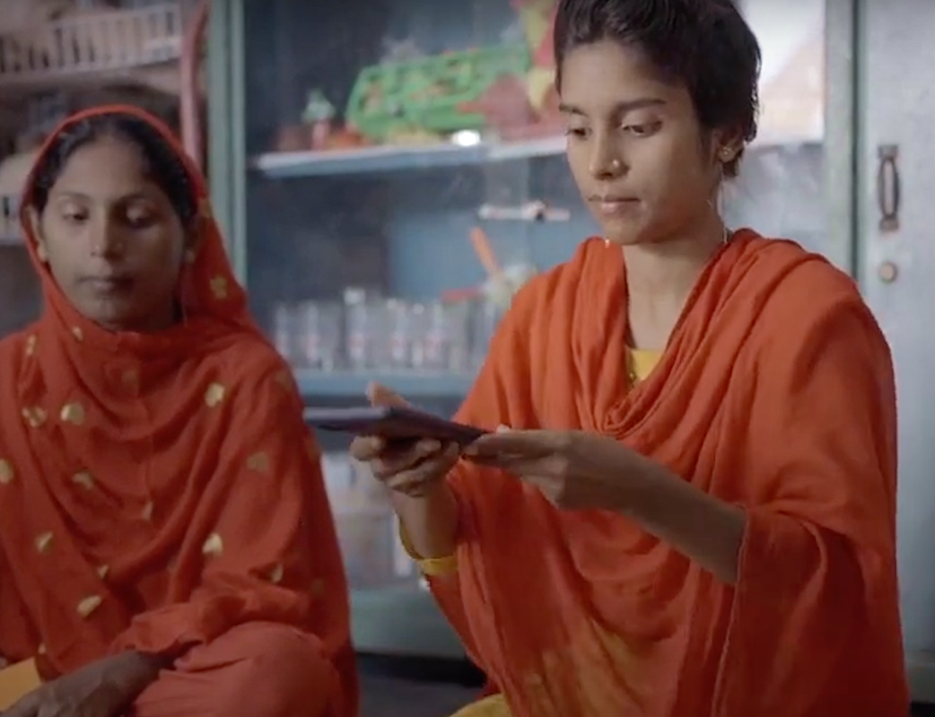
Thanks to Aid Comilla, our wonderful partner in that part of Bangladesh, 21-year-old Kakoli Khatun is studying her college degree. Not only that, Kakoli has set up and manages a group of gifted young artisans and entrepreneurs. This group has set up a craft making business. They now sell their gorgeous craftwork online using their mobiles as an interface to their customers.
“These women have become a powerful force for change in their communities,” says Christian Aid.
We at Commitment for Life want to thank you for your ongoing support of women just like Kakoli.
If you would like a visit, please contact David Hart: dhart@christian-aid.org

