Prayer for Our Communities in a Time of Conflict

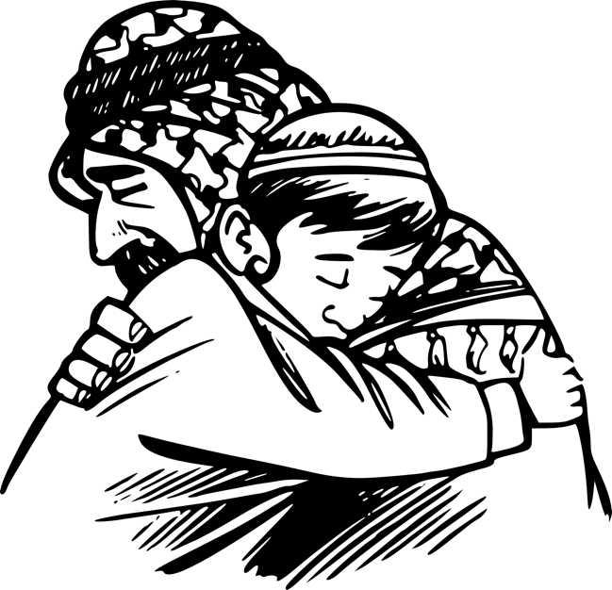
Peaceful God:
We are inundated with constant and distressing news of conflict and war.
Among the shouts of accusation
We are told that to we must choose sides,
That the good side’s violence is justifiable and should be accepted, even championed,
Because the bad side is plainly wrong and evil.
Yet choosing sides like this means that too often we no longer hear the cries of those on the other side of the conflict who are hurt, imprisoned, and killed.
Some actors are attempting to import these conflicts into our own settings, pitching one community against another.
Graphic: Pixabay
Help us only ever to choose the side of peace.
Because when faced with his own arrest and violent crucifixion,
Jesus refused to yield to fear, or hatred, or violence.
Jesus told Peter to put up his sword.
Jesus chose the side of peace.

We know from scripture,
That the absence of conflict does not necessarily signify peace,
That true peace grows in the fertile soil of justice, mercy, humility, and the equal sharing of your free gifts.
And so, you urge us to set aside our misguided attempt to choose whose violence is better,
The misplaced trust in missiles to shield us and usher in peace.
You invite us, God, to beat our swords into ploughshares,
And to sow seeds of sharing, justice, and unconditional love.

God of love, may your true peace be planted anew in us.
May your love fall gently upon our communities like morning dew on thirsting crops.

May your peace surround and bless our neighbours, Muslim, Jewish, Christian or of no faith, filling every one of us with compassion, patience, and understanding.

Finally, help us all to remember that nothing in creation:
Neither heights nor depths, nor Powers, nor Principalities,
can separate us from the indescribable love of the God of never-ending Peace.
Amen

