Moving
Stories
Committed to supporting our global partners ZIMBABWE

Ways to use CFL resources
Each year, Commitment for Life spends a small amount of its income to produce resources.
We give these away for free.
They help promote Commitment for Life as reminders to pray, give, and learn about global justice issues throughout the year.

It is wonderful to hear how congregations are using the resources!

- Northgate, Darlington, are holding an Afternoon Tea in
aid of Commitment for Life
- A member from Worcester keeps a supply of CFL trolley tokens in the car. They hand them out as people search for a pound coin in the supermarket car park and say “Have a present from my church”!
- Worcester is also giving each family a collecting box, in the hope that any loose change will be dropped into it.
We would love to hear your stories of how you use the resources. Please email: suzanne.pearson@urc.org.uk

Prayer
Creator God, we thank you for the creative thoughts and talents you have given each one of us. Help us to use those gifts in ways that express your sadness over global justice issues which affect people in regions such as Bangladesh, Zimbabwe and Israel and the occupied Palestinian territories. May our hearts be so moved that our response is simply to love and support these people, as you would, in the best way we can through Commitment for Life. Amen.
Improved livestock production, managing and marketing
Photo: by Kevin Snyman, Goat in Mudzi District
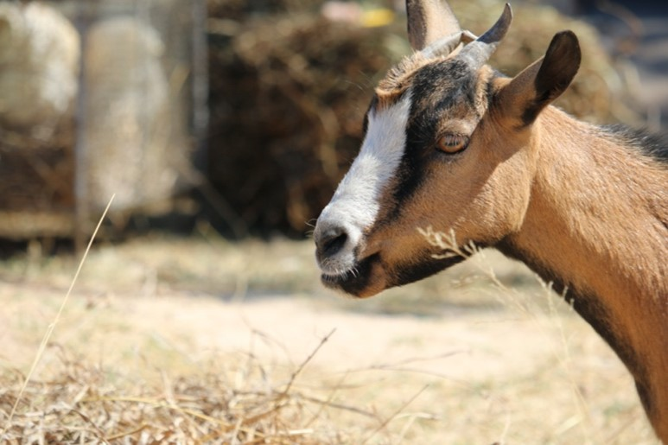

In the Mudzi District of Zimbabwe, our Commitment for Life partners work to support improved livestock production, managing and marketing.

Livestock such as cattle, goats, chickens, ducks and guinea fowl are incredibly valuable resources for communal farmers. Yet these resources suffer the impacts of climate change most acutely. Thanks to the education, training, and support that you enable through your support, local farmers are taught risk reduction techniques and financial literacy.

“[Our training…] covered goat production and management aspects such as improved housing, nutrition, and disease management.

“We are grateful for the improved knowledge,”
says communal farmer, Mr Never Kafura.

Watch this video for more on the work. www.bit.ly/45bYjnK

