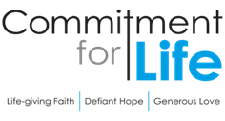
Moving
Stories
Committed to supporting ISRAEL & OCCUPIED PALESTINE

Ways to use CFL resources
Each year, Commitment for Life spends a small amount of its income to produce resources.
We give these away for free.
They help promote Commitment for Life as reminders to pray, give, and learn about global justice issues throughout the year.

It is wonderful to hear how congregations are using the resources!

- Northgate, Darlington, are holding an Afternoon Tea in
aid of Commitment for Life
- A member from Worcester keeps a supply of CFL trolley tokens in the car. They hand them out as people search for a pound coin in the supermarket car park and say “Have a present from my church”!
- Worcester is also giving each family a collecting box, in the hope that any loose change will be dropped into it.
We would love to hear your stories of how you use the resources. Please email: suzanne.pearson@urc.org.uk

Prayer
Creator God, we thank you for the creative thoughts and talents you have given each one of us. Help us to use those gifts in ways that express your sadness over global justice issues which affect people in regions such as Bangladesh, Zimbabwe and Israel and the occupied Palestinian territories. May our hearts be so moved that our response is simply to love and support these people, as you would, in the best way we can through Commitment for Life. Amen.
Christian Aid’s response and Appeal to the current Middle East Crisis
Photo: by Christian Aid
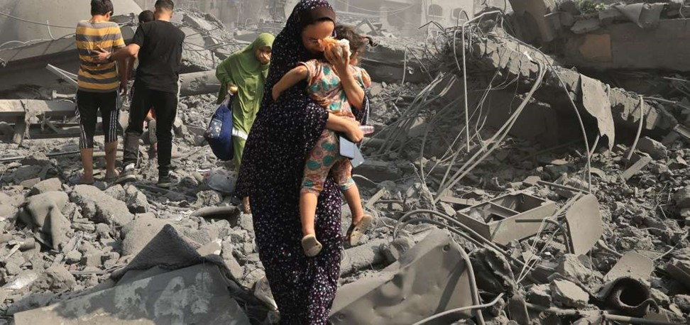
On Saturday, 7 October, Hamas launched a wave of rocket attacks and stormed into Israel, leading to the biggest escalation in violence there has been in the region. Members of armed groups entered Israeli towns, communities, and military facilities near the Gaza Strip, killing and capturing Israeli forces and civilians.

William Bell, Christian Aid’s Head of Middle East Policy & Advocacy, says, “Following atrocities against Israeli civilians, Israel's military response in Gaza is now creating an escalating humanitarian crisis that threatens more than two million people.”

Christian Aid has been working with the poorest and most vulnerable people in the Middle East since the early 1950s, when it provided humanitarian relief to Palestinian refugees.

Christian Aid’s established partners in Gaza are ready to respond with medical relief and community-led initiatives such as food, shelter, sanitation, and protection.

Commitment for Life thank you for your continued support to Christian Aid and its partners in Israel and the Occupied Palestinian territory. Your donations can make a huge difference to the current conditions of those affected.
You can donate direct to Christian Aid’s appeal here: Middle East Crisis Appeal | Christian Aid.

Christian Aid have a campaign at www.bit.ly/MECrisisAction for people to sign a petition
to the British Foreign Secretary.

