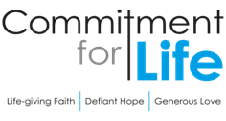
Moving
Stories
Committed to supporting our global partners BANGLADESH

Ways to use CFL resources
Each year, Commitment for Life spends a small amount of its income to produce resources.
We give these away for free.
They help promote Commitment for Life as reminders to pray, give, and learn about global justice issues throughout the year.

It is wonderful to hear how congregations are using the resources!

- Northgate, Darlington, are holding an Afternoon Tea in
aid of Commitment for Life
- A member from Worcester keeps a supply of CFL trolley tokens in the car. They hand them out as people search for a pound coin in the supermarket car park and say “Have a present from my church”!
- Worcester is also giving each family a collecting box, in the hope that any loose change will be dropped into it.
We would love to hear your stories of how you use the resources. Please email: suzanne.pearson@urc.org.uk

Prayer
Creator God, we thank you for the creative thoughts and talents you have given each one of us. Help us to use those gifts in ways that express your sadness over global justice issues which affect people in regions such as Bangladesh, Zimbabwe and Israel and the occupied Palestinian territories. May our hearts be so moved that our response is simply to love and support these people, as you would, in the best way we can through Commitment for Life. Amen.
Climate change makes dengue fever deadlier this year in Bangladesh
Photo: by WikiImages on Pixabay
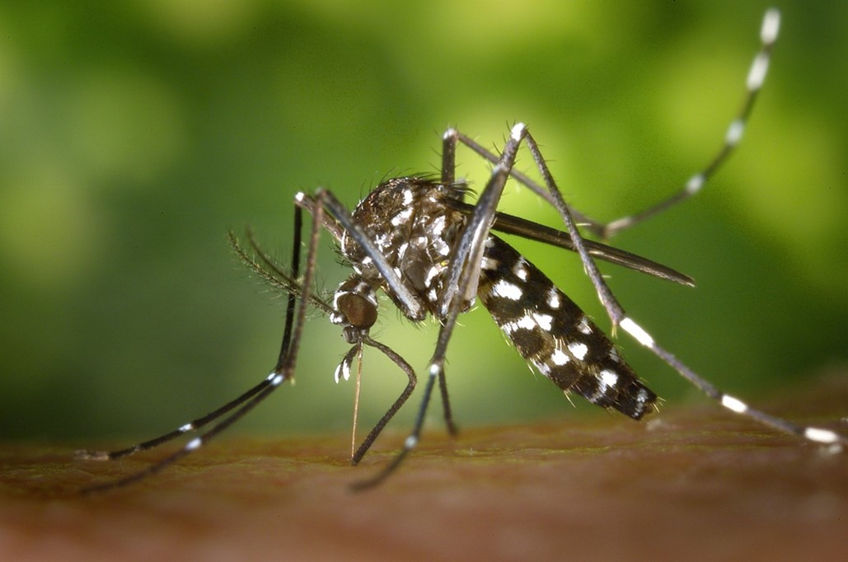
Rising temperatures and a longer monsoon season are providing ideal breeding conditions for mosquitoes. Bangladesh is grappling with record deaths of the Mosquito-borne dengue fever this year. Disease experts are linking worsening outbreaks to the impacts of climate change.
A lack of proper prevention measures has allowed the dengue carrying Aedes Aegypti mosquito to spread across almost all of Bangladesh.
Dengue is common during the June-September monsoon season when mosquitoes thrive in
stagnant water.
Authorities are scrambling to contain and treat the disease. By August of 2023, 778 people had died
so far in Bangladesh, making this the deadliest year since the first recorded epidemic in 2000.
Thanks to your prayers and support for people in Bangladesh, Commitment for Life can make a difference.
The Christian Aid Bangladesh Country Manager may be available to speak in some churches in early November.
If you would like a visit, please contact David Hart: dhart@christian-aid.org

