Moving
Stories
Committed to supporting our global partners ZIMBABWE

Harvest service
In July 2023 our Programme Officer Kevin Snyman travelled to Zimbabwe. He concentrated his
visit in the north-east and south-east of the country, visiting our Christian Aid partners to and hearing the good news stories from locals who have benefitted so enormously from our partnership. “I’m grateful to the Christian Aid Country Team that facilitated our visit,” says Kevin.
“The hospitality was always so generously offered, and I saw many examples of how effective our work in the region has been.”

This year’s harvest service focuses on Zimbabwe. You can find and download the PDF, Word, and PowerPoints for your harvest service on our Commitment for Life website under “order or download resources” and scroll down to ‘services of worship’.

Prayer
Thank you, Jesus, for your presence in our lives. We bless and praise you for the many gifts you pour so generously into our lives. May we be transformed by the infilling of your Holy Spirit to perfectly love you through our care and support for our neighbour in need. And, in so doing, may we increasingly come to resemble you. Amen.
Batsirai Byanutete, lives in the Mutoko District in Zimbabwe. He is a young man who has had his life turned around by the intervention of our Christian Aid partner. Christian Aid has assisted with the help of indigenous knowledge, doing brilliant work in identifying indigenous plants and shrubs that can be carefully combined into livestock feed. These bushes and plants are processed using a Christian Aid supplied milling machine. The product is then bagged and stored, ready for sale.
Photo: by Kevin Snyman, July 2023
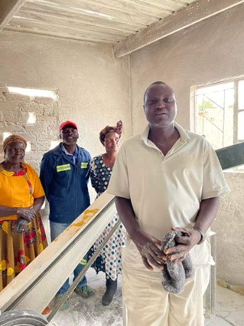

This highly nutritious supplement is given to animals in lean times (like now) and just before market. The animals are healthier, which means that the community is healthier too.

Your support for Commitment for Life, means that Batsirai Byamutete, instead of hanging out with directionless youths, drinking and getting into mischief, has a sense of purpose now that his milling expertise is much valued by the community.

