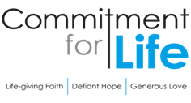
Moving
Stories
Committed to supporting ISRAEL & OCCUPIED PALESTINE

Harvest service
In July 2023 our Programme Officer Kevin Snyman travelled to Zimbabwe. He concentrated his
visit in the north-east and south-east of the country, visiting our Christian Aid partners to and hearing the good news stories from locals who have benefitted so enormously from our partnership. “I’m grateful to the Christian Aid Country Team that facilitated our visit,” says Kevin.
“The hospitality was always so generously offered, and I saw many examples of how effective our work in the region has been.”

This year’s harvest service focuses on Zimbabwe. You can find and download the PDF, Word, and PowerPoints for your harvest service on our Commitment for Life website under “order or download resources” and scroll down to ‘services of worship’.

Prayer
Thank you, Jesus, for your presence in our lives. We bless and praise you for the many gifts you pour so generously into our lives. May we be transformed by the infilling of your Holy Spirit to perfectly love you through our care and support for our neighbour in need. And, in so doing, may we increasingly come to resemble you. Amen.

Delicious Palestinian Food Workshops
Photo: by calum lewis, unsplash
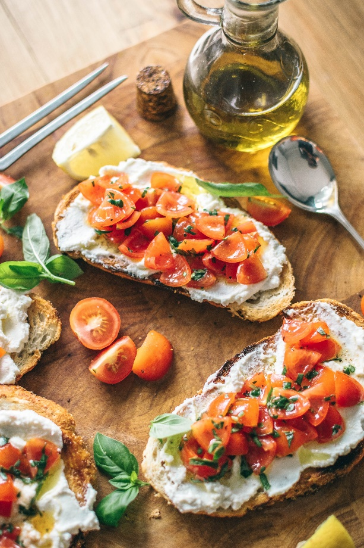

Sindyanna of Galilee is a nonprofit centre run by Jewish and Arab women. The visitor centre is a place where Jewish and Arab women work in equality and mutual respect.

One of the activities
taking place is ‘Cooking Without Borders Workshops.’ The most recent class, which brought a unique twist, was led by an Arab chef, Myasar Abu Shahade. With the goal of promoting Palestinian food culture, she put an emphasis on traditional dishes from her mother’s kitchen in Jaffa.

Maysar sees herself as a bridge between cultures, working to free people from the social stigmas they have towards Muslim Arab women from Jaffa.
Through this, she has authored a book Cooking and Stories in Arabic and Hebrew. As she says, “Arab is
my mother tongue which I can’t give up, while Hebrew is the language I live in, and which allows me to reach
a wider audience and convey a message of peace
and love.” For further information about the work of Sindyanna click here: https://www.sindyanna.com/

The URC Education trip to Israel and the occupied Palestinian territory, visited Sindyanna visitor centre in October 2019, and Commitment for Life ordered a limited supply of soap from there in 2022.

